Christ the King Catholic Church
300 Mendenhall Lane, P.O. Box 297 Benton, PA
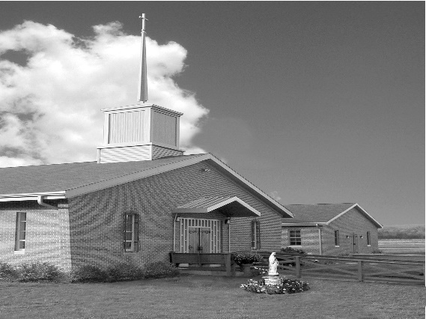
Phone: Phone: (570) 925-6969
E-mail: ctk@epix.net
Website: ctkbenton.weebly.com
Pastor: Rev. Richard J. Mowery
(570) 784-0801
Administrator: Fr. Andrew P. St. Hilaire
(570) 784-3123 (717) 884-9523
frasthilaire@hbgdiocese.org
CYE Coordinator: Betty Hnylanski
(570) 594-3687, bhnylan@gmail.com
Secretary: Lee Ann Boiwka
(570) 864-3090, boiwka@epix.net
Office Hours: Monday & Thursday, 8am -12pm

September 4, 2022 – 23rd Sunday in Ordinary Time

“Faithful discipleship demands complete surrender to God.”

While each of us can name important people and relationships in our lives that have a claim on our hearts, the Scriptures today remind us of what needs to be the highest priority for each of us. Jesus unequivocally states that just as he will lay down his life on the cross, each of us who wish to be faithful disciples will be asked to make sacrifices in our own lives.

Liturgy of the Word
The author of the Book of Wisdom observes that it can be difficult to comprehend God’s ways, pointing out that what is within our grasp we find with difficulty; but when things are in heaven, who can search them out? Saint Paul writes to Philemon from prison, asking him to welcome Onesimus as a brother, not a slave. In the Gospel, Jesus speaks to the crowd, saying: Whoever does not carry his own cross and come after me cannot be my disciple.

The Parish Office will be closed on Monday, September 5th, in observance of the Labor Day Holiday. There will be daily Mass Monday at 9:00 a.m.

In your prayers, please remember: Intentions of the Holy Father, all Priests including Msgr. Lawrence, Fr. Mowery, Fr. St. Hilaire and Fr. Sola, Josephine Folayemi Adewole, Michael Bardi, Maureen Beck, Lorena Bennet, Butch Bogart, Christina Capriola, Russell Castrogiovanni, Cobert Family, Edward Connell, Alan & Jen Culp, Michael Farrell, Michael Fontinell, Deb & Paul Haden,Vivian Whitenight Hynick, Bob Kalie, Carl Kalie, Margaret Kalie, Joseph LaBonte, Mary Ann Levan, James Mazonkey, Bernie Nichols, Nancy Oman, Sabo Family, Joan Sansouci, Jackie Scherer, Diane Talanca, Pat Treier’s daughter Christy, Sally Tucker, Max Whitenight, Nancy Wisbar, Sonny Womelsdorf, Mary Ann Zeveney and all the Parishioners of CTK.

Stewardship: August 28, 2022

Offerings $1492.50
Assumption $60.00
Project Fund $55.00
St. Nick $20.00

Total $1627.50

Mass Intentions

Saturday, September 3 – Dale Kingsbury by Ann Kingsbury
Sunday, September 4 – Arlene & Robert Wisniewski (Special Intention)
Monday, September 5 – Anne Eustice by Renee Hansen
Friday, September 9 – People of the Parish
Saturday, September 10 – Justin Kozak by Joe & Lee Ann Boiwka
Sunday, September 11 – CYE Children and Catachists

Mass intentions are available in memory of, or in honor of a loved one. The donation for having a Mass said for a personal request is $10.00. You can drop your request in the collection or contact the parish office.

Lector Schedule Extraordinary Minister Collection Stewards
September 4 – Peter Yastishock P.J. Haden Joe & Lee Ann Boiwka
September 11 – Barb Treier Lee Ann Boiwka Charlotte & Joe Casarella

Coffice: Saturdays at 8am, Fr. Andrew streams live on his YouTube channel to pray the liturgy of the hours and reflect on current events/culture through the lens of the Catholic faith. Visit frandrewpsth.com to learn more and sign up for weekly updates!

Unborn Candle Donations $3.00/ week, $5.00/ 2 weeks or $10.00/ month.
Month of September – Richard & Tamara Lindner

CYE News: As summer comes to a close and the new school year begins, we look forward to resuming CYE classes for children in grades Pre-School through Grade 12. Please note the following dates: September 11 CYE classes begin with participation in the 5:00 pm Saturday or 9:00 am Sunday Mass. CYE classroom instruction begins at 10:00 and dismisses at 11:30.
September 11. CYE Parent meeting in the social hall beginning at 10:00 am
September 18. Father Andrew will meet with CYE students in grades 3 through 12 during CYE class time.
September 25. No CYE classes. Please visit the Christ the King fair stand when you are at the Bloomsburg Fair this week.

Finance Committee and Parish Council Meeting – The next meeting will be Monday, September 12th in the Social Hall. This will be a combined meeting to begin at 6:00 p.m.

Charismatic Day of Renewal: This year’s theme is Restoration and Recovery in the Holy Spirit, with Keynote Speakers Msgr. Robert E. Lawrence and Fr. Bernard-Mary Ayo Oniwe, OP. The Day of Renewal will be on Saturday, September 17 from 8:00 a.m. to 3:30 p.m. at the Diocesan Center, 4800 Union Deposit Road, Harrisburg, Pa. Registration includes lunch and is $20 per person. To register, call Vicki Krone at 717-364-6260, Joyce at 717- 887-3515, email charismatic.harrisburg@gmail.com.

May He Rest in the Peace of the Lord! Please pray for the soul of Ray Hunsinger who died on August 26, 2022. The community of Christ the King extends its deepest sympathies to his family, relatives, and friends on their loss.
Join Us for the Pennsylvania March for Life! St. Joseph (Danville) Knights of Columbus will be sponsoring a bus to the Pennsylvania March for Life in September. Please call the parish office at 570-275-2512 to reserve your seat. With the repeal of Roe v. Wade, the abortion debate has been moved to the state level. Join us in voicing your support for life as we march around the Pennsylvania Capitol in Harrisburg on Monday, September 19. Rally begins at 11 a.m., with the March following at 12 noon. Hear from pro-life leaders about the most pressing issues of today and how you can build a culture of life in the great Keystone State.

2022 Diocesan Women’s Conference: The theme of the conference this year is Eucharist: Jesus in our Midst, on Saturday, October 15 at the Diocesan Center in Harrisburg. Awaken your faith and love for the Real Presence of Christ during this day-long event. In person and virtual registration options will be offered. Registration and full conference schedule will be available in July. Make plans now to join your sisters in Christ as we rediscover the Real Presence of the Eucharist during the 2022 Women’s Conference.

Fair Week – September 23rd through October 1st – with fair only a few weeks away, please sign up to volunteer and work at the fair. This is the biggest fundraiser that CTK has. Your help is appreciated.
Haluski Making - We are planning to process the onions on September 14 and 16 starting at 8:00 am. All help would be appreciated. We also ask if anyone has a food processor and is willing to bring it along it would be helpful and appreciated.
We will be making the haluski daily during the fair, so we ask anyone who would like to volunteer join us in the church kitchen at 8:00 am to assist with this task. Of course, more hands make for faster work.

Birthday Greetings for Father Sola – If you would like to send Father a birthday greeting/message his birthday is on September 10th. His address is Rev. Olusola Adewole, O.P.
955 Robert Fulton Highway, Quarryville, PA 17566-9543

Benton Food Bank - For the month of September we will be collecting toothpaste. The Food Bank at the N4C’s is the 3rd Tuesday of every month. Anyone in need is encouraged to come between 9:00 a.m. -11:00 a.m. and also 4:30 p.m. – 6:30 p.m.

