Christ the King Catholic Church
300 Mendenhall Lane, P.O. Box 297 Benton, PA
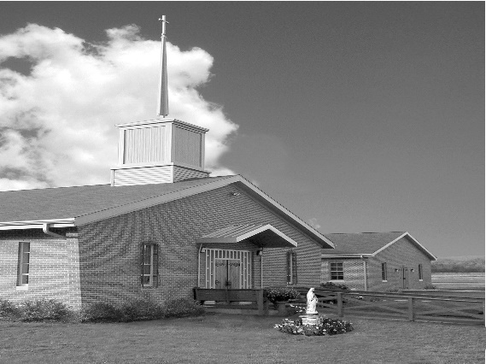
Phone: Phone: (570) 925-6969
E-mail: ctk@epix.net
Website: ctkbenton.weebly.com
Pastor: Rev. Richard J. Mowery
(570) 784-0801
Administrator: Fr. Andrew P. St. Hilaire
(570) 784-3123 (717) 884-9523
frasthilaire@hbgdiocese.org
CYE Coordinator: Betty Hnylanski
(570) 594-3687, bhnylan@gmail.com
Secretary: Lee Ann Boiwka
(570) 864-3090, boiwka@epix.net
Office Hours: Monday & Thursday, 8am -12pm

September 18, 2022 – 25th Sunday in Ordinary Time

“The person who is trustworthy in very small matters is also trustworthy in great ones.”

Loving God and neighbor are the highest priorities for Christians. The prophets challenged the Israelites when their love of wealth led to neglecting God, and warned them against treating others unjustly and dishonestly. Jesus reinforces the message: Our relationship with God requires a commitment to a higher calling by remaining true to him and treating others with honesty, generosity, and justice.

Liturgy of the Word
In the first reading, Amos warns those who trample upon the needy that the Lord will not forget the way they have treated the poor. In the second reading, Saint Paul advises Timothy to pray for everyone, including those in authority. In the Gospel, Jesus uses the parable of the dishonest steward to teach his disciples about trustworthiness.

**Daily Mass times will be Mondays at 9:00 a.m. and Fridays at 9:00 a.m.**
In your prayers, please remember: Intentions of the Holy Father, all Priests including
Fr. Mowery, Fr. St. Hilaire and Fr. Sola, Josephine Folayemi Adewole, Michael Bardi, Maureen Beck, Lorena Bennet, Butch Bogart, Christina Capriola, Russell Castrogiovanni, Cobert Family, Edward Connell, Alan & Jen Culp, Michael Farrell, Michael Fontinell, Deb & Paul Haden,Vivian Whitenight Hynick, Bob Kalie, Carl Kalie, Margaret Kalie, Joseph LaBonte, Mary Ann Levan, James Mazonkey, Bernie Nichols, Nancy Oman, Joan Sansouci, Jackie Scherer, Diane Talanca, Pat Treier’s daughter Christy, Sally Tucker, Max Whitenight, Nancy Wisbar, Sonny Womelsdorf, Mary Ann Zeveney and all the Parishioners of CTK.

Stewardship: September 11, 2022

Offerings $2142.00
Peter’s Pence $393.00
Rainy Day $50.00
St. Nick $175.00

Total $2760.00

Mass Intentions

Saturday, September 17 – People of the Parish
Sunday, September 18 – Nicholas Sabo by Justa Sabo
Monday, September 19 – Father Sola by the Sabo Family
Friday, September 23 – People of the Parish
Saturday, September 24 – People of the Parish
Sunday, September 25 – Daniel & Dolores Bauman by Joe & Lee Ann Boiwka

Mass intentions are available in memory of, or in honor of a loved one. The donation for having a Mass said for a personal request is $10.00. You can drop your request in the collection or contact the parish office.

Lector Schedule Extraordinary Minister Collection Stewards
September 18 – Meg Geffken Judith Scavone Mark & Patricia Sullivan
September 25 - Stephen Root Patricia Sullivan Anne Eustice & Florence Tapsak

Coffice: Saturdays at 8am, Fr. Andrew streams live on his YouTube channel to pray the liturgy of the hours and reflect on current events/culture through the lens of the Catholic faith. Visit frandrewpsth.com to learn more and sign up for weekly updates!

Unborn Candle Donations $3.00/ week, $5.00/ 2 weeks or $10.00/ month.
Month of September – Richard & Tamara Lindner

CYE - We welcomed our returning students and our new families to our CYE religious education program on Sunday September 11. We are grateful for the blessings of our dedicated catechists, parents and parishioners who support our program.
A snack is provided to the children after 9:00 am Mass each Sunday. Since we observe the one hour fast before Mass before receiving communion, the children enjoy a small healthy snack before going to class. Donations for individual prepackaged snacks for the children are always welcomed.
We look forward to celebrating the Sacrifice of the Mass with you on Saturday evening at 5:00 or Sunday morning at 9:00 in preparation for our classroom instruction.

Camp Courage has decided to provide an overnight bereavement camp this fall. The October camp will be held for two days starting on Saturday, October 29 and Sunday, October 30. The location will be on the grounds of Camp Lavigne, 35 Camp Lavigne Road, Benton. Please consider your church family who has lost a loved one and who would benefit from attending Camp Courage II.
Camp Courage is: ● a bereavement camp with fun filled activities as well as activities to help cope with grief ● free to everyone ● for children/teens ages 6-18 ● an overnight camp ● accepting camper applications until September 30
For more information about Camp Courage II please contact Susan Smith, Coordinator Bereavement Camps, at sssmith1@geisinger.edu or 570-271-6461.

Discovering Christ is a program for anyone who is curious. Enjoy some tasty food and listen to a thought-provoking talk that is designed to explore the meaning and purpose of your life. After the talk, you can share your thoughts in a small group (and talk as much or as little as you wish). It’s all done in a warm, friendly, and judgement-free environment.
Join us at Discovering Christ - Free Childcare is available. St. Joseph Parish - Danville Pa 17821
Wednesdays from October 5 to November 16, 6:30-8:30 pm. Register at stjosephdanville.org
Fair Week – September 23rd through October 1st – with fair only a few weeks away, please sign up to volunteer and work at the fair. This is the biggest fundraiser that CTK has. Your help is appreciated.
Haluski Making - We will be making the haluski daily during the fair, so we ask anyone who would like to volunteer join us in the church kitchen at 8:00 am to assist with this task. Of course, more hands make for faster work.

Benton Food Bank - For the month of September we will be collecting toothpaste. The Food Bank at the N4C’s is the 3rd Tuesday of every month. Anyone in need is encouraged to come between 9:00 a.m. -11:00 a.m. and also 4:30 p.m. – 6:30 p.m.

Welcome to Christ the King- We welcome our newest members to our Christ the King Family –
Fisher Family – Michael, Natasha, Veyda, Lylah and Vivian. Joga Family – Jose, Holly, Ariana and Ciara.

2022 Diocesan Annual Campaign as of September 1, 2022

Parish Goal for 2022: $9,442.53
Total Paid: $13,372.00
Outstanding Pledges: $50.00
Total Committed: $13,422.00
Over/(under)goal in cash: $3,929.47
Number of Donors: 38
Registered Households: 119
Percentage of Participation: 31.93%

