Christ the King Catholic Church
300 Mendenhall Lane, P.O. Box 297 Benton, PA
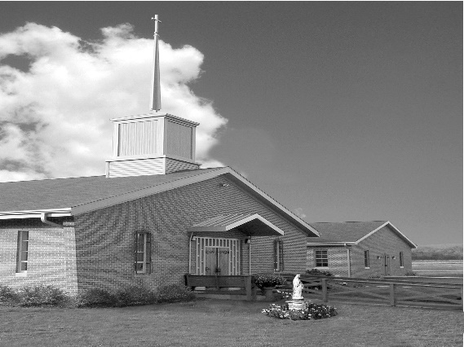
Phone: Phone: (570) 925-6969
E-mail: ctk@epix.net
Website: ctkbenton.weebly.com
Pastor: Rev. Richard J. Mowery
(570) 784-0801
Administrator: Fr. Andrew P. St. Hilaire
(570) 784-3123 (717) 884-9523
frasthilaire@hbgdiocese.org
CYE Coordinator: Betty Hnylanski
(570) 594-3687, bhnylan@gmail.com
Secretary: Lee Ann Boiwka
(570) 864-3090, boiwka@epix.net
Office Hours: Monday & Thursday, 8am -12pm

October 9, 2022 – 28th Sunday in Ordinary Time

“The Lord has done great things for us.”

Today’s readings invite us to reflect on our gratitude for what God has done for us, particularly through Christ. It begins with acknowledging that it is the Lord who has acted on our behalf. Such recognition can in turn lead us to a greater appreciation for God’s greatness, to a deeper faith, and to true worship.

Liturgy of the Word
In the first reading, Naaman is healed after following Elisha’s instructions to plunge himself into the Jordan seven times. Afterward, he pledges to offer sacrifice only to the Lord. Paul writes to Timothy that it is the Gospel of Jesus Christ for which he is suffering, even to the point of chains, like a criminal. In the Gospel, Jesus is traveling throughout Samaria and Galilee when ten lepers call to him, Jesus, Master! Have pity on us! Jesus tells them to go show themselves to the priests and the lepers are healed while on their way. Only one leper, a Samaritan, returns to give thanks to Jesus.

*No Daily Mass this week on Monday, October 10th and Friday, October 14th *
In your prayers, please remember: Intentions of the Holy Father, all Priests including
Fr. Mowery, Fr. St. Hilaire and Fr. Sola, Josephine Folayemi Adewole, Michael Bardi, Maureen Beck, Lorena Bennet, Butch Bogart, Christina Capriola, Joe Casarella, Russell Castrogiovanni, Cobert Family, Edward Connell, Alan & Jen Culp, Michael Farrell, Michael Fontinell, Deb & Paul Haden,Vivian Whitenight Hynick, Bob Kalie, Carl Kalie, Margaret Kalie, Joseph LaBonte, Mary Ann Levan, James Mazonkey, Bernie Nichols, Nancy Oman, Joan Sansouci, Jackie Scherer, Diane Talanca, Pat Treier’s daughter Christy, Sally Tucker, Max Whitenight, Nancy Wisbar, Sonny Womelsdorf, Mary Ann Zeveney and all the Parishioners of CTK.

Stewardship: October 2, 2022

Offerings $3172.28
Rainy Day $70.00
St. Nick $231.00
Votives $85.00

Total $3558.28

Mass Intentions

Saturday, October 8 – People of the Parish
Sunday, October 9 – Nicholas Sabo by Justa Sabo
Monday, October 10 – NO MASS
Friday, October 14 – NO MASS
Saturday, October 15 – Alberta A. McHenry by William McHenry
Sunday, October 16 – Alberta A. McHenry by William McHenry

Mass intentions are available in memory of, or in honor of a loved one. The donation for having a Mass said for a personal request is $10.00. You can drop your request in the collection or contact the parish office.

Lector Schedule Extraordinary Minister Collection Stewards

October 9 – Pete Yastishock Judith Scavone Charlotte & Joe Casarella
October 16 – Anne Eustice Patricia Sullivan Lee Ann Boiwka & Judie Scavone

Bloomsburg Fair 2022 – Thank you to all who volunteered in any way to make this fundraiser a success! A special thank you to Tom & Monique Heffner for heading this project year after year. Thank you to Elaine & Pat DiGirolamo for being in charge of the Haluski making. And also thanks to Bob & Peg Kalie for donating the onions and cabbage for the Haluski.

Coffice: Saturdays at 8am, Fr. Andrew streams live on his YouTube channel to pray the liturgy of the hours and reflect on current events/culture through the lens of the Catholic faith. Visit frandrewpsth.com to learn more and sign up for weekly updates!

CYE – October 16 - October is the month of the rosary. Please join the CYE students after 9:00 Mass on Sunday October 16 as we pray the rosary for our country. The children will have a short snack after Mass (they are usually a little hungry after observing the hour fast before receiving Holy Communion) and we will begin the rosary for our country around 10:15. This is a very solemn event and we hope you will join the children in this prayer.

October 23 - CYE students in grades 1-8 should bring their completed Saint posters to class.

October 29 and 30 - Festival of Saints. The CYE students will have their Saint posters on display in the social hall for parishioners attending the Saturday evening and Sunday morning Masses to view. Students will be available after the 9:00 Mass to discuss their posters with parishioners. Please come to the social hall and see the work of our CYE students as they learn about the Saints of our Church.

Unborn Candle Donations $3.00/ week, $5.00/ 2 weeks or $10.00/ month.
Month of October – Steve & Sue Root

Benton Food Bank - For the month of October we will be cereal. The Food Bank at the N4C’s is the 3rd Tuesday of every month. Anyone in need is encouraged to come between 9:00 a.m. -11:00 a.m. and also 4:30 p.m. – 6:30 p.m.

Are you able to spend an hour a week with Jesus? The Adoration Chapel at the Basilica of St. Cyril and Methodius in Danville IS NOW OPEN with adoration hours from Wednesdays at 7:00 AM through Thursdays at 8:00 PM. We need another adorer for the 8:00-9:00 AM hour on Wednesdays, 1:00-2:00 AM on Thursdays and we need at least 2 adorers for each hour of 2:00-3:00 AM and 3:00-4:00 AM Thursdays. Contact Sue 570-441-8252 or go to https://adoration24hours.wordpress.com/

2022 Diocesan Women’s Conference, Saturday, October 15th at the Diocesan Center in Harrisburg. Keynote speaker Barbara McGuigan, founder of Voice of Virtue International and a former EWTN radio host, and Capstone Speaker Meg Hunter-Kilmer, a hobo for Christ, along with Most Rev. Ronald W. Gainer, Bishop of Harrisburg and Katherine Phenicie, Spiritual Life Director at Delone Catholic High School, will awaken your faith and love for the Real Presence of Christ during this daylong event. In person and virtual attendance options. Registration and full conference schedule is available at www.hbgdiocese.org/women. Make plans now to join your sisters in Christ as we rediscover the Real Presence of the Eucharist during the 2022 Women’s Conference, The Eucharist: Jesus in Our Midst.

Treasure in Earthen Vessels – Embracing the Call of Missionary Discipleship
On Friday, October 14th, join others at St. Columba at 7:00 p.m. to hear Meg Hunter-Kilmer, Speaker, Blogger and “Hobo for Christ”. Eucharistic Adoration to follow at 8:00 p.m.

Combined Parish Council and Finance Committee Meeting – Monday, October 17th at
6:00 p.m. in the Social Hall.

