Christ the King Catholic Church
300 Mendenhall Lane, P.O. Box 297 Benton, PA
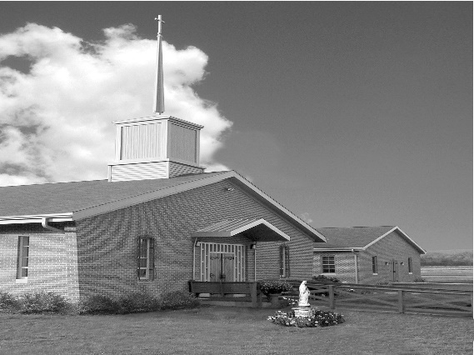
Phone: Phone: (570) 925-6969
E-mail: ctk@epix.net
Website: ctkbenton.weebly.com
Pastor: Rev. Richard J. Mowery
(570) 784-0801
Administrator: Fr. Andrew P. St. Hilaire
(570) 784-3123 (717) 884-9523
frasthilaire@hbgdiocese.org
CYE Coordinator: Betty Hnylanski
(570) 594-3687, bhnylan@gmail.com
Secretary: Lee Ann Boiwka
(570) 864-3090, boiwka@epix.net
Office Hours: Monday & Thursday, 8am -12pm

October 30, 2022 – 31st Sunday in Ordinary Time

“Receive the Lord with joy and be ready for change.”

Zacchaeus was not looking for a miracle; he just wanted to see Jesus. When Jesus called him, he came down quickly with great joy. When Jesus calls us, do we come quickly, or do we hesitate? Jesus comes to us in the Eucharist. As Zacchaeus did, we ought to receive him with great joy. For Zacchaeus received Jesus and was changed by the encounter. We, too, are meant to be transformed, for the sake of the world.

Liturgy of the Word
The author of the Book of Wisdom praises God for his love for all things he created and for the mercy he has on all people. Paul tells the Thessalonians that they always pray for them, that God may make [them] worthy of [their] calling. In the Gospel, Jesus calls Zacchaeus to come down from the tree, and the tax collector says he will give half his possessions away and repay what he owes anyone four times over.

All Saints Day – Oct. 31, Monday, 7:00 p.m. Vigil. (No 9:00 a.m. Mass on Monday)
Nov. 1, Tuesday, 9:00 a.m. Mass
All Souls Day – Nov. 2, Wednesday, 9:00 a.m. Mass
First Friday - Nov. 4, Friday, 9:00 a.m. Mass
In your prayers, please remember: Intentions of the Holy Father, all Priests including
Fr. Mowery, Fr. St. Hilaire and Fr. Sola, Josephine Folayemi Adewole, Michael Bardi, Maureen Beck, Lorena Bennet, Butch Bogart, Christina Capriola, Joe Casarella, Russell Castrogiovanni, Cobert Family, Edward Connell, Alan & Jen Culp, Michael Farrell, Michael Fontinell, Deb & Paul Haden,Vivian Whitenight Hynick, Bob Kalie, Carl Kalie, Margaret Kalie, Joseph LaBonte, Mary Ann Levan, James Mazonkey, Bernie Nichols, Nancy Oman, Joan Sansouci, Jackie Scherer, Diane Talanca, Pat Treier’s daughter Christy, Sally Tucker, Max Whitenight, Nancy Wisbar, Sonny Womelsdorf, Mary Ann Zeveney and all the Parishioners of CTK.

Prayer Warrior – Interested in becoming a Prayer Warrior and being part of the Prayer Chain for Christ the King and our Community? Contact the parish office with your name and e-mail address at ctk@epix.net. Each time we get a request an e-mail goes out with the information.

Stewardship: October 23, 2022

Offerings $1050.50
World Mission $559.00
Rainy Day $55.00

Total $1664.50

Mass Intentions

Saturday, October 29 – People of the Parish
Sunday, October 30 – Michelle Kotas (Birthday Blessings) by Justa Sabo
Monday, October 31 – Mama Grace Eshikena by Lee Ann Boiwka
Tuesday, November 1 – People of the Parish
Wednesday, November 2 – Nicholas Sabo by Justa Sabo
Friday, November 4 – People of the Parish
Saturday, November 5 – People of the Parish
Sunday, November 6 – People of the Parish

Mass intentions are available in memory of, or in honor of a loved one. The donation for having a Mass said for a personal request is $10.00. You can drop your request in the collection or contact the parish office.
Lector Schedule Extraordinary Minister Collection Stewards

October 30 – Pete Yastishock Stephen Root Anne Eustice & Florence Tapsak
November 6 - Pete Yastishock Judith Scavone Mark & Patricia Sullivan

Coffice: Saturdays at 8am, Fr. Andrew streams live on his YouTube channel to pray the liturgy of the hours and reflect on current events/culture through the lens of the Catholic faith. Visit frandrewpsth.com to learn more and sign up for weekly updates!

CYE – October 29 and 30 - Festival of Saints. The CYE students will have their Saint posters on display in the social hall for parishioners attending the Saturday evening and Sunday morning Masses to view. Students will be available after the 9:00 Mass to discuss their posters with parishioners. Please come to the social hall and see the work of our CYE students as they learn about the Saints of our Church.

Confirmation retreat for students in eighth grade who will be confirmed in May 2023 will be held at St Columba Church on Saturday November 5 beginning promptly at 10:00 am.

Unborn Candle Donations $3.00/ week, $5.00/ 2 weeks or $10.00/ month.
Month of November – Steve & Sue Root

Benton Food Bank - For the month of November we will be collecting chicken and turkey stuffing. The Food Bank at the N4C’s is the 3rd Tuesday of every month. Anyone in need is encouraged to come between 9:00 a.m. -11:00 a.m. and also 4:30 p.m. – 6:30 p.m.

Pray the Rosary on YouTube with Monsignor Robert Lawrence: Go St. Columba’s YouTube channel then go to “Playlists” and choose our Rosary Videos Playlist. There are 4 videos, one for each of the 4 Mysteries of the Rosary. Each has beautiful artwork and music incorporated.

World Mission Sunday – Thanks for participating on World Mission Sunday last weekend! Through your generous contributions to the Society for the Propagation of the Faith, you are Christ’s witnesses, building the Church in the Pope’s missions around the world, feeding the poor, and aiding the missionaries who are sharing the Gospel worldwide. May God Bless you for your compassionate missionary spirit!

Heart of Mercy – A Counseling Ministry of the Sister of the Good Shepherd.
Counseling for Relationship Difficulties, Depression, Anxiety, Post Abortion Healing, Grief and Loss, Anger, Spiritual Difficulties, Inability to Forgive, Self Esteem Issues, Fears and Isolation. Call Sr. Mary Frances Altavilla, RGS at 410-245-0870 or Sr. Patricia Marie Barnette, RGS at 352-328-8145. Website is www.heartofmercygs.org

Life Chain – Sunday, October 30th, 2022 at the Fountain in Bloomsburg from 1:00 – 2:00 p.m.
Life Chain is a peaceful and prayerful public witness. It is a visual statement of solidarity by
the Christian community that the Church supports the sanctity of life from the moment of
conception to natural death.

Apple Dumplings – The Benton Council of Churches is selling Apple Dumplings. They are $5.00 and the money is due by November 20th. They will be picked up the evening of November 22nd. You can make arrangements to get them that evening or pick them up after Mass the weekend of November 26th and 27th. The sign-up sheet is on the back counter. See Anne Eustice or Sue Root with any questions.

Fair News – Thanks to the support and volunteering of the parishioners of Christ the King, we made a profit of $15,300.00 this year at the Bloomsburg Fair.

Some additional Thanks –
- Dot & Bill Simons for donating money to buy hams for the bean soup.
- Gloria Galer for transporting supplies to and from the fair every morning.
- Bob Brewington for storing the trailer.
- Dick Brewington for transporting the trailer to and from the fair.

We are truly blessed with wonderful and generous parishioners at Christ the King!

