Christ the King Catholic Church
300 Mendenhall Lane, P.O. Box 297 Benton, PA
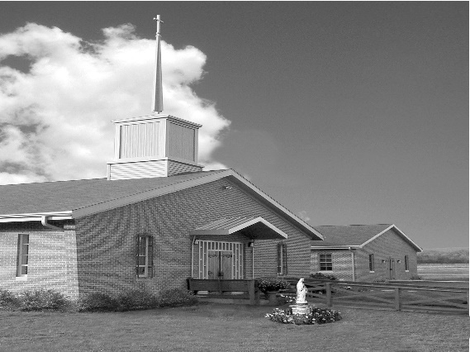
Phone: Phone: (570) 925-6969
E-mail: ctk@epix.net
Website: ctkbenton.weebly.com
Pastor: Rev. Richard J. Mowery
(570) 784-0801
Administrator: Fr. Andrew P. St. Hilaire
(570) 784-3123 (717) 884-9523
frasthilaire@hbgdiocese.org
CYE Coordinator: Betty Hnylanski
(570) 594-3687, bhnylan@gmail.com
Secretary: Lee Ann Boiwka
(570) 864-3090, boiwka@epix.net
Office Hours: Monday & Thursday, 8am -12pm

October 2, 2022 – 27th Sunday in Ordinary Time

“Christ helps us grow in faith and in the ability to act in his name.”

Courage, a gift of the Holy Spirit, lies at the heart of today’s Scripture – the courage to be faithful to Christ and the Gospel in all things and in all places. Like the disciples, we should be unafraid to ask Jesus for an increase in faith, for he reminds us that even with the smallest amount of faith we have the ability to do great things in his name.

Liturgy of the Word
In the first reading, Habakkuk cries out to the Lord, and the Lord answers. Saint Paul encourages Timothy to never lack courage or be ashamed of his faith in Jesus Christ. In the Gospel, the Apostles ask Jesus to increase [their] faith, and Jesus gives them instruction using a mustard seed as a metaphor.

**Daily Mass times will be Mondays at 9:00 a.m. and Fridays at 9:00 a.m.**
Starting October 1st, Saturday evening Mass will be at 4:00 p.m. instead of 5:00 p.m.

In your prayers, please remember: Intentions of the Holy Father, all Priests including
Fr. Mowery, Fr. St. Hilaire and Fr. Sola, Josephine Folayemi Adewole, Michael Bardi, Maureen Beck, Lorena Bennet, Butch Bogart, Christina Capriola, Russell Castrogiovanni, Cobert Family, Edward Connell, Alan & Jen Culp, Michael Farrell, Michael Fontinell, Deb & Paul Haden,Vivian Whitenight Hynick, Bob Kalie, Carl Kalie, Margaret Kalie, Joseph LaBonte, Mary Ann Levan, James Mazonkey, Bernie Nichols, Nancy Oman, Joan Sansouci, Jackie Scherer, Diane Talanca, Pat Treier’s daughter Christy, Sally Tucker, Max Whitenight, Nancy Wisbar, Sonny Womelsdorf, Mary Ann Zeveney and all the Parishioners of CTK.

Stewardship: September 25, 2022

Offerings $1313.00
Rainy Day $10.00

Total $1323.00

Mass Intentions

Saturday, October 1 – Marilyn LaBonte by Joseph LaBonte
Sunday, October 2 – People of the Parish
Monday, October 3 – Eileen Scherer by Mary Fontinell
Friday, October 7 – People of the Parish
Saturday, October 8 – People of the Parish
Sunday, October 9 – Nicholas Sabo by Justa Sabo

Mass intentions are available in memory of, or in honor of a loved one. The donation for having a Mass said for a personal request is $10.00. You can drop your request in the collection or contact the parish office.

Lector Schedule Extraordinary Minister Collection Stewards

October 2 – Paul Haden Meg Geffken Mark & Patricia Sullivan
October 9 – Pete Yastishock Judith Scavone Charlotte & Joe Casarella
Coffice: Saturdays at 8am, Fr. Andrew streams live on his YouTube channel to pray the liturgy of the hours and reflect on current events/culture through the lens of the Catholic faith. Visit frandrewpsth.com to learn more and sign up for weekly updates!

Unborn Candle Donations $3.00/ week, $5.00/ 2 weeks or $10.00/ month.
Month of October – Steve & Sue Root

CYE -Festival of Saints posters for Grades 1-8 are due Sunday October 23. Poster boards can be picked up in the social hall Saturday or Sunday after Mass or during regular office hours on Monday and Thursday. Please contact Ms Betty with any questions or ideas.

Discovering Christ is a program for anyone who is curious. Enjoy some tasty food and listen to a thought-provoking talk that is designed to explore the meaning and purpose of your life. After the talk, you can share your thoughts in a small group (and talk as much or as little as you wish). It’s all done in a warm, friendly, and judgement-free environment.
Join us at Discovering Christ - Free Childcare is available. St. Joseph Parish - Danville Pa 17821
Wednesdays from October 5 to November 16, 6:30-8:30 pm. Register at stjosephdanville.org
Fair Week – September 23rd through October 1st –This is the biggest fundraiser that CTK has. Your help is appreciated.

Benton Food Bank - For the month of October we will be cereal. The Food Bank at the N4C’s is the 3rd Tuesday of every month. Anyone in need is encouraged to come between 9:00 a.m. -11:00 a.m. and also 4:30 p.m. – 6:30 p.m.

Are you able to spend an hour a week with Jesus? The Adoration Chapel at the Basilica of St. Cyril and Methodius in Danville IS NOW OPEN with adoration hours from Wednesdays at 7:00 AM through Thursdays at 8:00 PM. We need another adorer for the 8:00-9:00 AM hour on Wednesdays, 1:00-2:00 AM on Thursdays and we need at least 2 adorers for each hour of 2:00-3:00 AM and 3:00-4:00 AM Thursdays. Contact Sue 570-441-8252 or go to https://adoration24hours.wordpress.com/

2022 Diocesan Women’s Conference, Saturday, October 15th at the Diocesan Center in Harrisburg. Keynote speaker Barbara McGuigan, founder of Voice of Virtue International and a former EWTN radio host, and Capstone Speaker Meg Hunter-Kilmer, a hobo for Christ, along with Most Rev. Ronald W. Gainer, Bishop of Harrisburg and Katherine Phenicie, Spiritual Life Director at Delone Catholic High School, will awaken your faith and love for the Real Presence of Christ during this daylong event. In person and virtual attendance options. Registration and full conference schedule is available at www.hbgdiocese.org/women. Make plans now to join your sisters in Christ as we rediscover the Real Presence of the Eucharist during the 2022 Women’s Conference, The Eucharist: Jesus in Our Midst.

Flea Market – Sisters of Saints Cyril and Methodius
Saturday, October 8th from 10:00 a.m. to 2:00 p.m. There will be furniture, books and crafts.
Visit us at Villa Sacred Heart, Danville, PA

Training Sessions for Extraordinary Ministers of Holy Communion
If you are currently an Extraordinary Minister of Holy Communion, and you are in need of renewing your Mandate, please look for the current training sessions on the Diocese of Harrisburg website. You can find and register for trainings by following Welcome, Office for Divine Worship, Extraordinary Ministers of Holy Communion. More training sessions will be added as they are requested. Below is a link to the registration page.
https://www.hbgdiocese.org/liturgy-worship-and-prayer/liturgical-catechesis-and-ministry-training/extraordinary-ministers-of-holy-communion/

If you received a Mandate prior to 2019, the Mandate is only valid for three years. If you received a Mandate in 2019 or thereafter, the Mandate is valid for five years or until it is decided otherwise by the Pastor, Priest Chaplain or the Extraordinary Minister. When the Extraordinary Minister leaves the parish or institution, the Mandate is terminated.

Training sessions for Extraordinary Ministers of Holy Communion for the Diocese of Harrisburg occur in October/November, January/February and July/August. If you would like to plan a session, please contact Mrs. Laura Loose at lloose@hbgdiocese.org

