Christ the King Catholic Church
300 Mendenhall Lane, P.O. Box 297 Benton, PA
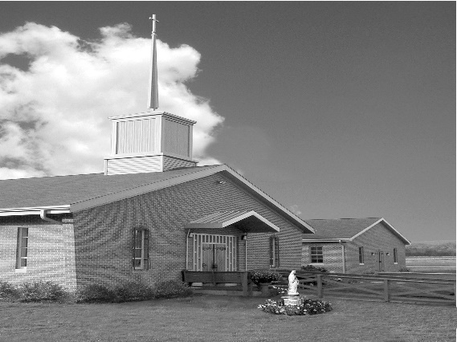
Phone: Phone: (570) 925-6969
E-mail: ctk@epix.net
Website: ctkbenton.weebly.com
Pastor: Rev. Richard J. Mowery
(570) 784-0801
Administrator: Fr. Andrew P. St. Hilaire
(570) 784-3123 (717) 884-9523
frasthilaire@hbgdiocese.org
CYE Coordinator: Betty Hnylanski
(570) 594-3687, bhnylan@gmail.com
Secretary: Lee Ann Boiwka
(570) 864-3090, boiwka@epix.net
Office Hours: Monday & Thursday, 8am -12pm

October 23, 2022 – 30th Sunday in Ordinary Time

“In prayer, we turn to God with all our needs.”

The Lord hears the cry of the poor, the oppressed, and the tax collector who share the virtue of humility. He knows no favorites but hears those who admit their need for his mercy and redemption. When we pray, it is not to exalt ourselves but to humble ourselves and place ourselves in his hands.

Liturgy of the Word
Sirach says that God hears the cry of the lowly and oppressed. Paul praises the Lord for giving him strength as his life is threatened. In the Gospel, Jesus tells the parable of the Pharisee and tax collector praying at the temple. The humble tax collector – not the self-righteous Pharisee – leaves justified.

In your prayers, please remember: Intentions of the Holy Father, all Priests including
Fr. Mowery, Fr. St. Hilaire and Fr. Sola, Josephine Folayemi Adewole, Michael Bardi, Maureen Beck, Lorena Bennet, Butch Bogart, Christina Capriola, Joe Casarella, Russell Castrogiovanni, Cobert Family, Edward Connell, Alan & Jen Culp, Michael Farrell, Michael Fontinell, Deb & Paul Haden,Vivian Whitenight Hynick, Bob Kalie, Carl Kalie, Margaret Kalie, Joseph LaBonte, Mary Ann Levan, James Mazonkey, Bernie Nichols, Nancy Oman, Joan Sansouci, Jackie Scherer, Diane Talanca, Pat Treier’s daughter Christy, Sally Tucker, Max Whitenight, Nancy Wisbar, Sonny Womelsdorf, Mary Ann Zeveney and all the Parishioners of CTK.

Prayer Warrior – Interested in becoming a Prayer Warrior and being part of the Prayer Chain for Christ the King and our Community? Contact the parish office with your name and e-mail address at ctk@epix.net. Each time we get a request an e-mail goes out with the information.

Stewardship: October 16, 2022

Offerings $1378.50
Contribution $1574.01
Rainy Day $95.00
St. Nick $5.00

Total $3052.51

Mass Intentions

Saturday, October 22 – People of the Parish
Sunday, October 23 – Charlotte & Joe Casarella by Lee Ann & Joe Boiwka
Monday, October 24 – Anne Eustice by Renee Hansen
Friday, October 28 – John Fontinell by CTK Family
Saturday, October 29 – People of the Parish
Sunday, October 30 – Michelle Kotas (Birthday Blessings) by Justa Sabo

Mass intentions are available in memory of, or in honor of a loved one. The donation for having a Mass said for a personal request is $10.00. You can drop your request in the collection or contact the parish office.
Lector Schedule Extraordinary Minister Collection Stewards

October 23 – Meg Geffken Shanna Haden Dottie Pole & Sharon Tishler
October 30 – Pete Yastishock Stephen Root Anne Eustice & Florence Tapsak

Coffice: Saturdays at 8am, Fr. Andrew streams live on his YouTube channel to pray the liturgy of the hours and reflect on current events/culture through the lens of the Catholic faith. Visit frandrewpsth.com to learn more and sign up for weekly updates!

CYE – October 23 - CYE students in grades 1-8 should bring their completed Saint posters to class.

October 29 and 30 - Festival of Saints. The CYE students will have their Saint posters on display in the social hall for parishioners attending the Saturday evening and Sunday morning Masses to view. Students will be available after the 9:00 Mass to discuss their posters with parishioners. Please come to the social hall and see the work of our CYE students as they learn about the Saints of our Church.

Confirmation retreat for students in eighth grade who will be confirmed in May 2023 will be held at St Columba Church on Saturday November 5 beginning promptly at 10:00 am.

Unborn Candle Donations $3.00/ week, $5.00/ 2 weeks or $10.00/ month.
Month of October – Steve & Sue Root

Benton Food Bank - For the month of October we will be cereal. The Food Bank at the N4C’s is the 3rd Tuesday of every month. Anyone in need is encouraged to come between 9:00 a.m. -11:00 a.m. and also 4:30 p.m. – 6:30 p.m.
World Mission Sunday – Today, World Mission Sunday, Pope Francis reminds us that in Baptism we are all called by the Lord to be His missionaries: “you shall be my witnesses” (Acts 1:8). Joining Catholic worldwide this Sunday, we offer our prayers and generous financial support, through the Society for the Propagation of the Faith, to the Pope’s missions.

Your prayers are most treasured, and they, along with financial help offered today, WORLD MISSION SUNDAY, answer Christ’s call to be His witnesses. Thank you!

Heart of Mercy – A Counseling Ministry of the Sister of the Good Shepherd.
Counseling for Relationship Difficulties, Depression, Anxiety, Post Abortion Healing, Grief and Loss, Anger, Spiritual Difficulties, Inability to Forgive, Self Esteem Issues, Fears and Isolation. Call Sr. Mary Frances Altavilla, RGS at 410-245-0870 or Sr. Patricia Marie Barnette, RGS at 352-328-8145. Website is www.heartofmercygs.org

Life Chain – Sunday, October 30th, 2022 at the Fountain in Bloomsburg from 1:00 – 2:00 p.m.
Life Chain is a peaceful and prayerful public witness. It is a visual statement of solidarity by
the Christian community that the Church supports the sanctity of life from the moment of
conception to natural death.

Apple Dumplings – The Benton Council of Churches is selling Apple Dumplings. They are $5.00 and the money is due by November 20th. They will be picked up the evening of November 22nd. You can make arrangements to get them that evening or pick them up after Mass the weekend of November 26th and 27th. The sign-up sheet is on the back counter. See Anne Eustice or Sue Root with any questions.

Pray the Rosary on YouTube with Monsignor Robert Lawrence: Go St. Columba’s YouTube channel then go to “Playlists” and choose our Rosary Videos Playlist. There are 4 videos, one for each of the 4 Mysteries of the Rosary. Each has beautiful artwork and music incorporated.

