Christ the King Catholic Church
300 Mendenhall Lane, P.O. Box 297 Benton, PA
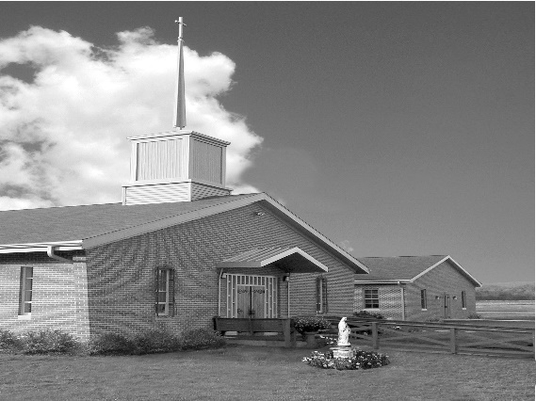
Phone: Phone: (570) 925-6969
E-mail: ctk@epix.net
Website: ctkbenton.weebly.com
Pastor: Rev. Richard J. Mowery
(570) 784-0801
Administrator: Fr. Andrew P. St. Hilaire
(570) 784-3123 (717) 884-9523
frasthilaire@hbgdiocese.org
CYE Coordinator: Betty Hnylanski
(570) 594-3687, bhnylan@gmail.com
Secretary: Lee Ann Boiwka
(570) 864-3090, boiwka@epix.net
Office Hours: Monday & Thursday, 8am -12pm

November 6, 2022 – 32nd Sunday in Ordinary Time

“Lift your hearts to the Lord.”

Today’s readings show difficult situations, whether physical in the first reading or moral in the Gospel. In each setting, the Scripture lifts our sights to what is most important. We are the children of God, and our strength is in the Lord. This is what truly matters in the world, no matter what we might face.

Liturgy of the Word

In the first reading, seven brothers and their mother are arrested and tortured. Under this intense duress, they keep their faith and proclaim that they will rise above such suffering. Paul urges the Thessalonians to find endurance in the Lord and strengthen their hearts. In the Gospel, some Sadducees question Jesus about a moral quandary involving marriage. Jesus responds by telling them that God is the God of the living, not the dead.

In your prayers, please remember: Intentions of the Holy Father, all Priests including
Fr. Mowery, Fr. St. Hilaire and Fr. Sola, Michael Bardi, Maureen Beck, Lorena Bennet, Butch Bogart, Christina Capriola, Joe Casarella, Russell Castrogiovanni, Cobert Family, Michael Farrell, Michael Fontinell, Deb & Paul Haden,Vivian Whitenight Hynick, Bob Kalie, Carl Kalie, Margaret Kalie, Joseph LaBonte, Mary Ann Levan, James Mazonkey, Bernie Nichols, Nancy Oman, Joan Sansouci, Joanne Sarisky, Richard Scavone, Jackie Scherer, Diane & Doug Talanca, Sally Tucker, Max Whitenight, Nancy Wisbar, Sonny Womelsdorf, Mary Ann Zeveney and all the Parishioners of CTK.

Prayer Warrior – Interested in becoming a Prayer Warrior and being part of the Prayer Chain for Christ the King and our Community? Contact the parish office with your name and e-mail address at ctk@epix.net. Each time we get a request an e-mail goes out with the information.

Stewardship: October 30, 2022

Offerings $1537.50
All Saints $30.00
All Souls $120.00
World Mission $8.00
Rainy Day $5.00
St. Nick $40.00

Total $1740.50

Mass Intentions

Saturday, November 5 – People of the Parish
Sunday, November 6 – People of the Parish
Monday, November 7 – Lois McMichael by CTK Parishioners
Friday, November 11 – John Everett (Birthday Blessings) by Mary Everett
Saturday, November 12 – People of the Parish
Sunday, November 13 – Kim Besel (Birthday Blessings) by Justa Sabo

Mass intentions are available in memory of, or in honor of a loved one. The donation for having a Mass said for a personal request is $10.00. You can drop your request in the collection or contact the parish office.
Lector Schedule Extraordinary Minister Collection Stewards

November 6 - Pete Yastishock Judith Scavone Mark & Patricia Sullivan
November 13 – Barb Treier P.J. Haden Lee Ann Boiwka & Judith Scavone

Come to St. Gabriel’s on Veterans Day, Friday, November 11th at 11:00 a.m. to celebrate the memory of our world War I Veterans. Ceremonies by Benton VFW, a Sing-a-long led by Pat Treier and Presentation at 1:00 p.m. by Mark Fritz, Compiler, Editor and Designer of Letters Home.

Unborn Candle Donations $3.00/ week, $5.00/ 2 weeks or $10.00/ month.
Month of November – Steve & Sue Root

Benton Food Bank - For the month of November we will be collecting chicken and turkey stuffing. The Food Bank at the N4C’s is the 3rd Tuesday of every month. Anyone in need is encouraged to come between 9:00 a.m. -11:00 a.m. and also 4:30 p.m. – 6:30 p.m.

Apple Dumplings – The Benton Council of Churches is selling Apple Dumplings. They are $5.00 and the money is due by November 20th. They will be picked up the evening of November 22nd. You can make arrangements to get them that evening or pick them up after Mass the weekend of November 26th and 27th. The sign-up sheet is on the back counter. See Anne Eustice or Sue Root with any questions.

May He rest in the Peace of the Lord! Please pray for the soul of Edward Connell who died on October 12, 2022. The Parish Community of Christ the King extends its deepest sympathies to his wife, Mary, to his family, relatives, and friends in their loss

Feast of Christ the King – November 19th and 20th

- Saturday, November 19th – 9:00 a.m. Morning Prayer, 9:00 a.m. – 3:00 p.m. Adoration
Confession 3:00 p.m. – 3:45 p.m. Vigil Mass at 4:00 p.m.

- Sunday, November 20th – 8:00 a.m. – 8:45 a.m. Confession & Adoration
9:00 a.m. Mass with breakfast to follow

Please sign up for Adoration for Saturday, November 19th. We need two adorers at all times.

Training for Extraordinary Ministers of Holy Communion: If you are currently an Extraordinary Minister of Holy Communion, and you need to renew your Mandate, please contact the parish office to verify if you are due and/or to register. If you received a Mandate prior to 2019, the Mandate is only valid for three years. If you received a Mandate in 2019 or thereafter, the Mandate is valid for five years or until it is decided otherwise by the Pastor, Priest Chaplain or the Extraordinary Minister. There are training sessions for Extraordinary Ministers of Holy Communion coming up locally in November. The next round of training sessions will not occur until January and February, so please register if you need to renew your mandate before January 2023. Training will be on Saturday, November 12 at 10:00 AM at Saint Joseph Parish, Danville with Deacon Tom Conlin, or on Tuesday, November 22 at 6:30 PM at Saint Columba Church with Father Richard Mowery

Winterfest 2022 at St. Columba, Bloomsburg, Saturday, Nov 19 from 9:00 a.m. – 2:00 p.m.
A variety of delicious soups, haluskie, chili, barbeque, hoagies, pizza, pierogies, and mouthwatering homemade baked goods will be served. You can dine in or take out. Also featured will be many wonderful raffles, the famous Dollar Tree, Build-a-Bear activity and a variety of talented craft vendors. Something for everybody! Benefits St. Columba School.

