Christ the King Catholic Church
300 Mendenhall Lane, P.O. Box 297 Benton, PA
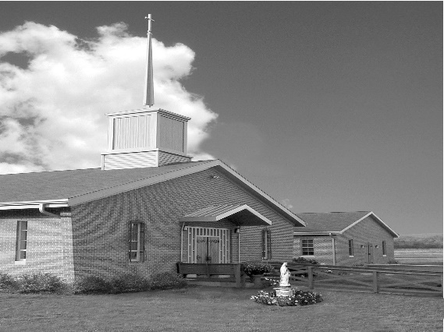
Phone: Phone: (570) 925-6969
E-mail: ctk@epix.net
Website: ctkbenton.weebly.com
Pastor: Rev. Richard J. Mowery
(570) 784-0801
Administrator: Rev. Olusola Adewole, O.P.
(570) 784-3123,
FrOAdewole@hbgdiocese.org
CYE Coordinator: Betty Hnylanski
(570) 594-3687, bhnylan@gmail.com
Secretary: Lee Ann Boiwka
(570) 864-3090, boiwka@epix.net
Office Hours: Monday & Thursday, 8am -12pm

November 28, 2021 – First Sunday of Advent

“In this graced Advent time, prepare for Jesus’ coming.”

Advent is a season of preparation. It is easy to lose Advent in the swirl of Christmas lights and decorations. In this time of anticipation as we consider Christ’s incarnation – his coming in the flesh – we also await his return in glory. Be ready: stand erect and raise your heads. Prepare your hearts to receive him. Don’t miss the grace of Advent.

Liturgy of the Word
In the first reading, Jeremiah prophesies the coming of a promised messiah for the house of Israel and Judah. Saint Paul exhorts the Thessalonians to conduct themselves in a way pleasing to God. In the Gospel, Jesus tells the disciples to stay vigilant and be prepared for the day when they will see the Son of Man coming in a cloud with power and great glory.

Sunday Confessions – November 28th – 8:00 a.m. – 8:45 a.m. before Mass
In your prayers, please remember: Intentions of the Holy Father, all Priests including Msgr. Lawrence, Fr. Mowery and Fr. Sola, Josephine Folayemi Adewole, Lorena Bennet, Christina Capriola, Christina Casiello, Russell Castrogiovanni, Cobert Family, Deb Haden, Ray Hunsinger, Vivian Whitenight Hynick, Joyce Kishbaugh. Mary Ann Levan, James Mazonkey, Nora & Terry McDaniels, Bernie Nichols, Joan Pauley, Helen Raski, Sabo Family, Joan Sansouci, Pat Scardigli, Jackie Scherer, Dot Shelmet, Douglas Talanca, Pat Treier’s daughter Christy, Max Whitenight, Sonny Womelsdorf, Stan Zalot, and all the Parishioners of CTK.

Stewardship: November 21, 2021

Offerings $1301.00
Matthew 25 $499.00
St. Nick $100.00
Votives $41.75

Total $1941.75

Mass Intentions

Saturday, November 27 – Marilyn LaBonte by LaBonte Family
Sunday, November 28 – Nicholas Sabo by Darlene & Robert Kellner
Monday, November 29 – People of the Parish
Thursday, December 2 – No Mass
Friday, December 3 – No Mass
Saturday, December 4 – John Lindner by Richard & Tamara Lindner
Sunday, December 5 – Nicholas Sabo by Sharon Tishler

Mass intentions are available in memory of, or in honor of a loved one. The donation for having a Mass said for a personal request is $10.00. You can drop your request in the collection or contact the parish office.

Lector Schedule Extraordinary Minister
November 28 – Barb Treier Shanna Haden
December 5 – Peter Yastishock Judith Scavone

CYE News: CYE students have been busy learning more about our great Catholic faith.
As Advent approaches, students in Grades 3-12 will have an opportunity to celebrate the sacrament of Reconciliation. All students will be reviewing the customs of the Jesse Tree, Advent wreath, and the Birth of Our Savior Jesus Christ.
It is so good to see many of our families participating at Mass each weekend. A few altar servers have returned to serving Mass and more are needed to help share the joy of this service. Students in Grades 5 and above are invited and encouraged to participate.
Blessings to all!

Benton Food Bank - For the month of December, Thank you for your generosity! The Food Bank at the N4C’s is the 3rd Tuesday of every month. Anyone in need is encouraged to come between 9:00 a.m. -11:00 a.m.

Monastery Pantry – If you wish to order for the holidays, there are order sheets on the back counter. You must have your order and money to Meg Geffken by Sunday, November 28th and delivery will be Saturday, December 18th. Checks can be made payable to Monastery of the Annunciation. You can also go on line to order – Monasterypantry.com.

Unborn Candle Donations $3.00/ week, $5.00/ 2 weeks or $10.00/ month.
Month of December –Justa & Nicholas Sabo

Jesse Tree – We will be doing our Jesse Star tree again this year. The stars will be available on the tree the weekend of November 27 & 28, first Sunday of Advent. The gifts that we buy are for the men who are Veterans that live at the Orangeville Manor and also children of the Benton Head Start Program. Please have your gifts wrapped with the Star attached, back to Christ the King by the weekend of December 11 & 12. Your generosity is greatly appreciated!

Poinsettias – You can order a Poinsettia for the Altar in Memory of, or in Honor of a loved one. The sheets are at the exit of the Church. Donation is $10.00 per plant. You can drop your order off in the collection or stop by the Office on Monday or Thursday mornings.

Mark your Calendars – We will be decorating our Church for Christmas immediately following Mass on Sunday, December19th. Please plan to stay and help!

ADVENT, CHRISTMAS AND NEW YEAR SCHEDULE FOR 2021/22

FIRST SUNDAY OF ADVENT, NOV. 27 & 28 Saturday: Confessions @ 4p.m., Mass @ 5p.m. Sunday: Confessions @ 8a.m - 8.45a.m., Mass @ 9a.m.

SECOND SUNDAY OF ADVENT, DEC. 4 & 5 Saturday: Confessions @ 4p.m., Mass @ 5p.m. Sunday: Mass @ 9a.m. CYE Confessions @ 10.15a.m.

WEDNESDAY, DEC. 8 Mass of the Solemnity of the Immaculate Conception @ 9a.m.

THIRD SUNDAY OF ADVENT, DEC. 11 & 12 Saturday: Confessions @ 4p.m., Mass @ 5p.m. Sunday: Mass @ 9a.m. Advent Talk @ 10.15a.m. (Social Hall)

FOURTH SUNDAY OF ADVENT, DEC. 18 & 19 Saturday: Confessions @ 4p.m., Mass @ 5p.m. Sunday: Mass @ 9a.m.

FRIDAY, DEC. 24 Christmas Vigil Mass @ 5p.m.

SATURDAY, DEC. 25 Christmas Day Mass @ 9a.m.

SUNDAY, DEC. 26 Mass of the Holy Family of Jesus, Mary & Joseph @ 9a.m.

SATURDAY, JAN. 1, 2022 Solemnity of Mary Mother of God (Not a Holy Day of Obligation this year) Confessions @ 4p.m. Vigil Mass of the Epiphany of the Lord @ 5p.m.

SUNDAY, JAN. 2, The Epiphany of the Lord, Mass @ 9a.m.

THE BAPTISM OF THE LORD, Jan. 8 & 9 Saturday: Confessions @ 4p.m., Mass @ 5p.m. Sunday: Mass @ 9a.m.

Northern Deanery Advent Penance Service Schedule (Sacrament of Reconciliation)
* Confessions will be heard by various priests at each location, beginning at 7 pm *

Monday, Dec 13 St. Joseph, Danville
Tuesday, Dec 14 St. Monica, Sunbury AND St. Mary, Berwick
Wednesday, Dec 15 St. Pius, Selinsgrove
Thursday, Dec 16 St. Joseph, Milton AND St. Columba, Bloomsburg
Friday, Dec 17 Sacred Heart, Lewisburg ‎

