Christ the King Catholic Church
300 Mendenhall Lane, P.O. Box 297 Benton, PA
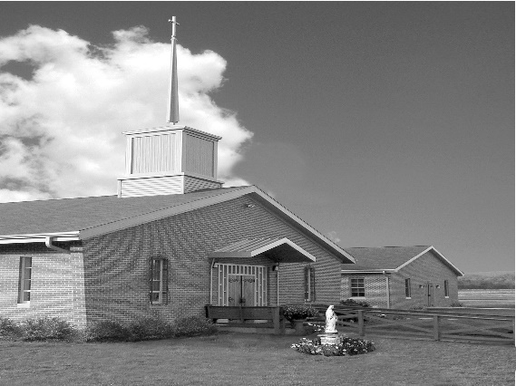
Phone: Phone: (570) 925-6969
E-mail: ctk@epix.net
Website: ctkbenton.weebly.com
Pastor: Rev. Richard J. Mowery
(570) 784-0801
Administrator: Rev. Olusola Adewole, O.P.
(570) 784-3123,
FrOAdewole@hbgdiocese.org
CYE Coordinator: Betty Hnylanski
(570) 594-3687, bhnylan@gmail.com
Secretary: Lee Ann Boiwka
(570) 864-3090, boiwka@epix.net
Office Hours: Monday & Thursday, 8am -12pm

November 21, 2021 – Our Lord Jesus Christ, King of the Universe

“Christ’s dominion is eternal.”

Today’s solemnity, by which we close the liturgical year, reminds us that Christ is king and ruler of all. He is the firstborn of the dead in whom all power and authority has been invested. By our baptism we share in that holy and royal identity so that we might witness to his glory and kingship before the world.

Liturgy of the Word
Daniel has a vision of one like a Son of Man coming, on the clouds of heaven, receiving dominion and kingship over all creation. In the second reading, John writes of Jesus Christ as the faithful witness who is coming amid the clouds. In the Gospel, Pilate asks Jesus if he is the King of the Jews, and Jesus responds, my kingdom does not belong to this world.

Sunday Confessions – November 21st and November 28th – 8:00 a.m. – 8:45 a.m. before Mass

In your prayers, please remember: Intentions of the Holy Father, all Priests including Msgr. Lawrence, Fr. Mowery and Fr. Sola, Josephine Folayemi Adewole, Lorena Bennet, Christina Capriola, Christina Casiello, Russell Castrogiovanni, Cobert Family, Deb Haden, Ray Hunsinger, Vivian Whitenight Hynick, Joyce Kishbaugh. Mary Ann Levan, James Mazonkey, Bernie Nichols, Lucas Pappa, Joan Pauley, Sabo Family, Joan Sansouci, Pat Scardigli, Jackie Scherer, Dot Shelmet, Douglas Talanca, Pat Treier’s daughter Christy, Max Whitenight, Sonny Womelsdorf, Stan Zalot, and all the Parishioners of CTK.

Stewardship: November 14, 2021

Offerings $1467.00
St. Nick $155.00

Total $1622.00

Mass Intentions
Saturday, November 20 – Nicholas Sabo by Sally Tucker and Family
Sunday, November 21 – Tommy Tishler by Sharon Tishler
Monday, November 22 – Nicholas Sabo by Richard & Tamara Lindner
Tuesday, November 23 – Dorothy & Mas Dzugan by Dzugan Family
Thursday, November 25 – Nicholas Sabo by Grant & Sharon Little and Family
Saturday, November 27 – Marilyn LaBonte by LaBonte Family
Sunday, November 28 – Nicholas Sabo by Darlene & Robert Kellner

Mass intentions are available in memory of, or in honor of a loved one. The donation for having a Mass said for a personal request is $10.00. You can drop your request in the collection or contact the parish office.

Lector Schedule Extraordinary Minister
November 21 – Anne Eustice Meg Geffken
November 28 – Barb Treier Shanna Haden

CYE News: Happy Feast of Christ the King!
CYE students have been busy learning more about our great Catholic faith.
As Advent approaches, students in Grades 3-12 will have an opportunity to celebrate the sacrament of Reconciliation. All students will be reviewing the customs of the Jesse Tree, Advent wreath, and the Birth of Our Savior Jesus Christ.
It is so good to see many of our families participating at Mass each weekend. A few altar servers have returned to serving Mass and more are needed to help share the joy of this service. Students in Grades 5 and above are invited and encouraged to participate.
Blessings to all this our feast day!!!

Benton Food Bank - For the month of November, we will be collecting tissues and floor cleaner. Thank you for your generosity! The Food Bank at the N4C’s is the 3rd Tuesday of every month. Anyone in need is encouraged to come between 9:00 a.m. -11:00 a.m.

Apple Dumplings for Sale –Delivery is November 23rd. Checks can be made out to Anne Eustice or Benton Council of Churches.

Monastery Pantry – If you wish to order for the holidays, there are order sheets on the back counter. You must have your order and money to Meg Geffken by Sunday, November 28th and delivery will be Saturday, December 18th. Checks can be made payable to Monastery of the Annunciation. You can also go on line to order – Monasterypantry.com.

The Bishop is coming to St. Columba: Please mark your calendars! The First Sunday of Advent, November 28, at 10:30 a.m., come and celebrate the beginning of the new Church Year with Bishop Ronald Gainer. After the Mass is over, we will have a reception with food from “That’s Amore” and homemade desserts by our parish bakers. Please share in the day’s festivities!!

Fishers of Men - Join us in supporting the seminarians of the Diocese of Harrisburg through our Fishers of Men event. Although we are not able to host our annual dinner again in 2021 due to the ongoing pandemic, the seminarians for the Diocese still need your support. In these challenging times, we must continue to provide a solid seminary formation for the abundant number of men responding to God’s call. Please pray for our men in formation and if you are able, please consider a gift to financially support our seminarians’ education. Gifts can be made securely online by visiting the Diocesan website, www.hbgdiocese.org. Thank you for your support.

Feast of Christ the King
Our Feast Day is Sunday, November 21, 2021. The celebrant will be Father Dominic Eshikena, O.P. The theme is: By His wounds, we are healed (1 Pet 2:24)
There will be confession Sunday, November 21, before Mass, 8:00 a.m. until 8:45 a.m.

There will be Mass at 9:00, Sunday, then a procession with the Monstrance by the priests and ministers around the Church to the social hall and back to the altar with Benediction. We will have coffee and donuts after Mass. No evening Service.
Monday, November 22, Mass at 9 a.m. then Adoration until 11:00 a.m. Confessions will be available with Father Dominic. No evening service.
Tuesday, November 23rd, Mass at 9:00 a.m. with Adoration until 7 p.m. Closing of 40 hours is at 7:00 p.m.

CALIX (Catholic group of recovery for those who struggle with alcoholism/addiction)
Do you or a family member or friend need to learn about resources to help with an addiction concern? Or you just need someone to talk with? You can reach out to a member of CALIX.

HELP IS ONE CALL AWAY - CALIX is an association of Catholic alcoholics, drug addicts, and family members and friends affected by addiction, who are maintaining their sobriety through participation in their Catholic faith and a 12 Step program.

On a confidential basis, you can call 651-779-6828. The CALIX contact will not be a member of the parish and you need not disclose your name. You can receive information on CALIX, Meeting times, resources, etc. Perhaps this one call will be a crucial recovery path action. And save a life.”

Jesse Tree – We will be doing our Jesse Star tree again this year. The stars will be available on the tree the weekend of November 27 & 28, first Sunday of Advent. The gifts that we buy are for the men who are Veterans that live at the Orangeville Manor and also children of the Benton Head Start Program. Please have your gifts wrapped with the Star attached, back to Christ the King by the weekend of December 11 & 12. Your generosity is greatly appreciated!
‎

