Christ the King Catholic Church
300 Mendenhall Lane, P.O. Box 297 Benton, PA
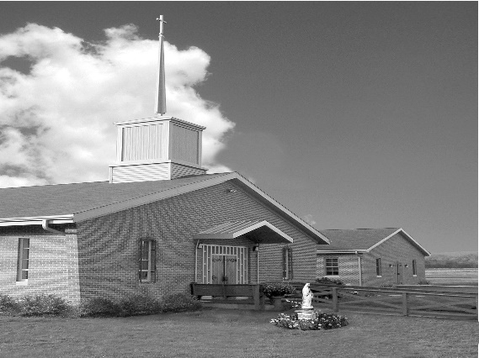
Phone: Phone: (570) 925-6969
E-mail: ctk@epix.net
Website: ctkbenton.weebly.com
Pastor: Rev. Richard J. Mowery
(570) 784-0801
Administrator: Fr. Andrew P. St. Hilaire
(570) 784-3123 (717) 884-9523
frasthilaire@hbgdiocese.org
CYE Coordinator: Betty Hnylanski
(570) 594-3687, bhnylan@gmail.com
Secretary: Lee Ann Boiwka
(570) 864-3090, boiwka@epix.net
Office Hours: Monday & Thursday, 8am -12pm

November 20, 2022 – Our Lord Jesus Christ, King of the Universe

“Our true King is worthy of praise and adoration.”

Kings are celebrated, whether or not they deserve honor. Some emperors claim divinity. What about the King of the Universe? A king who is the image of the invisible God. How does he use his mighty power? He ransoms sinners and reconciles them with the Father. He uses his title firstborn from the dead to share his triumph with all who follow him. How do we respond to this King?

Liturgy of the Word
In the first reading, the elders of Israel anoint David as king. Paul writes to the Colossians, giving thanks to the Father for the inheritance he has given. In the Gospel, the soldiers and onlookers jeer at Jesus on the cross, questioning the inscription that declares him King of the Jews.

**No Daily Mass on Friday, November 25th**

In your prayers, please remember: Intentions of the Holy Father, all Priests including
Fr. Mowery, Fr. St. Hilaire and Fr. Sola, Ken Barchik, Michael Bardi, Maureen Beck, Lorena Bennet, Christina Capriola, Joe Casarella, Russell Castrogiovanni, Cobert Family, Michael Farrell, Michael Fontinell, Deb Haden,Vivian Whitenight Hynick, Bob Kalie, Carl Kalie, Margaret Kalie, Joseph LaBonte, Mary Ann Levan, James Mazonkey, Bernie Nichols, Nancy Oman, Richard Scavone, Jackie Scherer, Diane & Doug Talanca, Sally Tucker, Max Whitenight, Nancy Wisbar, Sonny Womelsdorf, Mary Ann Zeveney and all the Parishioners of CTK.

Stewardship: November 13, 2022

Offerings $1351.50
All Saints $10.00
Military Services $45.00
St. Nick $65.00

Total $1471.50

Mass Intentions

Saturday, November 19 – Kathleen DiSalva by Ginny & Joe English
Sunday, November 20 – People of the Parish
Monday, November 21 – James Martin Gibbons by Ginny & Joe English
Friday, November 25 – No Mass
Saturday, November 26 – Marilyn LaBonte by Joseph LaBonte
Sunday, November 27 – Tommy Tishler by Sharon Tishler

Mass intentions are available in memory of, or in honor of a loved one. The donation for having a Mass said for a personal request is $10.00. You can drop your request in the collection or contact the parish office.

Lector Schedule Extraordinary Minister Collection Stewards

November 20 – Stephen Root Patricia Sullivan Charolotte & Joe Casarella
November 27 – Paul Haden Shanna Haden Sharon Tishler & Dottie Poles
CYE News - Please pray for Brianna Kishbaugh and Chloe Schumacher who are preparing to receive the sacrament of Confirmation in May, and Brianna Kelsey and Lucianna McHenry who are preparing to receive the sacraments of First Reconciliation and First Eucharist.

Many thanks to the CYE students and catechists who removed the covers from the Breaking Bread and put new covers on the new Breaking Bread books.

Upcoming events for CYE in December. We prepare during the Advent season to celebrate the coming of Jesus in history, mystery, and majesty. We prepare, we remember, and we celebrate this Advent season in many ways. Jesus is truly the reason for the season.

December 4 - Advent workshop prepared for all CYE children by the high school CYE youth and their catechist Shanna Haden. We prepare ourselves by the reception of the sacrament of Reconciliation. The sacrament of Reconciliation will be available during the CYE Advent workshop from 10-11:30.

December 11 - We share our story of Advent and the preparation for Christmas with our families and friends. Children’s Advent/Christmas program beginning with 9:00 Mass and following. Also a parish meal of celebration and fellowship. The children will be involved in the program about the Advent Wreath, the Jesse tree, the Novena of St Andrew, and the First Nativity.

December 18 - We prepare our church for Christmas. Decorating the church is a parish family affair, beginning immediately after 9:00 Mass. please plan to stay after Mass and help with this event. Regular CYE classes will not be held.

Many thanks to those who donated snacks and drinks for the children on Sunday mornings after the 9:00 Mass. The donations are greatly appreciated. Ms Betty

Unborn Candle Donations $3.00/ week, $5.00/ 2 weeks or $10.00/ month.
Month of November – Steve & Sue Root

Benton Food Bank - For the month of November we will be collecting chicken and turkey stuffing. The Food Bank at the N4C’s is the 3rd Tuesday of every month. Anyone in need is encouraged to come between 9:00 a.m. -11:00 a.m. and also 4:30 p.m. – 6:30 p.m
.
Matthew 25 Collection – November 19th & 20th
Together we can make a difference in our families and communities. Please donate
prayerfully & generously.

May She Rest in the Peace of the Lord! Please pray for the soul of Joanna Mary Sarisky who passed away on November 5, 2022. The parish community of Christ the King extends its deepest sympathies to her family, relatives, and friends on their loss.

Praying for Holy Souls – We remember and pray for the faithful departed, especially those awaiting a final purification in purgatory before entering heaven. The Catholic Church dedicates November to this spiritual work of mercy – praying for the dead. Incorporating these practices can help.

- Pray for the holy souls at Mass or Adoration

- Schedule Masses for the faithful departed

- Pray the Rosary, Divine Mercy Chaplet or Stations of the Cross

- Pray the Office of the Dead in the Liturgy of the Hours

- Offer something up

- Memorize the “Eternal Rest” prayer for souls – “Eternal rest grant unto them, O Lord.
And let the perpetual light shine upon them. And may the souls of the faithful departed, through the mercy of God, rest in peace. Amen
.
- Visit a cemetery.

- Spread devotion to the holy souls.

Jesse Tree – Starting the weekend of November 26th and 27th you will have the opportunity to take a star off the tree. Gifts will be due back the weekend of December 10th & 11th.

