Christ the King Catholic Church
300 Mendenhall Lane, P.O. Box 297 Benton, PA
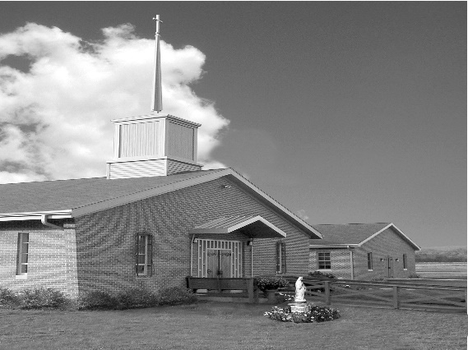
Phone: Phone: (570) 925-6969
E-mail: ctk@epix.net
Website: ctkbenton.weebly.com
Pastor: Rev. Richard J. Mowery
(570) 784-0801
Administrator: Rev. Olusola Adewole, O.P.
(570) 784-3123,
FrOAdewole@hbgdiocese.org
CYE Coordinator: Betty Hnylanski
(570) 594-3687, bhnylan@gmail.com
Secretary: Lee Ann Boiwka
(570) 864-3090, boiwka@epix.net
Office Hours: Monday & Thursday, 8am -12pm

November 14, 2021 – 33rd Sunday in Ordinary Time

” We are destined to live with God forever, to have the fullness of joys in [his] presence.”

The Lord is our inheritance, says today’s psalm. He will show us the path to life and the fullness of joys in [his] presence. But we know not when that time will come – for each one of us individually, and for the world. So vigilance is the order of the day: preparing ourselves and the world for the great prince of whom Daniel speaks – the coming of the Son of Man who has taken away our sins.

Liturgy of the Word
The prophet Daniel speaks of a time when a great prince shall arise, a guardian of the people, and many of those who sleep in the dust of the earth shall awake. The Letter to the Hebrews speaks of the one [who] offered one sacrifice for sins, and took his seat forever at the right hand of God. In the Gospel, Jesus speaks to his disciples about the Son of Man’s coming after a time of tribulation.

Sunday Confessions – November 21st and November 28th – 8:00 a.m. – 8:45 a.m. before Mass

In your prayers, please remember: Intentions of the Holy Father, all Priests including Msgr. Lawrence, Fr. Mowery and Fr. Sola, Josephine Folayemi Adewole, Lorena Bennet, Christina Capriola, Christina Casiello, Russell Castrogiovanni, Cobert Family, Deb Haden, Ray Hunsinger, Vivian Whitenight Hynick, Joyce Kishbaugh. Mary Ann Levan, James Mazonkey, Bernie Nichols, Lucas Pappa, Joan Pauley, Curt Rie, Sabo Family, Joan Sansouci, Pat Scardigli, Jackie Scherer, Dot Shelmet, Douglas Talanca, Pat Treier’s daughter Christy, Max Whitenight, Sonny Womelsdorf, Stan Zalot, and all the Parishioners of CTK.

Stewardship: November 7, 2021

Offerings $2135.00
All Saints $145.00
All Souls $ 10.00
St. Nick $135.00
Votives $50.00

Total $2475.00

Mass Intentions
Saturday, November 13 – Anne Lindner by Richard & Tamara Lindner
Sunday, November 14 - Kim Besel (Birthday Blessings) by Justa & Nick Sabo
Monday, November 15 – Nicholas Sabo by Judy & Sonny Womelsdorf
Thursday, November 18 – People of the Parish
Saturday, November 20 – Nicholas Sabo by Sally Tucker and Family
Sunday, November 21 – Tommy Tishler by Sharon Tishler

Mass intentions are available in memory of, or in honor of a loved one. The donation for having a Mass said for a personal request is $10.00. You can drop your request in the collection or contact the parish office.

Lector Schedule Extraordinary Minister
November 14 – Paul Haden PJ Haden
November 21 – Anne Eustice Meg Geffken

CYE News: Grades 8-12 Decision Point class will be held on Sunday November 14 from 11:30 – 2:15. Pizza lunch will be provided. Hope to see you all there!

Benton Food Bank - For the month of November, we will be collecting tissues and floor cleaner. Thank you for your generosity! The Food Bank at the N4C’s is the 3rd Tuesday of every month. Anyone in need is encouraged to come between 9:00 a.m. -11:00 a.m.

Saint Columba Church and School in Bloomsburg will be holding its annual Winterfest on November 20th from 9am – 2pm at the school, 40 E. 3rd St, Bloomsburg. A variety of delicious soups, haluskies, Father’s homemade lasagna, chili, barbeque, hoagies, pizza, pierogies, and mouthwatering homemade baked goods will be served. You can dine in or take out. Also featured will be many wonderful raffles, the famous Dollar Tree, all new Build a Bear and a variety of talented craft vendors. Something for everybody! Benefits St. Columba School.

Unborn Candle Donations $3.00/ week, $5.00/ 2 weeks or $10.00/ month.
Month of November – Nora & Terry McDaniel

Apple Dumplings for Sale – Money is due to by November 15th and Delivery is November 23rd. Checks can be made out to Anne Eustice or Benton Council of Churches.

Monastery Pantry – If you wish to order for the holidays, there are order sheets on the back counter. You must have your order and money to Meg Geffken by Sunday, November 28th and delivery will be Saturday, December 18th. Checks can be made payable to Monastery of the Annunciation. You can also go on line to order – Monasterypantry.com.

The Bishop is coming to St. Columba: Please mark your calendars! The First Sunday of Advent, November 28, at 10:30 a.m., come and celebrate the beginning of the new Church Year with Bishop Ronald Gainer. After the Mass is over, we will have a reception with food from “That’s Amore” and homemade desserts by our parish bakers. Please share in the day’s festivities!!

Thank you to all who attended the funeral of Joseph Tapsak, sent cards, called, or had Masses said. Your thoughtfulness is appreciated at this difficult time – Florence Tapsak

2021 Diocesan Annual Campaign as of October 31st
Parish Goal for 2021: $9,322.00
Total Paid: $12,650.00
Over goal: $3,328.00
Number of Donors: 40
Registered Households: 118
Percentage of Participation: 33.90%

Pierogi Fundraiser 2021

Sales $5231.00
Expenses -$1567.02
Profit $3663.98

On behalf of the entire parishioners of Christ the King Church, Benton, I express my profound gratitude to Thomas and Monique Heffner for coordinating the making and selling of pierogies for the parish once again this year. Thank you very much; your commitment and dedication are highly appreciated. May God continue to keep you in his love, grant you health of body and mind, and bless you abundantly. Fr. Olusola Adewole, O.P.

‎

Fishers of Men - Join us in supporting the seminarians of the Diocese of Harrisburg through our Fishers of Men event. Although we are not able to host our annual dinner again in 2021 due to the ongoing pandemic, the seminarians for the Diocese still need your support. In these challenging times, we must continue to provide a solid seminary formation for the abundant number of men responding to God’s call. Please pray for our men in formation and if you are able, please consider a gift to financially support our seminarians’ education. Gifts can be made securely online by visiting the Diocesan website, www.hbgdiocese.org. Thank you for your support.

