Christ the King Catholic Church
300 Mendenhall Lane, P.O. Box 297 Benton, PA
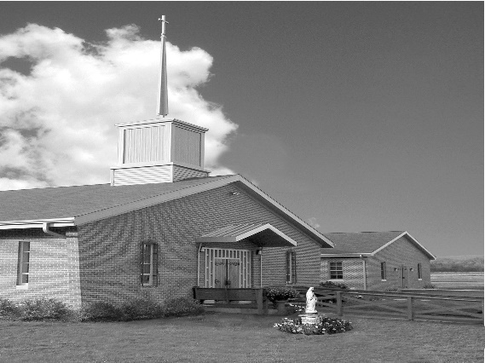
Phone: Phone: (570) 925-6969
E-mail: ctk@epix.net
Website: ctkbenton.weebly.com
Pastor: Rev. Richard J. Mowery
(570) 784-0801
Administrator: Fr. Andrew P. St. Hilaire
(570) 784-3123 (717) 884-9523
frasthilaire@hbgdiocese.org
CYE Coordinator: Betty Hnylanski
(570) 594-3687, bhnylan@gmail.com
Secretary: Lee Ann Boiwka
(570) 864-3090, boiwka@epix.net
Office Hours: Monday & Thursday, 8am -12pm

November 13, 2022 – 33rd Sunday in Ordinary Time

“Let us be vigilant and prayerfully prepare for the return of Christ in glory.”

Life is sometimes described as a journey with an ultimate destination. As we near the end of another liturgical year we are invited to reflect on the last things – death, judgment, heaven, and hell. But we do so not in fear but in hope, for while this earthly life might end, the promise of life eternal shines brightly in Christ.

Liturgy of the Word
Malachi prophesies how God’s power is like a consuming fire that will destroy all evil and wickedness. Paul writes to the Thessalonians, calling them to daily virtue. In the Gospel, Jesus challenges his followers to remain steadfast and faithful.

In your prayers, please remember: Intentions of the Holy Father, all Priests including
Fr. Mowery, Fr. St. Hilaire and Fr. Sola, Michael Bardi, Maureen Beck, Lorena Bennet, Christina Capriola, Joe Casarella, Russell Castrogiovanni, Cobert Family, Michael Farrell, Michael Fontinell, Deb & Paul Haden,Vivian Whitenight Hynick, Bob Kalie, Carl Kalie, Margaret Kalie, Joseph LaBonte, Mary Ann Levan, James Mazonkey, Bernie Nichols, Nancy Oman, Joan Sansouci, Richard Scavone, Jackie Scherer, Diane & Doug Talanca, Sally Tucker, Max Whitenight, Nancy Wisbar, Sonny Womelsdorf, Mary Ann Zeveney and all the Parishioners of CTK.

Stewardship: November 6, 2022

Offerings $2204.35
All Saints $233.00
All Souls $135.00
Matthew 25 $25.00
Military Services $275.00
World Mission $125.00
Rainy Day $100.00
St. Nick $80.00
Votives $92.00

Total $3269.35

Mass Intentions

Saturday, November 12 – People of the Parish
Sunday, November 13 – Kim Besel (Birthday Blessings) by Justa Sabo
Monday, November 14 - James Martin Gibbons by Ginny & Joe English
Friday, November 18 – Anne Eustice by Renee Hansen
Saturday, November 19 – Kathleen DiSalva by Ginny & Joe English
Sunday, November 20 – People of the Parish

Mass intentions are available in memory of, or in honor of a loved one. The donation for having a Mass said for a personal request is $10.00. You can drop your request in the collection or contact the parish office.
Lector Schedule Extraordinary Minister Collection Stewards

November 13 – Barb Treier P.J. Haden Lee Ann Boiwka & Judith Scavone
November 20 – Stephen Root Patricia Sullivan Charolotte & Joe Casarella

Unborn Candle Donations $3.00/ week, $5.00/ 2 weeks or $10.00/ month.
Month of November – Steve & Sue Root

Benton Food Bank - For the month of November we will be collecting chicken and turkey stuffing. The Food Bank at the N4C’s is the 3rd Tuesday of every month. Anyone in need is encouraged to come between 9:00 a.m. -11:00 a.m. and also 4:30 p.m. – 6:30 p.m.

Parish Council & Finance Committee – There will be a combined meeting in the Social Hall on Monday, November 14th, beginning at 6:00 p.m.

Feast of Christ the King – November 19th and 20th

- Saturday, November 19th – 9:00 a.m. Morning Prayer, 9:00 a.m. – 3:00 p.m. Adoration
Confession 3:00 p.m. – 3:45 p.m. Vigil Mass at 4:00 p.m.

- Sunday, November 20th – 8:00 a.m. – 8:45 a.m. Confession & Adoration
9:00 a.m. Mass with breakfast to follow

Please sign up for Adoration for Saturday, November 19th. We need two adorers at all times.

Winterfest 2022 at St. Columba, Bloomsburg, Saturday, Nov 19 from 9:00 a.m. – 2:00 p.m.
A variety of delicious soups, haluskie, chili, barbeque, hoagies, pizza, pierogies, and mouthwatering homemade baked goods will be served. You can dine in or take out. Also featured will be many wonderful raffles, the famous Dollar Tree, Build-a-Bear activity and a variety of talented craft vendors. Something for everybody! Benefits St. Columba School.

Matthew 25 Collection – November 19th & 20th
Together we can make a difference in our families and communities. Please donate
prayerfully & generously.

Stamps for the Wounded – We received a thank you stating the following – We gratefully acknowledge your kind support of our program. Your contributions of US & Foreign stamps will help cheer a hospitalized or out-patient Veteran. Thank you for your support and generosity.

Praying for Holy Souls – We remember and pray for the faithful departed, especially those awaiting a final purification in purgatory before entering heaven. The Catholic Church dedicates November to this spiritual work of mercy – praying for the dead. Incorporating these practices can help.

- Pray for the holy souls at Mass or Adoration

- Schedule Masses for the faithful departed

- Pray the Rosary, Devine Mercy Chaplet or Stations of the Cross

- Pray the Office of the Dead in the Liturgy of the Hours

- Offer something up

- Memorize the “Eternal Rest” prayer for souls – “Eternal rest grant unto them, O Lord.
And let the perpetual light shine upon them. And may the souls of the faithful departed, through the mercy of God, rest in peace. Amen
.
- Visit a cemetery.

- Spread devotion to the holy souls.

