Christ the King Catholic Church
300 Mendenhall Lane, P.O. Box 297 Benton, PA
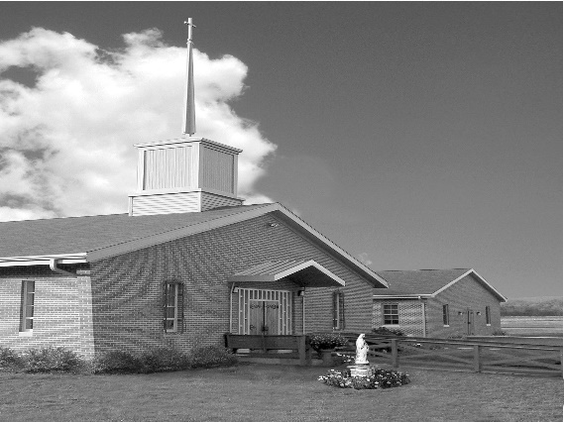
Phone: Phone: (570) 925-6969
E-mail: ctk@epix.net
Website: ctkbenton.weebly.com
Pastor: Rev. Richard J. Mowery
(570) 784-0801
Administrator: Rev. Olusola Adewole, O.P.
(570) 784-3123,
FrOAdewole@hbgdiocese.org
CYE Coordinator: Betty Hnylanski
(570) 594-3687, bhnylan@gmail.com
Secretary: Lee Ann Boiwka
(570) 864-3090, boiwka@epix.net
Office Hours: Monday & Thursday, 8am -12pm

May 8, 2022 – Fourth Sunday of Easter

“Our God knows and loves each of us.”

What a blessing it is to have a God who knows each one of us. Each of us is created and gifted with our own unique purpose. As Jesus says in today’s Gospel: My sheep hear my voice; I know them, and they follow me. Let us celebrate Jesus’ presence in our lives and follow after him.

Liturgy of the Word
In the first reading, the preaching of Paul and Barnabas is rejected by the Jews and welcomed by the Gentiles. In the second reading, John sees a diverse remnant of people who survived the great tribulation. They give worship to the Lamb of God, who shepherds them. In the Gospel, Jesus says that his sheep know his voice and follow him. He leads them to eternal life, for he and the Father are one.

Wishing all our Mothers a Blessed and Happy Mother’s Day!

In your prayers, please remember: Intentions of the Holy Father, all Priests including Msgr. Lawrence, Fr. Mowery and Fr. Sola, Josephine Folayemi Adewole, Maureen Beck, Lorena Bennet, Butch Bogart, Christina Capriola, Russell Castrogiovanni, Cobert Family, Michael Fontinell, Deb Haden, Ray Hunsinger, Vivian Whitenight Hynick, Carl Kalie, Margaret Kalie, Dick Kocher, Joseph LaBonte, Mary Ann Levan, James Mazonkey, Nora & Terry McDaniels, Bernie Nichols, Joan Pauley, Helen Raski, Sabo Family, Joan Sansouci, Pat Scardigli, Jackie Scherer, Pat Treier’s daughter Christy, Sally Tucker, Max Whitenight, Nancy Wisbar, Sonny Womelsdorf, and all the Parishioners of CTK.

Stewardship: May 1, 2022

Offerings $2032.00
Catholic Home Missions $5.00
Project Fund $925.00
Ukraine $10.00
St. Nick $255.00

Total $3227.00

Mass Intentions
Saturday, May 7 – Marilyn LaBonte by Joseph LaBonte
Sunday, May 8 – Marie Grendzinski & Brian O’Handley Jr. by Maryann Grendzinski &
John Vinciguerra
Sonja Patterson by Meg Geffken
Monday, May 9 – Anne Eustice (Mother’s Day Blessings) by Renee Hansen
Thursday, May 12 – Alicia Smiley by Justa Sabo
Saturday, May 14 – Beverly Charles by Richard & Tamara Lindner
Sunday, May 15 – Joseph Tapsak by Sandy Dennis
Kevin Sabo (Birthday Blessings) by Justa Sabo

Mass intentions are available in memory of, or in honor of a loved one. The donation for having a Mass said for a personal request is $10.00. You can drop your request in the collection or contact the parish office.

Lector Schedule Extraordinary Minister
May 8 – Barb Treier Paul J. Haden
May 15 – Meg Geffken Patricia Sullivan
Knights of Columbus News:

May 8, Sunday – Mother’s Day breakfast following the 9:00 a.m. Mass.

May 27 & 28, Friday & Saturday - Rummage Sale - Parishioners are asked for donations of items that are in good enough shape to sell. The items can be dropped off at the social hall beginning Monday morning May 23rd from 7 a.m. to 6 p.m., Tuesday, Mary 24th from 9 a.m. to 6 p.m. or Wednesday, May 25th from 9 a.m. to 6 p.m. If someone needs help with a large item they can call Ken Houck at 570-951-2608 or email him at kjhouck@reagan.com.
We are also looking for assistance during the week leading up to the rummage sale. Separating items into group that make sense and otherwise taking things out of boxes and placing them on tables or using floor space where appropriate.

CYE News: Congratulations to Corbin McHenry who received Jesus for the very first time in Holy Communion. We welcome him to the table of the Lord and we celebrate with his family and our parish family.

Attention all fall 2022 high school students. Mrs. Shanna Haden will be teaching high school CYE in the fall. She will be meeting briefly with all Christ the King 8th-11th graders on Sunday May 15th in the CYE building immediately after Mass. Hope to see you all then.

Listening Session for Snyodal Process – May 15th following the 9:00 a.m. Mass.
Pope Francis called for a synodal process that will go on from 2021 to 2023. He wants to hear from us about what is happening in our local parishes. The way of synodality is how the Church operates for it is about journeying together as people called to fulfill the mission of Christ on earth in our own time. The Synod Handbook points out that the synod is intended to inspire people to dream about the Church we are called to be, to make people’s hopes flourish, to stimulate trust, bind up wounds, weave new and deeper relationships, to learn from one another, to build bridges, to enlighten minds, and restore strength to our hands for our common mission.
Responding to the call of Pope Francis we will be having a listening session after Sunday Mass on May 15, 2022, in the social hall. Refreshments will be served. I encourage you all to come and share your thoughts about our common faith.

Unborn Candle Donations $3.00/ week, $5.00/ 2 weeks or $10.00/ month.
Month of May – Richard & Tamara Lindner

Benton Food Bank - For the month of May we will be collecting paper towels. Thank you for your generosity! The Food Bank at the N4C’s is the 3rd Tuesday of every month. Anyone in need is encouraged to come between 9:00 a.m. -11:00 a.m.

Holy Family Radio App: Starting out solely at 720 AM on the radio dial, Holy Family has expanded. Listeners can now tune in live at www.720whyf.com, access the station on the myTuner Radio app, or listen to its programs as podcasts on PodBean. Most recently, the station unveiled its first-ever app, WHYF Holy Family Radio. The free app is available on Google Play and in the App Store, and is an easy way to listen live.

Heart of Mercy Counseling (Sisters of the Good Shepherd), in the Danville area has two licensed therapists available to serve adults for individual, or couples counseling. In-person or virtual counseling options. Please contact either one of them to schedule an appointment if you are seeking counseling based in Catholic teaching: Sr. Mary Frances Altavilla, Licensed Clinical Social Worker 410-245-0870 faltavilla@hotmail.com OR: Sr. Patricia Marie Barnette, Licensed Professional Counselor 352-328-8145 guadalupe531@aol.com (at Our Lady of Hope, Coal Town, on Mondays)

A Prayer for Ukraine – God of love, our world is wrought with war and violence, as brother turns on brother, and the innocent awake to gunfire and bombs. May your compassion and healing move hearts and bring a new day to Ukraine. Fortify your children to resist aggression and instead become instruments of peace. We ask this in the name of the One who is the Prince of Peace, Jesus Christ. Amen.

