Christ the King Catholic Church
300 Mendenhall Lane, P.O. Box 297 Benton, PA
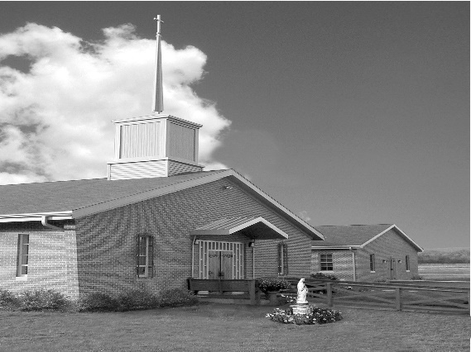
Phone: Phone: (570) 925-6969
E-mail: ctk@epix.net
Website: ctkbenton.weebly.com
Pastor: Rev. Richard J. Mowery
(570) 784-0801
Administrator: Rev. Olusola Adewole, O.P.
(570) 784-3123,
FrOAdewole@hbgdiocese.org
CYE Coordinator: Betty Hnylanski
(570) 594-3687, bhnylan@gmail.com
Secretary: Lee Ann Boiwka
(570) 864-3090, boiwka@epix.net
Office Hours: Monday & Thursday, 8am -12pm

May 22, 2022 – Sixth Sunday of Easter

“As our Easter journey continues, may the promise of the Holy Spirit
give us hope and strength.”

Our Gospel brings us back to the Last Supper. Knowing his disciples will need encouragement for the events that lie ahead, Jesus grants them the gift of peace and the promise of the Spirit. We also need those gifts as we strive to live the Gospel life and be faithful to Christ.

Liturgy of the Word
The early Church – under the guidance of the Holy Spirit – debates whether the Gentiles should be forced to abide by Jewish ways and customs. John describes a stunning vision of the holy city Jerusalem with its walls, gates, inscriptions, and the glory of God giving it light. In the Gospel, Jesus grants his disciples the gift of peace and the promise of the Spirit, who will teach and remind them of all he taught them.

The Ascension of the Lord - May 26, Thursday, – Mass at 9:00 a.m. and 7:00 p.m.

In your prayers, please remember: Intentions of the Holy Father, all Priests including Msgr. Lawrence, Fr. Mowery and Fr. Sola, Josephine Folayemi Adewole, Maureen Beck, Lorena Bennet, Butch Bogart, Christina Capriola, Russell Castrogiovanni, Cobert Family, Edward Connell, Alan & Jen Culp, Michael Farrell, Michael Fontinell, Deb & Paul Haden, Ray Hunsinger, Vivian Whitenight Hynick, Carl Kalie, Margaret Kalie, Dick Kocher, Joseph LaBonte, Mary Ann Levan, James Mazonkey, Bernie Nichols, Nancy Oman, Helen Raski, Sabo Family, Joan Sansouci, Pat Scardigli, Jackie Scherer, Pat Treier’s daughter Christy, Sally Tucker, Max Whitenight, Nancy Wisbar, Sonny Womelsdorf, and all the Parishioners of CTK.

Stewardship: May 15, 2022

Offerings $1339.00
Project Fund $95.00
St. Nick $40.00
Votives $39.00

Total $1513.00

Mass Intentions
Saturday, May 21 – People of the Parish
Sunday, May 22 – Dolores Bauman & Lynne Greenly by Joe & Lee Ann Boiwka
Deborah Shaffer (Birthday Blessings) by David Strazdus
Monday, May 23 – Anne Eustice (Birthday Blessings) by Steve & Sue Root
Thursday, May 26 – 9:00 a.m. Mass – Nancy Wisbar by Justa Sabo
7:00 p.m. Mass – People of the Parish
Saturday, May 28 – Ray Lindner by Richard & Tamara Lindner
John Trudnak by Mary Ann Zeveney
Sunday, May 29 – Joseph Tapsak by Jean & Ken Ehling

Mass intentions are available in memory of, or in honor of a loved one. The donation for having a Mass said for a personal request is $10.00. You can drop your request in the collection or contact the parish office.

Lector Schedule Extraordinary Minister
May 22 – Steve Root Meg Geffken
May 29 – Paul Haden Shanna Haden

Knights of Columbus News: May 27 & 28, Friday & Saturday - Rummage Sale - Parishioners are asked for donations of items that are in good enough shape to sell. The items can be dropped off at the social hall beginning Monday morning May 23rd from 7 a.m. to 6 p.m., Tuesday, Mary 24th from 9 a.m. to 6 p.m. or Wednesday, May 25th from 9 a.m. to 6 p.m. If someone needs help with a large item they can call Ken Houck at 570-951-2608 or email him at kjhouck@reagan.com.
We are also looking for assistance during the week leading up to the rummage sale. Separating items into group that make sense and otherwise taking things out of boxes and placing them on tables or using floor space where appropriate.

CYE News: Sunday, May 22nd is the final CYE class! Please join us as we celebrate our successful year! Food- Games- Fun- Fellowship outside after celebrating our journey of faith together at 9:00 am Mass.

Special thanks to our dedicated catechists who have guided us along the way, and to our parents who have shown us the importance and value of living as Catholic Christians.
We welcome returning catechist Maryann Grendzinski who will teach our preschool and kindergarten class next fall and returning catechist Shanna Haden who will teach our high school youth group grades 9-12 next fall.

Heartfelt gratitude to Ginny Weibel, Debra Haden, Sue Root and Betty Hnylanski who have been teaching our CYE children this year. Substitute catechists and teacher aids are always needed. Please contact Ms. Betty at 570-594-3687 or Lee Ann Boiwka at the parish office, if you are interested in helping in our CYE program. Now is the perfect time to begin the clearance process. You will find your own faith enriched as you journey in faith with our children.

A special Thank You to all who came out on May 14th for our CTK work day! Throughout the summer if you see a need for weeding or maintenance around the outside of the church, please feel free to help out. Christ the King is Our Church!

Unborn Candle Donations $3.00/ week, $5.00/ 2 weeks or $10.00/ month.
Month of May – Richard & Tamara Lindner
Benton Food Bank - For the month of May we will be collecting paper towels. Thank you for your generosity! The Food Bank at the N4C’s is the 3rd Tuesday of every month. Anyone in need is encouraged to come between 9:00 a.m. -11:00 a.m.

Diocesan Annual Campaign – If you have not sent in your donation for the Annual Campaign, please consider doing so. There are envelopes at the entrance of the Church.

Parish Goal for 2022: $9,442.53
Total Paid: $11,432.00
Over/(under)goal in cash: $1,989.47
Number of Donors: 32
Registered Households: 119
Percentage of Participation: 26.89%

Any monies collected over our goal, comes back to Christ the King.

Were you Married in 1972? In honor of your 50th Wedding Anniversary, there will be a special Mass and reception on Sunday, July 10, 2022 at 2:00 p.m. at Good Shepherd Parish in Camp Hill. Bishop Ronald W. Gainer will be the celebrant. To receive an invitation, please contact the parish office.

Christ the King Ambassadors - we are recruiting and reorganizing members for a service group of Christ the King. Our focus would be to reach out to our homebound and sick; contact our younger families who aren’t attending; visit or call members who have lost a loved one; taking communion to parishioners if you are an Extraordinary Minister; welcoming new members; being part of the Christ the King Prayer Chain.

The ambassadors will provide opportunities for our parish to grow as a Community of Christians eager to know, love and serve the Lord.

If you are interested and willing to be on this committee, please contact Meg Geffken at 570-925-6264, Lee Ann at 570-864-3090 or the Parish Office at 570-925-6969. There will be a meeting Saturday, June 4th and Sunday, June 5th, immediately following Mass.

