Christ the King Catholic Church
300 Mendenhall Lane, P.O. Box 297 Benton, PA
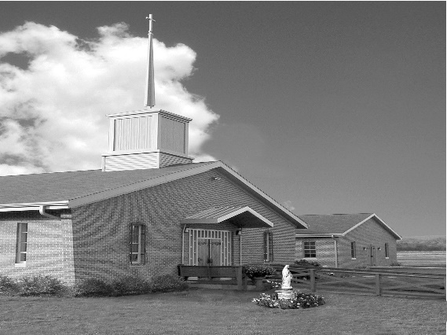
Phone: Phone: (570) 925-6969
E-mail: ctk@epix.net
Website: ctkbenton.weebly.com
Pastor: Rev. Richard J. Mowery
(570) 784-0801
Administrator: Rev. Olusola Adewole, O.P.
(570) 784-3123,
FrOAdewole@hbgdiocese.org
CYE Coordinator: Betty Hnylanski
(570) 594-3687, bhnylan@gmail.com
Secretary: Lee Ann Boiwka
(570) 864-3090, boiwka@epix.net
Office Hours: Monday & Thursday, 8am -12pm

May 1, 2022 – Third Sunday of Easter

“We continue to celebrate and give thanks for the gift of the Resurrection.”

As we continue to celebrate this glorious season of Easter, our readings today show us how the Resurrection was preached and made manifest to the early Church. They also indicate how Jesus’ first followers were strengthened in their faith, becoming enthusiastic and faithful witnesses to the risen Lord.

Liturgy of the Word
The Apostles continue to speak out in the name of Jesus despite formal warnings from the Jewish authorities. John writes of the vision he had which included angels surrounding a throne and all creatures gave praise to the one who sat on the throne. In the Gospel, Jesus reveals himself once again to the disciples, while they are fishing. Jesus asks Peter three times if he loves him and tells Peter to take care of his sheep.

In your prayers, please remember: Intentions of the Holy Father, all Priests including Msgr. Lawrence, Fr. Mowery and Fr. Sola, Josephine Folayemi Adewole, Maureen Beck, Lorena Bennet, Butch Bogart, Christina Capriola, Russell Castrogiovanni, Cobert Family, Michael Fontinell, Deb Haden, Shanna Haden, Ray Hunsinger, Vivian Whitenight Hynick, Carl Kalie, Margaret Kalie, Dick Kocher, Joseph LaBonte, Mary Ann Levan, James Mazonkey, Nora & Terry McDaniels, Bernie Nichols, Joan Pauley, Helen Raski, Sabo Family, Joan Sansouci, Pat Scardigli, Jackie Scherer, Pat Treier’s daughter Christy, Sally Tucker, Max Whitenight, Nancy Wisbar, Sonny Womelsdorf, and all the Parishioners of CTK.

Stewardship: April 24, 2022

Offerings $978.00
Catholic Home Missions $275.00
Catholic Relief Services $50.00
Easter $205.00
Project Fund $25.00
Votives $50.00

Total $1583.00

Mass Intentions
Saturday, April 30 – John Charles by Richard & Tamara Lindner
Sunday, May 1 – Nicholas Sabo by Justa Sabo
Bianca Beck by Amanda McHenry
Monday, May 2 – Catherine & Kenneth Masters by Anne & Donald Berends
Thursday, May 5 – Daniel Bauman by Joe & Lee Ann Boiwka
Friday, May 6 – Jack Eustice by Anne Eustice
Saturday, May 7 – Marilyn LaBonte by Joseph LaBonte
Sunday, May 8 – Marie Grendzinski & Brian O’Handley Jr. by Maryann Grendzinski &
John Vincrguerra
Sonja Patterson by Meg Geffken

Mass intentions are available in memory of, or in honor of a loved one. The donation for having a Mass said for a personal request is $10.00. You can drop your request in the collection or contact the parish office.

Lector Schedule Extraordinary Minister
May 1 – Peter Yastishock Judith Scavone
May 8 – Barb Treier Paul J. Haden

Knights of Columbus News:

May 7, Saturday - Work Day led by the Knights of Columbus starting at 9:00 a.m. to clean up the grounds for Spring and do some painting. Hope to have some volunteers join us.

May 8, Sunday – Mother’s Day breakfast following the 9:00 a.m. Mass.

May 27 & 28, Friday & Saturday - Rummage Sale - Parishioners are asked for donations of items that are in good enough shape to sell. The items can be dropped off at the social hall beginning Monday morning May 23rd from 7 a.m. to 6 p.m., Tuesday, Mary 24th from 9 a.m. to 6 p.m. or Wednesday, May 25th from 9 a.m. to 6 p.m. If someone needs help with a large item they can call Ken Houck at 570-951-2608 or email him at kjhouck@reagan.com.
We are also looking for assistance during the week leading up to the rummage sale. Separating items into group that make sense and otherwise taking things out of boxes and placing them on tables or using floor space where appropriate.

CYE News: Sunday May 1st – First Holy Communion and May Crowning. Please keep Corbin McHenry and his family in your prayers.

We present our Confirmation candidates:
Gavin Michael SEBASTIAN Birkett
Collin Alan PATRICK Cashman
Taylor Jude JOSEPH Chikotas
who will be confirmed at St Columba Church by Father Richard Mowery on Saturday May 14.

Many blessings to these children, their families, and our parish family.

Attention all fall 2022 high school students. Mrs. Shanna Haden will be teaching high school CYE in the fall. She will be meeting briefly with all Christ the King 8th-11th graders on Sunday May 15th in the CYE building immediately after Mass. Hope to see you all then.

Listening Session for Snyodal Process – May 15th following the 9:00 a.m. Mass.
Pope Francis called for a synodal process that will go on from 2021 to 2023. He wants to hear from us about what is happening in our local parishes. The way of synodality is how the Church operates for it is about journeying together as people called to fulfill the mission of Christ on earth in our own time. The Synod Handbook points out that the synod is intended to inspire people to dream about the Church we are called to be, to make people’s hopes flourish, to stimulate trust, bind up wounds, weave new and deeper relationships, to learn from one another, to build bridges, to enlighten minds, and restore strength to our hands for our common mission.
Responding to the call of Pope Francis we will be having a listening session after Sunday Mass on May 15, 2022, in the social hall. Refreshments will be served. I encourage you all to come and share your thoughts about our common faith.

Thank You – A very special thank you to Anne and Rick Kingsbury for always taking care of delivering and donating the flowers on the Altar at Christmas and Easter. Your time and generosity is truly appreciated.

Unborn Candle Donations $3.00/ week, $5.00/ 2 weeks or $10.00/ month.
Month of May – Richard & Tamara Lindner

Benton Food Bank - For the month of May we will be collecting paper towels. Thank you for your generosity! The Food Bank at the N4C’s is the 3rd Tuesday of every month. Anyone in need is encouraged to come between 9:00 a.m. -11:00 a.m.

Please join us on Friday, May 6th for a Festival of Praise at St. Joseph Church in Danville. A time of sung worship will begin at 7:00 PM, led by guest musician, Chris Wood. This music will lift your spirits in praise to almighty God. Then, we will transition into a period of Eucharistic Adoration which will include meditative music, silent prayer, and a dynamic reflection. Concluding this time of praise, worship and adoration, we'll continue the gathering afterwards with refreshments, fellowship and music. You won't want to miss this.

