Christ the King Catholic Church
300 Mendenhall Lane, P.O. Box 297 Benton, PA
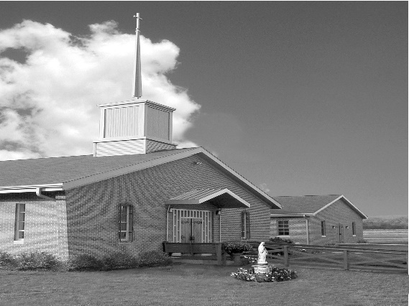
Phone: Phone: (570) 925-6969
E-mail: ctk@epix.net
Website: ctkbenton.weebly.com
Pastor: Rev. Richard J. Mowery
(570) 784-0801
Administrator: Rev. Olusola Adewole, O.P.
(570) 784-3123,
FrOAdewole@hbgdiocese.org
CYE Coordinator: Betty Hnylanski
(570) 594-3687, bhnylan@gmail.com
Secretary: Lee Ann Boiwka
(570) 864-3090, boiwka@epix.net
Office Hours: Monday & Thursday, 8am -12pm

May 15, 2022 – Fifth Sunday of Easter

“Jesus commands us to love one another.”

Jesus wants us to love as he loves. Our faithfulness and attentiveness to right and wrong, to holiness, and to the practice of faith is important. Yet Jesus furthers our understanding of following him by making clear the greatest commandment of every disciple: to love as he loves.

Liturgy of the Word
In the first reading, Paul and Barnabas continue their work and encourage the others to persevere in their faith. In the second reading, John describes his vision of a new heaven and a new earth where God dwells with his people and wipes the tears from their eyes: He proclaims, Behold, I make all things new. In the Gospel, Jesus gives his disciples a new commandment to love one another as he loves them.

In your prayers, please remember: Intentions of the Holy Father, all Priests including Msgr. Lawrence, Fr. Mowery and Fr. Sola, Josephine Folayemi Adewole, Maureen Beck, Lorena Bennet, Butch Bogart, Christina Capriola, Russell Castrogiovanni, Cobert Family, Alan & Jen Culp, Michael Farrell, Michael Fontinell, Deb & Paul Haden, Ray Hunsinger, Vivian Whitenight Hynick, Carl Kalie, Margaret Kalie, Dick Kocher, Joseph LaBonte, Mary Ann Levan, James Mazonkey, Nora & Terry McDaniels, Bernie Nichols, Nancy Oman, Joan Pauley, Helen Raski, Sabo Family, Joan Sansouci, Pat Scardigli, Jackie Scherer, Pat Treier’s daughter Christy, Sally Tucker, Max Whitenight, Nancy Wisbar, Sonny Womelsdorf, and all the Parishioners of CTK.

Stewardship: May 8, 2022

Offerings $2477.00
Easter $100.00
Operation Rice Bowl $17.20
Project Fund $25.00
St. Nick $15.00

Total $2634.20

Mass Intentions
Saturday, May 14 – Beverly Charles by Richard & Tamara Lindner
Sunday, May 15 – Joseph Tapsak by Sandy Dennis
Kevin Sabo (Birthday Blessings) by Justa Sabo
Monday, May 16 – Jen Culp by Justa Sabo
Joseph English by Ginny & Joe English
Thursday, May 19 – Mary English by Ginny & Joe English
Saturday, May 21 – People of the Parish
Sunday, May 22 – Dolores Bauman & Lynne Greenly by Joe & Lee Ann Boiwka
Deborah Shaffer (Birthday Blessings) by David Strazdus

Mass intentions are available in memory of, or in honor of a loved one. The donation for having a Mass said for a personal request is $10.00. You can drop your request in the collection or contact the parish office.

Lector Schedule Extraordinary Minister
May 15 – Meg Geffken Patricia Sullivan
May 22 – Steve Root Meg Geffken
Knights of Columbus News: Thank you to the Knights for a great Mother’s Day breakfast.

May 27 & 28, Friday & Saturday - Rummage Sale - Parishioners are asked for donations of items that are in good enough shape to sell. The items can be dropped off at the social hall beginning Monday morning May 23rd from 7 a.m. to 6 p.m., Tuesday, Mary 24th from 9 a.m. to 6 p.m. or Wednesday, May 25th from 9 a.m. to 6 p.m. If someone needs help with a large item they can call Ken Houck at 570-951-2608 or email him at kjhouck@reagan.com.
We are also looking for assistance during the week leading up to the rummage sale. Separating items into group that make sense and otherwise taking things out of boxes and placing them on tables or using floor space where appropriate.

CYE News: High school students in grades 8-12 will be meeting briefly with Mrs. Shanna Haden in the CYE building to discuss the high school program to begin in the fall.
The last day of CYE classes is Sunday May 22. All completed textbooks should be returned before that date.

A field day will be held for all CYE students and their families after Mass on May 22. A make your own sundae treat will be provided for all.

Listening Session for Snyodal Process – May 15th following the 9:00 a.m. Mass.
Responding to the call of Pope Francis we will be having a listening session after Sunday Mass on May 15, 2022, in the social hall. Refreshments will be served. I encourage you all to come and share your thoughts about our common faith.

Unborn Candle Donations $3.00/ week, $5.00/ 2 weeks or $10.00/ month.
Month of May – Richard & Tamara Lindner

Benton Food Bank - For the month of May we will be collecting paper towels. Thank you for your generosity! The Food Bank at the N4C’s is the 3rd Tuesday of every month. Anyone in need is encouraged to come between 9:00 a.m. -11:00 a.m.

Diocesan Annual Campaign – If you have not sent in your donation for the Annual Campaign, please consider doing so. There are envelopes at the entrance of the Church.

Parish Goal for 2022: $9,442.53
Total Paid: $11,432.00
Over/(under)goal in cash: $1,989.47
Number of Donors: 32
Registered Households: 119
Percentage of Participation: 26.89%

Any monies collected over our goal, comes back to Christ the King.

Newly Baptized – Christ the King congratulates the family and welcomes into the faith
Colton James Ney and Brynlee Ann Ney who were baptized here on May 7, 2022.
Grandparents are Deacon & Mrs. Earl Roberts.

Christ the King Ambassadors - we are recruiting and reorganizing members for a service group of Christ the King. Our focus would be to reach out to our homebound and sick; visit or call members who have lost a loved one; taking communion to parishioners if you are an Extraordinary Minister; welcoming new members; being part of the Christ the King Prayer Chain.

The ambassadors will provide opportunities for our parish to grow as a Community of Christians eager to know, love and serve the Lord.

If you are interested and willing to be on this committee, please contact Meg Geffken at 570-925-6264, Lee Ann at 570-864-3090 or the Parish Office at 570-925-6969.

