Christ the King Catholic Church
300 Mendenhall Lane, P.O. Box 297 Benton, PA
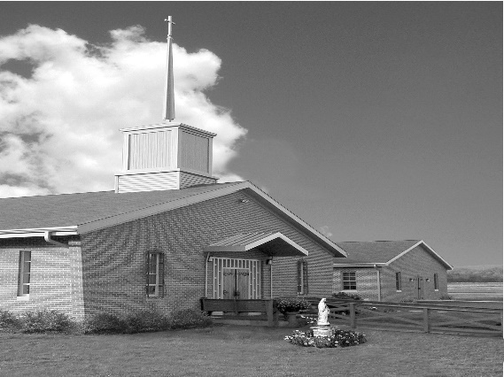
Phone: Phone: (570) 925-6969
E-mail: ctk@epix.net
Website: ctkbenton.weebly.com
Pastor: Rev. Richard J. Mowery
(570) 784-0801
Administrator: Rev. Olusola Adewole, O.P.
(570) 784-3123,
FrOAdewole@hbgdiocese.org
CYE Coordinator: Betty Hnylanski
(570) 594-3687, bhnylan@gmail.com
Secretary: Lee Ann Boiwka
(570) 864-3090, boiwka@epix.net
Office Hours: Monday & Thursday, 8am -12pm

March 6, 2022 – First Sunday of Lent

Ash Wednesday signifies the beginning of the Lenten season. It's a time to work on our interior disposition to focus on goodness, repentance, forgiveness and God-given mandate to build up our world. Pope Francis exhorts us to sow seeds of goodness, so that we might reap a harvest of salvation for ourselves and others. In a world that seems to be inundated with strife, oppression, wickedness and greed, we might become weary of seeking the good of others. Let us keep in mind the Holy Father's admonition: "Lent invites us to conversion, to a change in mindset, so that life's truth and beauty may be found not so much in possessing as in giving, not so much in accumulating as in sowing and sharing goodness." Wishing a spiritually enriching Lenten season!

Blessings,

Fr.'Sola,op

Stations of the Cross – Fridays at 6:00 p.m. during Lent.

No Daily Mass this week on Monday, March 7th and Thursday, March 10th.

“Faithfulness to God is rewarded with grace and strength.”

The Church has begun the spiritual journey of this holy season of Lent. With Christ, we enter the desert – to confront the Evil One and resist his false and empty promises. Once again, we seek the abundant mercy and power of God.

Liturgy of the Word
Moses gives the people instruction on giving proper praise and thanksgiving before the Lord God. Saint Paul writes, if you confess with your mouth that Jesus is Lord and believe in your heart that God raised him from the dead, you will be saved. In the Gospel, Jesus is led into the desert by the Spirit, where he overcomes three temptations by the devil.

In your prayers, please remember: Intentions of the Holy Father, all Priests including Msgr. Lawrence, Fr. Mowery and Fr. Sola, Josephine Folayemi Adewole, Maureen Beck, Lorena Bennet, Butch Bogart, Christina Capriola, Russell Castrogiovanni, Cobert Family, Michael Fontinell, Deb Haden, Ray Hunsinger, Vivian Whitenight Hynick, Margaret Kalie, Dick Kocher, Mary Ann Levan, James Mazonkey, Nora & Terry McDaniels, Bernie Nichols, Joan Pauley, Helen Raski, Sabo Family, Joan Sansouci, Pat Scardigli, Jackie Scherer, Pat Treier’s daughter Christy, Sally Tucker, Max Whitenight, Nancy Wisbar, Sonny Womelsdorf, and all the Parishioners of CTK.

Stewardship: February 27

Offerings $998.00
Rainy Day/Project Fund $45.00
St. Nicholas Fund $30.00

Total $1073.00

Mass Intentions
Saturday, March 5 – People of the Parish
Sunday, March 6 – Nicholas Sabo by Justa Sabo
Monday, March 7 – No Mass
Thursday, March 10 – No Mass
Saturday, March 12 – Gerald Zeveney by Mary Ann Zeveney
Sunday, March 13 – Joseph Tapsak by Auntie Irene & Family, Cousins Paul, Terry
Ron & Rick

Mass intentions are available in memory of, or in honor of a loved one. The donation for having a Mass said for a personal request is $10.00. You can drop your request in the collection or contact the parish office.

Lector Schedule Extraordinary Minister

March 6 – Peter Yastishock Lee Ann Boiwka
March 13 – Barb Treier Paul J. Haden

CYE News - The CYE youth group fundraiser for Mardi Gras has been postponed. A Spring Fling will be held in April/May this year in place of the Mardi Gras fundraiser.
Decision Point class for students in Grades 8-12 will be held on Sunday March 20 from 1130-130. Lunch will be provided.

Please remember in your prayers Corbin McHenry, who is in his final preparation to receive the sacraments of Reconciliation and Eucharist this spring.

Please remember Gavin Birkett, Collin Cashman, and Taylor Chikotas who are in their final preparation to receive the sacrament of Confirmation in May at St Columba.

Unborn Candle Donations $3.00/ week, $5.00/ 2 weeks or $10.00/ month.
Month of March – Judy Womelsdorf
(Looking for Parishioners to take a week, 2 weeks or a month)
Benton Food Bank - For the month of March we will be collecting Liquid Hand Soap. Thank you for your generosity! The Food Bank at the N4C’s is the 3rd Tuesday of every month. Anyone in need is encouraged to come between 9:00 a.m. -11:00 a.m.

Catholic Relief Services Rice Bowl – Please pick up your For Lent, For Life Rice Bowl on the back table. What you give up for Lent changes lives. 75% of your CRS Rice Bowl donations supports Catholic Relief Services’ work around the world. 25% helps fight hunger and poverty in your own community. Turn in your donation at the end of Lent marked CRS Rice Bowl.
2022 Diocesan Annual Campaign - The 2022 Diocesan Annual Campaign, One Faith, One Family, has begun. Because of the generosity of the faithful throughout the Diocese of Harrisburg, our 2021 effort was remarkable with 72 parishes reaching and exceeding their goals. The many ministries and programs which received funding are humbled by the interest in and support of their efforts. From Evangelization efforts, to the many social service programs offered by Catholic Charities, to ongoing education and formation for our seminarians, clergy and ordained deacons, to support for Catholic education, your gift does make a difference. Please prayerfully consider your gift this year to ensure that the mission of the Church is fulfilled. To learn more about the Diocesan Annual Campaign, please visit https://www.hbgdiocese.org/diocesan-annual-campaign/

Christ the King Final Report for 2021 Diocesan Annual Campaign
Parish Goal for 2021: $9,322.00
Total Paid: $12,670.00
Over: $3,348.00 (Money comes back to Christ the King)

Average per donor: $309.02

Number of Donors: 41
Registered Households: 118
Percentage of Participation: 34.75%

Grief Share – Tuesdays @ 7:00 p.m. March 1st – May 24th, 2022. Weekly Grief Support Group at the Benton Christian Church, Corner of Church & Third Streets. Contact Kim Keller @ 570-204-3888 for more information. Everyone is Welcome. $20.00 fee for workbook.

