Christ the King Catholic Church
300 Mendenhall Lane, P.O. Box 297 Benton, PA
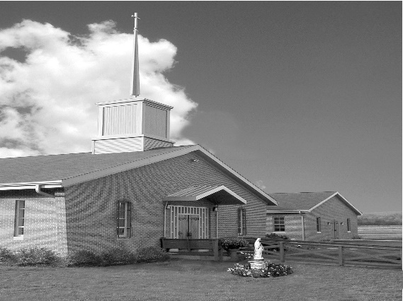
Phone: Phone: (570) 925-6969
E-mail: ctk@epix.net
Website: ctkbenton.weebly.com
Pastor: Rev. Richard J. Mowery
(570) 784-0801
Administrator: Fr. Andrew P. St. Hilaire
(570) 784-3123 (717) 884-9523
frasthilaire@hbgdiocese.org
CYE Coordinator: Betty Hnylanski
(570) 594-3687, bhnylan@gmail.com
Secretary: Lee Ann Boiwka
(570) 864-3090, boiwka@epix.net
Office Hours: Monday & Thursday, 8am -12pm

March 5, 2023 – Second Sunday of Lent

“We will one day share in the glory of the Lord.”

The true and full identity of Jesus is revealed in the great moment of the Transfiguration. This revelation shows us that the Father has entrusted to him the salvation of the world. We see the glory of the Lord upon Jesus, and understand that we are meant to share that when the fullness of the kingdom is at hand.

God tells Abram to leave his homeland and go to a land that he will show him, where the Lord will make of him a great nation. Saint Paul tells Timothy to bear [his] share of hardship for the gospel with the strength that comes from God. In the Gospel, Jesus takes Peter, James, and John up a mountain and he is transfigured before them.

Friday Daily Mass will be at 6:00 p.m. along with Stations of the Cross at 6:30 p.m. every Friday during Lent at Christ the King

In your prayers, please remember: Intentions of the Holy Father, all Priests including
Fr. Mowery, Fr. St. Hilaire and Fr. Sola, Lisa Baehre, Michael Bardi, Maureen Beck, Lorena Bennet, Christina Capriola, Russell Castrogiovanni, Cobert Family, Honor & Joe Dell, Ryan Dell,
Alex Haden, Deb Haden,Vivian Whitenight Hynick, Bob Kalie, Margaret Kalie, Austin Kelsey, Joseph LaBonte, Mary Ann Levan, Bernie Nichols, Nancy Oman, Logan & Oliver Root, Richard Scavone, Jackie Scherer, Scott Thomas, Sally Tucker, Max Whitenight, Nancy Wisbar, Sonny Womelsdorf, Mary Ann Zeveney and all the Parishioners of CTK.

Mass Intentions

Saturday, March 4 – Bill Lindner by Richard & Tamara Lindner
Sunday, March 5 – People of the Parish
Monday, March 6 – Nicholas Sabo by Justa Sabo
Friday, March 10 – Joseph English by Ginny & Joe English
Saturday, March 11 – Mary & Richard Walker by Kathy & Rich Walker
Sunday, March 12 – Dottie Poles by Lee Ann & Joe Boiwka

Mass intentions are available in memory of, or in honor of a loved one. The donation for having a Mass said for a personal request is $10.00. You can drop your request in the collection or contact the parish office.

Stewardship: February 26, 2023

Offerings $1293.50
Ash Wednesday $283.50
St. Nick $40.00

Total $1617.00

Lector Schedule Extraordinary Minister Collection Stewards

March 5 – Pete Yastishock PJ Haden Sharon Tishler & Dottie Poles
March 12 – Barb Treier Lee Ann Boiwka Anne Eustice & Florence Tapsak

Unborn Candle Donations $3.00/ week, $5.00/ 2 weeks or $10.00/ month.
Month of March – Judy & Sonny Womelsdorf

CYE News
On Saturday, March 18, the CYE Youth Group, (Grades 6-12), will go bowling at P-Nut Bowl in Bloomsburg beginning at noon. Students needing a ride to Bloomsburg can be picked up at Christ the King parking lot at 11:20 a.m. Please contact Ms Betty at 570-594-3687 if you need a ride.

Place a Memorium, Prayer Request, Spiritual Notation or become a Sponsor for our new bulletin. The art department of Diocesan will design a spot for you which will appear weekly on our church bulletin’s advertisement page. What better way to show your continued love for those special to you and support your church bulletin at the same time. You can call Adam Snyder for more information at 1-814-771-8628 or contact the Parish Office at 570-925-6969.

Benton Food Bank - From now until March 20th we will be collecting liquid hand soap. The Food Bank at the N4C’s is the 3rd Tuesday of every month.

2023 Benton Community Lenten Services – Sunday Evenings at 7 p.m.

Date Location Speaker Special Music

3/05/23 UMC Benton Pastor Bill McClure Christ the King
3/12/23 Benton Christian Pastor Tyler Rauhauser Assembly of God
3/19/23 Assembly of God Pastor Ron Shelhamer Benton UMC
3/26/23 Raven Creek Rev. Andrew St. Hilaire Joe & Lorraine Feola

Diocesan Chrism Mass: All are invited to join the Most Rev. Ronald W. Gainer, Bishop of Harrisburg, as he celebrates the DIOCESAN CHRISM Mass at 4 p.m. on Monday, April 3, in the Cathedral Parish of Saint Patrick, Harrisburg. The Chrism Mass offers a solemn occasion to witness the blessing of the oils and the consecration of the Sacred Chrism that will be used in the celebration of the sacraments throughout the coming year.

Lenten Series - This Sunday, March 5th, and each Sunday in March, following the 9:00 a.m. Mass, Father Andrew will be facilitating a Lenten series called "No Greater Love: A Biblical Walk Through Christ's Passion".

All are invited and encouraged to attend!

Your Old Palm Branches should be burnt or buried. This type of disposal honors their sacred purpose and returns them to the earth in a dignified way. Anyone can do this, but if you don’t have the ability to burn or bury them, please drop them off at the parish office

Were you married in 1973? In honor of your 50th Wedding Anniversary, there will be a special Mass and reception on Sunday, July 9, 2023 at 2:00 p.m. at Good Shepherd Parish in Camp Hill. Bishop Ronald W. Gainer will be the celebrant. To receive an invitation, please contact your parish office.

St. Columba School is searching for an Elementary Principal to serve as a beacon of Christ’s light while nurturing individual gifts in a faith-infused, academically challenging, safe and secure environment. Find out more regarding our K-8 school at https://www.saintcolumbaschool.org

Ushers – We are in need of men or women to help at Mass with the collection and greeting the parishioners as they enter Church. If you can help with this ministry, please see Lee Ann Boiwka or call the Parish Office at 570-925-6969.

Monastery Pantry – our dear nuns are busy preparing Pascha breads, the traditional Easter bread which is round, festive and topped with a cross, and other goodies for Easter. There are order forms in the back of the church and the deadline to give to Meg Geffken is March 19th. You can also call in your order by March 20th. The orders will be delivered to Christ the King for the weekend of April 1st and 2nd. Checks should be made payable to Holly Annunciation Monastery.

