Christ the King Catholic Church
300 Mendenhall Lane, P.O. Box 297 Benton, PA
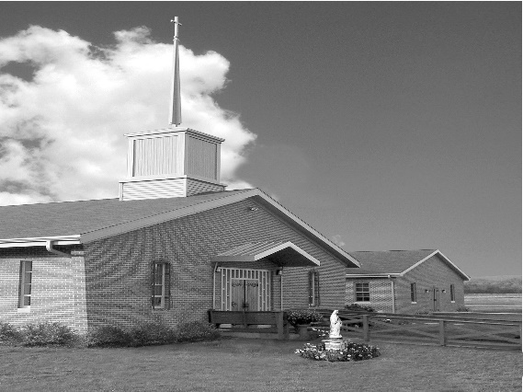
Phone: Phone: (570) 925-6969
E-mail: ctk@epix.net
Website: ctkbenton.weebly.com
Pastor: Rev. Richard J. Mowery
(570) 784-0801
Administrator: Rev. Olusola Adewole, O.P.
(570) 784-3123,
FrOAdewole@hbgdiocese.org
CYE Coordinator: Betty Hnylanski
(570) 594-3687, bhnylan@gmail.com
Secretary: Lee Ann Boiwka
(570) 864-3090, boiwka@epix.net
Office Hours: Monday & Thursday, 8am -12pm

March 27, 2022 – Fourth Sunday of Lent

“We have been reconciled to the Father through the Son.”

We can rejoice in today’s theme of God’s forgiveness and mercy. He led the Israelites to the Promised Land; he has reconciled us to himself through Christ; and he is always ready to forgive, awaiting us with open arms to come and rest in his love.

Liturgy of the Word
In the first reading, the Israelites celebrate Passover in Gilgal, feasting on the produce of the land. Saint Paul writes, whoever is in Christ is a new creation, for God has reconciled us to himself through Christ. In the Gospel, Jesus addresses a parable to the Pharisees and scribes. The parable is of a father and his two sons, the younger of whom squanders his inheritance but returns home to be welcomed by his father.

Saturday evening Mass will return to 5 p.m. on April 2nd with Confessions 4 p.m.

Second Collection April 2nd & 3rd will be for Catholic Relief Services.

The Parish Office will open at 8:30 on Monday & Thursday the month of March.

In your prayers, please remember: Intentions of the Holy Father, all Priests including Msgr. Lawrence, Fr. Mowery and Fr. Sola, Josephine Folayemi Adewole, Maureen Beck, Lorena Bennet, Butch Bogart, Christina Capriola, Russell Castrogiovanni, Cobert Family, Michael Fontinell, Deb Haden, Ray Hunsinger, Vivian Whitenight Hynick, Carl Kalie, Margaret Kalie, Dick Kocher, Mary Ann Levan, James Mazonkey, Nora & Terry McDaniels, Bernie Nichols, Joan Pauley, Helen Raski, Sabo Family, Joan Sansouci, Pat Scardigli, Jackie Scherer, Pat Treier’s daughter Christy, Sally Tucker, Max Whitenight, Nancy Wisbar, Sonny Womelsdorf, and all the Parishioners of CTK.

Stewardship: March 20, 2022

Offerings $2229.50
Ash Wednesday $10.00
Rainy Day/Project Fund $70.00
St. Nicholas Fund $50.00

Total $2359.50

Mass Intentions
Saturday, March 26 – Rollin Neal & Family by Mary Ellen Neal
Sunday, March 27 – Joseph Tapsak by Connie & Fred Bischke
Monday, March 28 – William Diglman by Dorothy Poles
Thursday, March 31 – Anne Eustice by Renee Hansen
Friday, April 1 – People of the Parish
Saturday, April 2 – John B. Eustice by Anne Eustice
Sunday, April 3 – Mike Talanca by Diane & Douglas Talanca

Mass intentions are available in memory of, or in honor of a loved one. The donation for having a Mass said for a personal request is $10.00. You can drop your request in the collection or contact the parish office.

Lector Schedule Extraordinary Minister
March 27 – Mary Ann Zeveney Patricia Sullivan
April 3 – Paul Haden Meg Geffken

CYE News – Congratulations to Corbin McHenry who made his First Reconciliation on Sunday, March 20th.

First Communion – Sunday, May 1st. Confirmation Saturday, May 14th. Please keep our children and young adults in your prayers as they prepare for these Sacraments.

Unborn Candle Donations $3.00/ week, $5.00/ 2 weeks or $10.00/ month.
Month of April – Anne Kingsbury

Benton Food Bank - For the month of April we will be collecting cans of Tuna. Thank you for your generosity! The Food Bank at the N4C’s is the 3rd Tuesday of every month. Anyone in need is encouraged to come between 9:00 a.m. -11:00 a.m.

The Harrisburg Diocesan Council of Catholic Women invites all women of the Diocese to attend the 96th Annual Convention - registration is now open. Our theme this year is “Be God’s Hands on Earth.” The convention will take place Saturday, April 23, 2022. at the Roman Catholic Diocesan Center, Harrisburg PA. More details are available on our website: https://hdccw.webs.com/hdccw-convention
Our Keynote Speaker will be Emily Jaminet who is executive director of the Sacred Heart Enthronement Network and coauthor of Divine Mercy for Moms, The Friendship Project, Pray Fully, and Our Friend Faustina.

Harrisburg Diocesan Council of Catholic Women 10th Annual Weekend Retreat June 10-12, 2022. Mount St. Mary’s University, Emmitsburg, MD. Retreat Master Father Chris Alar, MIC. See Lee Ann at Parish Office or Kathy Walker for more information and registration form. Registration deadline is 5/16/22.

Easter Flowers – You can order an Easter Flower for the Altar in Memory of, or in Honor of a loved one. The sheets are at the exit of the Church. Donation is $10.00 per plant. You can drop your order off in the collection or stop by the office on Monday or Thursday mornings.
LENTEN AND EASTER SEASON SCHEDULE FOR 2022

Stations of the Cross @ 6 p.m. on Fridays

CYE CONFESSIONS
Sunday, April 3 @ 10 a.m.

CHRIST THE KING LENTEN CONFESSIONS
Saturday, April 2 @ 4 p.m.
Sunday, April 3 @ 8 a.m. (Two Priests on hand)

PALM SUNDAY MASSES, APRIL 9 & 10
Saturday: 5 p.m. Mass
Sunday: 9 a.m. Mass

MONDAY OF HOLY WEEK, APRIL 11
Mass @ 9 a.m.
Chrism Mass @ St. Patrick Cathedral, Harrisburg, PA @ 2 p.m.

HOLY THURSDAY, APRIL 14
Mass of the Lord’s Supper @ 7 p.m.
Adoration of the Blessed Sacrament thereafter.

GOOD FRIDAY, APRIL 15
Stations of the Cross @ 2.30 p.m.
Celebration of the Passion of the Lord @ 3 p.m.

HOLY SATURDAY, APRIL 16
Easter Vigil Mass @ 8 p.m.

EASTER SUNDAY, APRIL 17
Mass @ 9 a.m.

FIRST EUCHARIST – MAY 1
Sunday, First Holy Communion at the 9:00 a.m. Mass
May Crowning to follow Mass

SACRAMENT OF CONFIRMATION, MAY 14
Saturday at St. Columba Church, Bloomsburg @ 10 a.m.
(Saturday, April 9, Confirmation Retreat at St. Joseph’s in Danville)

