Christ the King Catholic Church
300 Mendenhall Lane, P.O. Box 297 Benton, PA
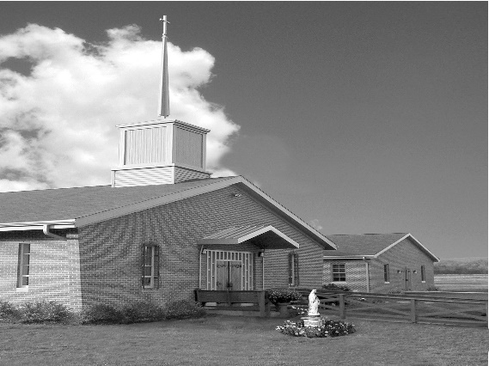
Phone: Phone: (570) 925-6969
E-mail: ctk@epix.net
Website: ctkbenton.weebly.com
Pastor: Rev. Richard J. Mowery
(570) 784-0801
Administrator: Fr. Andrew P. St. Hilaire
(570) 784-3123 (717) 884-9523
frasthilaire@hbgdiocese.org
CYE Coordinator: Betty Hnylanski
(570) 594-3687, bhnylan@gmail.com
Secretary: Lee Ann Boiwka
(570) 864-3090, boiwka@epix.net
Office Hours: Monday & Thursday, 8am -12pm

March 19, 2023 – Fourth Sunday of Lent

“Live as children of light, for light produces every kind of goodness.”

Sometimes doing God’s will can seem strange, foolish, or even wrong to others. Jesse assumed his youngest son couldn’t be the next king, so David was left to care for the sheep when Samuel came. The Pharisees thought Jesus sinned by healing on the Sabbath. Are we preoccupied with what others will think, or are we focusing on doing God’s will?

God sends Samuel to anoint the new king of Israel. Samuel surprises everyone by calling for and anointing David, the youngest of Jesse’s sons. The Lord’s Spirit rushed upon David. Saint Paul tells the Ephesians to live as children of light and expose darkness. In the Gospel, Jesus heals a blind man on the Sabbath, breaking the Sabbath rules.

**The Parish Office will open at 8:30 a.m. on Mondays for the month of March

Mass at 6:00 p.m. followed by Stations of the Cross every Friday at Christ the King

In your prayers, please remember: Intentions of the Holy Father, all Priests including
Fr. Mowery, Fr. St. Hilaire and Fr. Sola, Lisa Baehre, Michael Bardi, Maureen Beck, Lorena Bennet, Christina Capriola, Russell Castrogiovanni, Cobert Family, Honor & Joe Dell, Ryan Dell,
Vivian Whitenight Hynick, Bob Kalie, Margaret Kalie, Austin Kelsey, Joseph LaBonte, Mary Ann Levan, Nancy Oman, Logan & Oliver Root, Richard Scavone, Jackie Scherer, Scott Thomas, Sally Tucker, Max Whitenight, Josephine Wilson, Nancy Wisbar, Sonny Womelsdorf, Mary Ann Zeveney and all the Parishioners of CTK.

Mass Intentions

Saturday, March 18 – John Charles by Richard & Tamara Lindner
Sunday, March 19 – Jonathan Sabo (Birthday Blessings) by Justa Sabo
Monday, March 20 – Anne Eustice (Birthday Blessings) by Renee Hansen
Friday, March 24 – Mary English by Joe & Ginny English
Saturday, March 25 – NO MASS (Bishop at St. Columba, Bloomsburg, for 5:00 p.m. Mass)
Sunday, March 26 – Deborah Haden by Catechists & Students in CYE

Mass intentions are available in memory of, or in honor of a loved one. The donation for having a Mass said for a personal request is $10.00. You can drop your request in the collection or contact the parish office.

Stewardship: March 12, 2023

Offerings $1547.43
Ash Wednesday $10.00
Catholic Relief $100.00
Rainy Day $130.00
St. Nick $25.00

Total $1812.43

Lector Schedule Extraordinary Minister Collection Stewards
March 19 – Meg Geffken Patricia Sullivan Patricia & Mark Sullivan
March 26 – Stephen Root Meg Geffken Charlotte & Joe Casarella
CYE News - March 19 - St Patrick’s parish breakfast followed by CYE classes. Distribution of pew banners to First Communion students to be completed and returned on April 2.
March 26 - CYE classes following 9:00 Mass

April 2 - Palm Sunday Mass followed by CYE classes with the washing of the feet, the reenactment of the Last Supper, and Stations of the Cross.
Sacrament of Reconciliation for CYE
First Communion pew banners due. First Communion rehearsal for students and parents

April 9- Easter Sunday Mass at 9:00 with the celebration of First Communion. Celebration cake and Easter egg hunt after Mass.

Unborn Candle Donations $3.00/ week, $5.00/ 2 weeks or $10.00/ month.
Month of March – Judy & Sonny Womelsdorf

Place a Memorium, Prayer Request, Spiritual Notation or become a Sponsor for our new bulletin. The art department of Diocesan will design a spot for you which will appear weekly on our church bulletin’s advertisement page. What better way to show your continued love for those special to you and support your church bulletin at the same time. You can call Adam Snyder for more information at 1-814-771-8628 or contact the Parish Office at 570-925-6969.

Benton Food Bank - From now until April 16th we will be collecting 5 oz. cans of tuna. The Food Bank at the N4C’s is the 3rd Tuesday of every month.

2023 Benton Community Lenten Services – Sunday Evenings at 7 p.m.

Date Location Speaker Special Music

3/19/23 Assembly of God Pastor Ron Shelhamer Benton UMC
3/26/23 Raven Creek Rev. Andrew St. Hilaire Joe & Lorraine Feola

St. Patrick’s Day Breakfast – The Knights of Columbus will be having their annual St. Patrick’s Day breakfast immediately following the 9:00 a.m. Mass on Sunday, March 19th. All are welcome for good food and fellowship.

The Haden Family would like to express sincere thanks and deep appreciation for all the prayers, Masses, comforting words, flowers and donations extended to us during this sad time. Special thanks to all who provided a feast following the funeral and to Father Andrew, Father Mowery and Father Marcoe who officiated at the Mass. It was a truly memorable day! Debby would have been very pleased.

May she rest in the peace of the Lord! Please pray for the soul of Deborah A. Haden who died on March 3, 2023. The parish community of Christ the King extends its deepest sympathies to her family, relative, and friends on their loss.

Lenten Series - Each Sunday in March (with the exception of March 19th) , following the 9:00 a.m. Mass, Father Andrew will be facilitating a Lenten series called "No Greater Love: A Biblical Walk Through Christ's Passion". All are invited and encouraged to attend!

The Third Order Carmelite Community is planning a Day of Recollection to be held at Christ the King on a Saturday in May or June led by Father Andrew St. Hilaire. If you are interested, please contact Meg Geffken to be on their mailing list for information about the Day of Recollection. The Carmelites meet once a month at St. Joseph’s Church in Danville. Our “growing community” includes women and men from six counties in PA, who are studying Carmelite Spirituality and attempting to follow the teaching of St. Teresa of Avila, St. John of the cross and Therese of Lisieux.

Benton Council of Churches sponsoring an Easter Egg Hunt and Bake Sale – Saturday, April 1st at 1:00 P.M. at the Benton Community Park. Age Groups: 0 – Pre K, K-3 and 4-6 grades. There will be special prize eggs to find. If you are willing to donate small individually wrapped candies that will fit into plastic eggs they are being collected through March 26th. Please see Anne Eustice.

