Christ the King Catholic Church
300 Mendenhall Lane, P.O. Box 297 Benton, PA
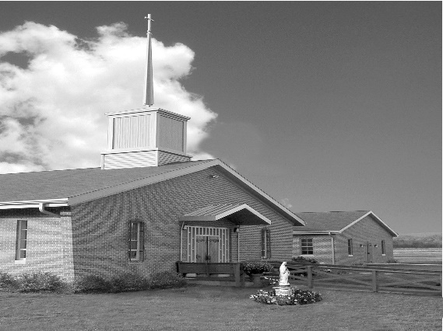
Phone: Phone: (570) 925-6969
E-mail: ctk@epix.net
Website: ctkbenton.weebly.com
Pastor: Rev. Richard J. Mowery
(570) 784-0801
Administrator: Fr. Andrew P. St. Hilaire
(570) 784-3123 (717) 884-9523
frasthilaire@hbgdiocese.org
CYE Coordinator: Betty Hnylanski
(570) 594-3687, bhnylan@gmail.com
Secretary: Lee Ann Boiwka
(570) 864-3090, boiwka@epix.net
Office Hours: Monday & Thursday, 8am -12pm

March 12, 2023 – Third Sunday of Lent

“If today you hear his voice, harden not your hearts.”

Just as Jesus approaches the outcast Samaritan woman at the well with intimate knowledge of her history and her heart, so, too, does Christ approach us. He comes with the offer of living water that will forever satiate our thirst if only we soften our hearts to hear his voice.

In the first reading, the people are thirsty and complaining. Moses strikes a rock with his staff, and God provides flowing water for the people to drink. Paul writes to the Romans that we have been justified by faith. In God’s great love he sent Christ to die for sinners. In the Gospel, Jesus encounters a woman by a well in Samaria. He speaks of living water and knows her past; she believes he is the Messiah.

**The Parish Office will open at 8:30 a.m. on Mondays for the month of March

In your prayers, please remember: Intentions of the Holy Father, all Priests including
Fr. Mowery, Fr. St. Hilaire and Fr. Sola, Lisa Baehre, Michael Bardi, Maureen Beck, Lorena Bennet, Christina Capriola, Russell Castrogiovanni, Cobert Family, Honor & Joe Dell, Ryan Dell,
Alex Haden, Vivian Whitenight Hynick, Bob Kalie, Margaret Kalie, Austin Kelsey, Joseph LaBonte, Mary Ann Levan, Bernie Nichols, Nancy Oman, Logan & Oliver Root, Richard Scavone, Jackie Scherer, Scott Thomas, Sally Tucker, Max Whitenight, Nancy Wisbar, Sonny Womelsdorf, Mary Ann Zeveney and all the Parishioners of CTK.

Mass Intentions

Saturday, March 11 – Mary & Richard Walker by Kathy & Rich Walker
Sunday, March 12 – Dottie Poles by Lee Ann & Joe Boiwka
Monday, March 13 – People of the Parish
Wednesday, March 15 – People of the Parish
Friday, March 17 – Daniel Sullivan by Mark & Patricia Sullivan
Saturday, March 18 – John Charles by Richard & Tamara Lindner
Sunday, March 19 – Jonathan Sabo (Birthday Blessings) by Justa Sabo

Mass intentions are available in memory of, or in honor of a loved one. The donation for having a Mass said for a personal request is $10.00. You can drop your request in the collection or contact the parish office.

Stewardship: March 5, 2023

Offerings $1509.10
Rainy Day $55.00
St. Nick $170.00

Total $1734.10

Lector Schedule Extraordinary Minister Collection Stewards

March 12 – Barb Treier Lee Ann Boiwka Anne Eustice & Florence Tapsak
March 19 – Meg Geffken Patricia Sullivan Patricia & Mark Sullivan
Unborn Candle Donations $3.00/ week, $5.00/ 2 weeks or $10.00/ month.
Month of March – Judy & Sonny Womelsdorf

CYE News
On Saturday, March 18, the CYE Youth Group, (Grades 6-12), will go bowling at P-Nut Bowl in Bloomsburg beginning at noon. Students needing a ride to Bloomsburg can be picked up at Christ the King parking lot at 11:20 a.m. Please contact Ms Betty at 570-594-3687 if you need a ride.

Place a Memorium, Prayer Request, Spiritual Notation or become a Sponsor for our new bulletin. The art department of Diocesan will design a spot for you which will appear weekly on our church bulletin’s advertisement page. What better way to show your continued love for those special to you and support your church bulletin at the same time. You can call Adam Snyder for more information at 1-814-771-8628 or contact the Parish Office at 570-925-6969.

Benton Food Bank - From now until March 20th we will be collecting liquid hand soap. The Food Bank at the N4C’s is the 3rd Tuesday of every month.

2023 Benton Community Lenten Services – Sunday Evenings at 7 p.m.

Date Location Speaker Special Music

3/12/23 Benton Christian Pastor Tyler Rauhauser Assembly of God
3/19/23 Assembly of God Pastor Ron Shelhamer Benton UMC
3/26/23 Raven Creek Rev. Andrew St. Hilaire Joe & Lorraine Feola

St. Patrick’s Day Breakfast – The Knights of Columbus will be having their annual St. Patrick’s Day breakfast immediately following the 9:00 a.m. Mass on Sunday, March 19th. All are welcome for good food and fellowship.

May she rest in the peace of the Lord! Please pray for the soul of Deborah A. Haden who died on March 3, 2023. The parish community of Christ the King extends its deepest sympathies to her family, relative, and friends on their loss.
Lenten Series - Each Sunday in March (with the exception of March 19th) , following the 9:00 a.m. Mass, Father Andrew will be facilitating a Lenten series called "No Greater Love: A Biblical Walk Through Christ's Passion". All are invited and encouraged to attend!

The Third Order Carmelite Community is planning a Day of Recollection to be held at Christ the King on a Saturday in May or June led by Father Andrew St. Hilaire. If you are interested, please contact Meg Geffken to be on their mailing list for information about the Day of Recollection. The Carmelites meet once a month at St. Joseph’s Church in Danville. Our “growing community” includes women and men from six counties in PA, who are studying Carmelite Spirituality and attempting to follow the teaching of St. Teresa of Avila, St. John of the cross and Therese of Lisieux.

97th Annual Women’s Convention – Live in the Love of Christ. Keynote Speaker: Liz Kelly
Liz Kelly is a retreat leader and the award-winning author of ten books, including Reasons I Love Being Catholic, which won the Catholic Press Association First Place award for Best Popular Presentation of the Faith in 2007, and Jesus Approaches, What Contemporary Women Can Learn about Healing, Freedom & Joy from the Women of the New Testament, which has won several awards, including Best Book in the Religion/Christianity category for 2017-2019. For more about Liz please visit: https://www.lizk.org/

Hybrid Event: In-Person and Virtual Options, Saturday, April 15, 2023 at the Roman Catholic Diocesan Center, Harrisburg, PA. Registration and continental breakfast begin at 8:00 a.m. with closing prayer at 2:30 p.m.

For more information about the convention visit https://hdccw.webs.com/hdccw-convention

Ushers – We are in need of men or women to help at Mass with the collection and greeting the parishioners as they enter Church. If you can help with this ministry, please see Lee Ann Boiwka or call the Parish Office at 570-925-6969.

Monastery Pantry – our dear nuns are busy preparing Pascha breads, the traditional Easter bread which is round, festive and topped with a cross, and other goodies for Easter. There are order forms in the back of the church and the deadline to give to Meg Geffken is March 19th. You can also call in your order by March 20th. The orders will be delivered to Christ the King for the weekend of April 1st and 2nd. Checks should be made payable to Holly Annunciation Monastery.

