Christ the King Catholic Church
300 Mendenhall Lane, P.O. Box 297 Benton, PA
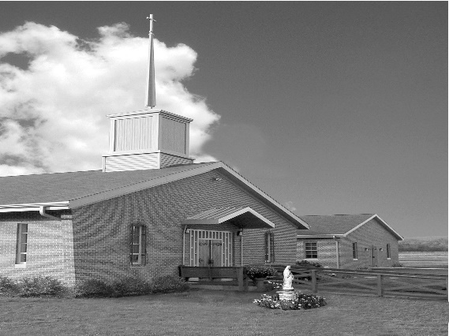
Phone: Phone: (570) 925-6969
E-mail: ctk@epix.net
Website: ctkbenton.weebly.com
Pastor: Rev. Richard J. Mowery
(570) 784-0801
Administrator: Fr. Andrew P. St. Hilaire
(570) 784-3123
frasthilaire@hbgdiocese.org
CYE Coordinator: Betty Hnylanski
(570) 594-3687, bhnylan@gmail.com
Secretary: Lee Ann Boiwka
(570) 864-3090, boiwka@epix.net
Office Hours: Monday & Thursday, 8am -12pm

June 26, 2022 – 13th Sunday in Ordinary Time

“Jesus makes clear that there is an urgency in leaving the things of the
world behind to follow him.”

Jesus calls each of us to give up the things of the world, to repent of our sins, and to follow him no matter the cost. He does not violate our freedom, however; he allows us to choose whether we will stay where we are or follow the way of the cross, which ultimately leads to everlasting life.

Liturgy of the Word
In the first reading, Elijah passes Elisha and casts his mantle on him. Elisha asks if he may go home and kiss his parents goodbye. In the second reading, Paul writes that Christ set us free from slavery, and explains that freedom comes through the greatest commandment – to love. In the Gospel, Jesus tells a man who wishes to follow him that the kingdom of God requires following him in that very moment.

This weekend we welcome Father Andrew St. Hilaire (Father Andrew)
who will be our new Administrator.

In your prayers, please remember: Intentions of the Holy Father, all Priests including Msgr. Lawrence, Fr. Mowery and Fr. Sola, Josephine Folayemi Adewole, Maureen Beck, Lorena Bennet, Butch Bogart, Christina Capriola, Russell Castrogiovanni, Cobert Family, Edward Connell, Alan & Jen Culp, Michael Farrell, Michael Fontinell, Deb & Paul Haden, Ray Hunsinger, Vivian Whitenight Hynick, Carl Kalie, Margaret Kalie, Dick Kocher, Joseph LaBonte, Mary Ann Levan, James Mazonkey, Bernie Nichols, Nancy Oman, Helen Raski, Sabo Family, Joan Sansouci, Pat Scardigli, Jackie Scherer, Pat Treier’s daughter Christy, Sally Tucker, Max Whitenight, Nancy Wisbar, Sonny Womelsdorf, and all the Parishioners of CTK.

Stewardship: June 19, 2022

Offerings $2090.70
Ascension $30.00
Catholic Communication $382.00
Pentecost $10.00
Project Fund $218.00
St. Nick $20.00

Total $2750.70

Mass Intentions
Saturday, June 25 – Kathy & Rich Walker by Mary Ellen Neal
Sunday, June 26 – Delores Strazdus by David Strazdus
Monday, June 27 – Daniel Bauman by Lee Ann & Joe Boiwka
Thursday, June 30 – Joseph Anthony Kaeli by Margaret House
Anna Mae Hanlon by Anne Eustice
Friday, July 1 – No Mass
Saturday, July 2 – John B. Eustice by Anne Eustice
Sunday, July 3 – Bertha Heffner & Leona Chikotas by Chikotas Family

Mass intentions are available in memory of, or in honor of a loved one. The donation for having a Mass said for a personal request is $10.00. You can drop your request in the collection or contact the parish office.

Lector Schedule Extraordinary Minister
June 26 – Mary Ann Zeveney Patricia Sullivan
July 3 – Paul Haden Meg Geffken

Benton Food Bank - For the month of June we will be collecting canned soup. Thank you for your generosity! The Food Bank at the N4C’s is the 3rd Tuesday of every month. Anyone in need is encouraged to come between 9:00 a.m. -11:00 a.m.

Vacation Bible School at St. Columba - July 11 to July 15. It will be held from 9:00 a.m. to 12:00 p.m. Hope to see you all there! This year's theme "Monumental - Celebrating God's Greatness" for K through grade 6, and we are accepting 7th and 8th grade volunteers...and of course adults! $20/child preregistered $25/walk-in. Go to this link to register: //vbspro.events/p/www-saintcolumbachurch-org

Unborn Candle Donations $3.00/ week, $5.00/ 2 weeks or $10.00/ month.
Month of June – Mark & Patricia Sullivan

Bloomsburg Fair, September 24 – October 1 – Looking for volunteers specifically someone to be in charge of the haluski making. Please sign the sheet on the back counter.

Pierogi Making Schedule – Fridays: July 8, 15 ,22, 29 and August 5, 12, 19

Father Sola’s new address: Rev. Olusola Adewole, O.P., Saint Catherine of Sienna,
955 Robert Fulton Highway, Quarryville, PA 17566

Collecting Tabs - This is just a reminder that we are still collecting soda tabs for Ronald McDonald house in Danville. By collecting the tabs you will help care for families who stay at the house each year. A clear plastic bear will be on the table just inside the church. Please put the tabs in it. Thank you for your help. Tamara Lindner.
Quo Vadis Days: Calling all young Catholic men – are you wondering what God’s plan is for your life? Do you need guidance in your discernment? Join us for Quo Vadis Days for a time of recreation, fellowship, prayer and guidance as you explore God’s call for your life. Mass, Adoration of the Blessed Sacrament, recreation and sports, discernment talks and great food are all included in this weeklong camp. Quo Vadis Days is for men ages 15-25 and will be June 26 - 30 at Mount Saint Mary's University and Seminary. Cost is $100 per person. Register by June 17 to attend. Details and registration can be found at https:// www.hbgdiocese.org/event/quo-vadis-days/. Questions? Please contact the Office of Vocations at (717) 657-4804, ext. 282 or email vocations@hbgdiocese.org. There are pamphlets at the entrance of the Church.

Fiat Days: Attention all Catholic young women ages 15-25. Our Lord Jesus Christ has a great plan and mission for you! You are invited to attend the Diocese of Harrisburg’s Annual Fiat Days vocation discernment retreat to spend time with other young women your age as you listen to the Lord’s call in your life while having fun. Activities include – Holy Mass, Eucharistic Adoration, sports, games, great food, talks and more. Fiat Days will be held July 5-8, 2022 at Saint Mary Providence Center in Elverson, PA. There is a $100 registration fee, all other expenses funded by the Diocese of Harrisburg. Registration forms can be found on our website at www.hbgdiocese.org. You may also contact the Office of Vocations at (717) 657-4804, ext. 282 or email vocations@hbgdiocese.org with questions or for a registration packet. Deadline for registration is June 21, 2022.

World Meeting of Families - The World Meeting of Families will take place June 22 – 26 in Rome. The 10th meeting of its kind, this year the event will have a virtual element, allowing families from around the world to participate. All Catholic families at Christ the King are invited to participate virtually. This year’s event, “Family Love: A Vocation and a Path to Holiness,” encourages families to connect virtually with the main event in Rome, creating a worldwide community. The World Meeting of Families will reflect on the spirituality of the family in light of the call to holiness expressed in Gaudete et Exsultate. Sign up to participate virtually by visiting https://app.romefamily2022.com/en/login-register.

50th Wedding Anniversary Mass
Were you married in 1972? In honor of your 50th Wedding Anniversary, there will be a special Mass and reception on Sunday, July 10, 2022 at 2:00 p.m. at Good Shepherd Parish in Camp Hill. Bishop Ronald W. Gainer will be the celebrant. To receive an invitation, please contact your parish office.

