Christ the King Catholic Church
300 Mendenhall Lane, P.O. Box 297 Benton, PA
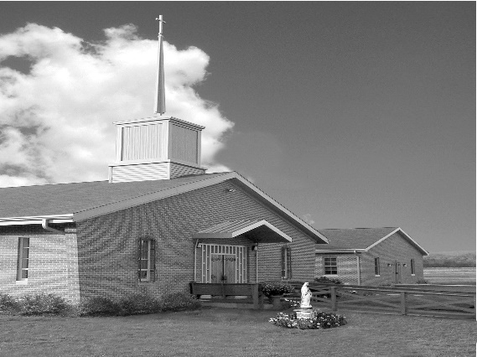
Phone: Phone: (570) 925-6969
E-mail: ctk@epix.net
Website: ctkbenton.weebly.com
Pastor: Rev. Richard J. Mowery
(570) 784-0801
Administrator: Rev. Olusola Adewole, O.P.
(570) 784-3123,
FrOAdewole@hbgdiocese.org
CYE Coordinator: Betty Hnylanski
(570) 594-3687, bhnylan@gmail.com
Secretary: Lee Ann Boiwka
(570) 864-3090, boiwka@epix.net
Office Hours: Monday & Thursday, 8am -12pm

June 19, 2022 – Corpus Christi

Message from Father –

Serving as your priest these past three years has been an honor. We faced the ups and downs of the different challenging situations of our time together, guided and strengthened by Christ. I leave with tons of delightful memories. A special thank you to all of you for bearing robust witness to our common faith, persevering through good and bad times by being there for one another, and steadily supporting our faith community. May God, in His infinite wisdom and kindness, continue to hold you in the palm of His hands until we see again. Blessings!

Fr. 'Sola,op

Daily Mass schedule for this week –

Monday, June 20th, No Mass
Thursday, June 23, Mass at 9:00 a.m.
Friday, June 24, Feast of the Most Sacred Heart of Jesus, Mass at 6:00 p.m. (Adoration & Litany
of the Sacred Heart to follow)

In your prayers, please remember: Intentions of the Holy Father, all Priests including Msgr. Lawrence, Fr. Mowery and Fr. Sola, Josephine Folayemi Adewole, Maureen Beck, Lorena Bennet, Butch Bogart, Christina Capriola, Russell Castrogiovanni, Cobert Family, Edward Connell, Alan & Jen Culp, Michael Farrell, Michael Fontinell, Deb & Paul Haden, Ray Hunsinger, Vivian Whitenight Hynick, Carl Kalie, Margaret Kalie, Dick Kocher, Joseph LaBonte, Mary Ann Levan, James Mazonkey, Bernie Nichols, Nancy Oman, Helen Raski, Sabo Family, Joan Sansouci, Pat Scardigli, Jackie Scherer, Pat Treier’s daughter Christy, Sally Tucker, Max Whitenight, Nancy Wisbar, Sonny Womelsdorf, and all the Parishioners of CTK.

Stewardship: June 12, 2022

Offerings $1224.00
Mission Coop $1103.00
Pentecost $30.00
Project Fund $55.00
St. Nick $45.00

Total $2457.00

Mass Intentions
Saturday, June 18 – Anne Lindner by Richard & Tamara Lindner
Sunday, June 19 – Betty Hnylanski by Justa Sabo
Father Sola by CTK Family
Monday, June 20 – NO MASS
Thursday, June 23 – Gary Ormont by Justa Sabo, Edith Barton by Lee Ann & Joe Boiwka
Friday, June 24 – People of the Parish
Saturday, June 25 – Kathy & Rich Walker by Mary Ellen Neal
Sunday, June 26 – Delores Strazdus by David Strazdus

Mass intentions are available in memory of, or in honor of a loved one. The donation for having a Mass said for a personal request is $10.00. You can drop your request in the collection or contact the parish office.
Lector Schedule Extraordinary Minister
June 19 – Meg Geffken Judith Scavone
June 26 – Mary Ann Zeveney Patricia Sullivan

Save the Date – Sunday, June 19th is Father Sola’s last day at Christ the King. We will celebrate after the 9:00 a.m. Mass with a Father’s Day Breakfast. All are invited to attend and wish him well.

Benton Food Bank - For the month of June we will be collecting canned soup. Thank you for your generosity! The Food Bank at the N4C’s is the 3rd Tuesday of every month. Anyone in need is encouraged to come between 9:00 a.m. -11:00 a.m.

Vacation Bible School at St. Columba - July 11 to July 15. It will be held from 9:00 a.m. to 12:00 p.m. Hope to see you all there! This year's theme "Monumental - Celebrating God's Greatness" for K through grade 6, and we are accepting 7th and 8th grade volunteers...and of course adults! $20/child preregistered $25/walk-in. Go to this link to register: //vbspro.events/p/www-saintcolumbachurch-org

Benton Council of Churches – June 20th Monday – June 23rd Thursday, Vacation Bible School from 4 p.m. – 6 p.m. at the Benton United Methodist Church, 350 Main Street, Benton. Looking for Adult Volunteers to help at VBS. Questions – Contact Pastor Tyler Rauhauser at 859-230-4456.

Unborn Candle Donations $3.00/ week, $5.00/ 2 weeks or $10.00/ month.
Month of June – Mark & Patricia Sullivan

Bloomsburg Fair, September 24 – October 1 – Looking for volunteers specifically someone to be in charge of the haluski making. Please sign the sheet on the back counter.
Quo Vadis Days: Calling all young Catholic men – are you wondering what God’s plan is for your life? Do you need guidance in your discernment? Join us for Quo Vadis Days for a time of recreation, fellowship, prayer and guidance as you explore God’s call for your life. Mass, Adoration of the Blessed Sacrament, recreation and sports, discernment talks and great food are all included in this weeklong camp. Quo Vadis Days is for men ages 15-25 and will be June 26 - 30 at Mount Saint Mary's University and Seminary. Cost is $100 per person. Register by June 17 to attend. Details and registration can be found at https:// www.hbgdiocese.org/event/quo-vadis-days/. Questions? Please contact the Office of Vocations at (717) 657-4804, ext. 282 or email vocations@hbgdiocese.org. There are pamphlets at the entrance of the Church.

Fiat Days: Attention all Catholic young women ages 15-25. Our Lord Jesus Christ has a great plan and mission for you! You are invited to attend the Diocese of Harrisburg’s Annual Fiat Days vocation discernment retreat to spend time with other young women your age as you listen to the Lord’s call in your life while having fun. Activities include – Holy Mass, Eucharistic Adoration, sports, games, great food, talks and more. Fiat Days will be held July 5-8, 2022 at Saint Mary Providence Center in Elverson, PA. There is a $100 registration fee, all other expenses funded by the Diocese of Harrisburg. Registration forms can be found on our website at www.hbgdiocese.org. You may also contact the Office of Vocations at (717) 657-4804, ext. 282 or email vocations@hbgdiocese.org with questions or for a registration packet. Deadline for registration is June 21, 2022.

World Meeting of Families - The World Meeting of Families will take place June 22 – 26 in Rome. The 10th meeting of its kind, this year the event will have a virtual element, allowing families from around the world to participate. All Catholic families at Christ the King are invited to participate virtually. This year’s event, “Family Love: A Vocation and a Path to Holiness,” encourages families to connect virtually with the main event in Rome, creating a worldwide community. The World Meeting of Families will reflect on the spirituality of the family in light of the call to holiness expressed in Gaudete et Exsultate. Sign up to participate virtually by visiting https://app.romefamily2022.com/en/login-register.

Rev. Olusola Adewole, O.P (Father Sola) is being transferred to St. Catherine Sienna in Quarryville. His last day at Christ the King will be June 19th.
Rev. Andrew P. St. Hilaire (Father Andrew) will join us the week of June 20th as the new Administrator of Christ the King.

