Christ the King Catholic Church
300 Mendenhall Lane, P.O. Box 297 Benton, PA
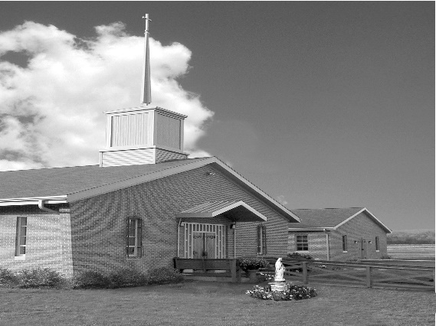
Phone: Phone: (570) 925-6969
E-mail: ctk@epix.net
Website: ctkbenton.weebly.com
Pastor: Rev. Richard J. Mowery
(570) 784-0801
Administrator: Rev. Olusola Adewole, O.P.
(570) 784-3123,
FrOAdewole@hbgdiocese.org
CYE Coordinator: Betty Hnylanski
(570) 594-3687, bhnylan@gmail.com
Secretary: Lee Ann Boiwka
(570) 864-3090, boiwka@epix.net
Office Hours: Monday & Thursday, 8am -12pm

June 12, 2022 – The Most Holy Trinity

Come, Holy Spirit!

We believe in one God, the Father, Son, and Holy Spirit. Just as Jesus assured the Apostles that the Spirit of truth would guide them, we, too, can count on the Holy Spirit to strengthen us in faith, hope, and charity.

Liturgy of the Word
The Wisdom of God declares her existence as before all things, of being brought forth before the beginning of time, delighting in all of creation and the human race. Paul assures the Romans that their faith will sustain them even in the face of afflictions, saying hope does not disappoint. In the Gospel, Jesus promises the disciples that the Holy Spirit will guide them to all truth.

In your prayers, please remember: Intentions of the Holy Father, all Priests including Msgr. Lawrence, Fr. Mowery and Fr. Sola, Josephine Folayemi Adewole, Maureen Beck, Lorena Bennet, Butch Bogart, Christina Capriola, Russell Castrogiovanni, Cobert Family, Edward Connell, Alan & Jen Culp, Michael Farrell, Michael Fontinell, Deb & Paul Haden, Ray Hunsinger, Vivian Whitenight Hynick, Carl Kalie, Margaret Kalie, Dick Kocher, Joseph LaBonte, Mary Ann Levan, James Mazonkey, Bernie Nichols, Nancy Oman, Helen Raski, Sabo Family, Joan Sansouci, Pat Scardigli, Jackie Scherer, Pat Treier’s daughter Christy, Sally Tucker, Max Whitenight, Nancy Wisbar, Sonny Womelsdorf, and all the Parishioners of CTK.

Stewardship: June 5, 2022

Offerings $2408.00
Ascension $30.00
Pentecost $682.00
Project Fund $50.00
St. Nick $236.00
Votives $51.00

Total $3457.00

Mass Intentions
Saturday, June 11 – Nicholas Sabo by Justa Sabo
Sunday, June 12 – Leona Chikotas & Bertha Heffner by Chikotas Family
Monday, June 13 – Joseph Rosencrans by John & Mary Everett
John Landis by Gloria Galer Hess
Thursday, June 16 – Anne Eustice by Renee Hansen
Saturday, June 18 – Anne Lindner by Richard & Tamara Lindner
Sunday, June 19 – Betty Hnylanski by Justa Sabo
Father Sola by CTK Family

Mass intentions are available in memory of, or in honor of a loved one. The donation for having a Mass said for a personal request is $10.00. You can drop your request in the collection or contact the parish office.

Lector Schedule Extraordinary Minister
June 12 - Barb Treier P.J. Haden
June 19 – Meg Geffken Judith Scavone

Save the Date – Sunday, June 19th is Father Sola’s last day at Christ the King. We will celebrate after the 9:00 a.m. Mass with a Father’s Day Breakfast. All are invited to attend and wish him well.

Benton Food Bank - For the month of June we will be collecting canned soup. Thank you for your generosity! The Food Bank at the N4C’s is the 3rd Tuesday of every month. Anyone in need is encouraged to come between 9:00 a.m. -11:00 a.m.

Vacation Bible School at St. Columba - July 11 to July 15. It will be held from 9:00 a.m. to 12:00 p.m. Hope to see you all there! This year's theme "Monumental - Celebrating God's Greatness" for K through grade 6, and we are accepting 7th and 8th grade volunteers...and of course adults! $20/child preregistered $25/walk-in. Go to this link to register: //vbspro.events/p/www-saintcolumbachurch-org

Benton Council of Churches – Save the Dates

June 15 at 5:45 p.m. - Vesper Services opening night of the Benton Carnival.

June 20th Monday – June 23rd Thursday, Vacation Bible School from 4 p.m. – 6 p.m. at the Benton United Methodist Church, 350 Main Street, Benton. Looking for Adult Volunteers to help at VBS. Questions – Contact Pastor Tyler Rauhauser at 859-230-4456.

Unborn Candle Donations $3.00/ week, $5.00/ 2 weeks or $10.00/ month.
Month of June – Mark & Patricia Sullivan
Quo Vadis Days: Calling all young Catholic men – are you wondering what God’s plan is for your life? Do you need guidance in your discernment? Join us for Quo Vadis Days for a time of recreation, fellowship, prayer and guidance as you explore God’s call for your life. Mass, Adoration of the Blessed Sacrament, recreation and sports, discernment talks and great food are all included in this weeklong camp. Quo Vadis Days is for men ages 15-25 and will be June 26 - 30 at Mount Saint Mary's University and Seminary. Cost is $100 per person. Register by June 17 to attend. Details and registration can be found at https:// www.hbgdiocese.org/event/quo-vadis-days/. Questions? Please contact the Office of Vocations at (717) 657-4804, ext. 282 or email vocations@hbgdiocese.org. There are pamphlets at the entrance of the Church.

2022 Diocesan Annual Campaign as of June 1

Parish Goal for 2022: $9,442.53
Total Paid: $12,582.00
Outstanding Pledges: $350.00
Total Committed: $12,932.00
Over goal in cash: $3,139.47

Number of Donors: 34
Registered Households: 119
Percentage of Participation: 28.57%

Combined Parish Council /Finance Committee Meeting – Tuesday, June 14th at 6:00 p.m.
in the Social Hall.

Rev. Olusola Adewole, O.P (Father Sola) is being transferred to St. Catherine Sienna in Quarryville. His last day at Christ the King will be June 19th.
Rev. Andrew P. St. Hilaire (Father Andrew) will join us the week of June 20th as the new Administrator of Christ the King.

