Christ the King Catholic Church
300 Mendenhall Lane, P.O. Box 297 Benton, PA
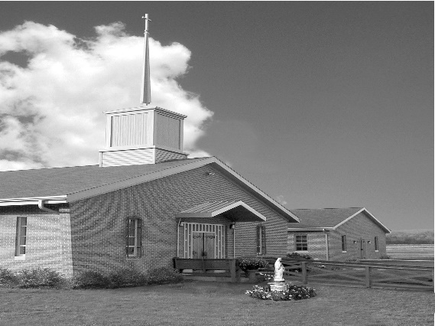
Phone: Phone: (570) 925-6969
E-mail: ctk@epix.net
Website: ctkbenton.weebly.com
Pastor: Rev. Richard J. Mowery
(570) 784-0801
Administrator: Fr. Andrew P. St. Hilaire
(570) 784-3123 (717) 884-9523
frasthilaire@hbgdiocese.org
CYE Coordinator: Betty Hnylanski
(570) 594-3687, bhnylan@gmail.com
Secretary: Lee Ann Boiwka
(570) 864-3090, boiwka@epix.net
Office Hours: Monday & Thursday, 8am -12pm

July 3, 2022 – 14th Sunday in Ordinary Time

“Our encounter with Christ transforms us for the sake of the world.”

The Gospel tells of Jesus sending out the first disciples with a mission of healing and peace – a task that now belongs to the baptized. As we gather today in worship, may our encounter with Christ change our hearts and strengthen us to be instruments of peace and mercy in our world.

Liturgy of the Word
Isaiah prophesies the wealth and prosperity that Jerusalem will once again have. In the second reading, Paul states that he has nothing to boast about except the cross of Christ. In the Gospel, Jesus sends out the disciples in his name with a mission of healing and Good News.

The office will be closed on Monday, July 4th, in observance of the holiday. However, there will be daily Mass Monday, July 4th, at 9:00 a.m. No daily Mass on Thursday, July 7th. There will be Mass on Friday, July 8th, at 7:00 p.m.

In your prayers, please remember: Intentions of the Holy Father, all Priests including Msgr. Lawrence, Fr. Mowery, Fr. St. Hilaire and Fr. Sola, Josephine Folayemi Adewole, Michael Bardi, Maureen Beck, Lorena Bennet, Butch Bogart, Christina Capriola, Russell Castrogiovanni, Cobert Family, Edward Connell, Alan & Jen Culp, Michael Farrell, Michael Fontinell, Deb & Paul Haden, Ray Hunsinger, Vivian Whitenight Hynick, Carl Kalie, Margaret Kalie, Joseph LaBonte, Mary Ann Levan, James Mazonkey, Bernie Nichols, Nancy Oman, Helen Raski, Sabo Family, Joan Sansouci, Pat Scardigli, Jackie Scherer, Pat Treier’s daughter Christy, Sally Tucker, Max Whitenight, Nancy Wisbar, Sonny Womelsdorf, and all the Parishioners of CTK.

Stewardship: June 26, 2022

Offerings $1595.00
Catholic Communication $45.00
Project Fund $35.00

Total $1675.00

Mass Intentions
Saturday, July 2 – John B. Eustice by Anne Eustice
Sunday, July 3 – Bertha Heffner & Leona Chikotas by Chikotas Family
Monday, July 4 – Gary Ormont by Justa Sabo
Thursday, July 7 – No Mass
Friday, July 8 – Anna Mae Hanlon by Pat Mazonkey
Saturday, July 9 – Willard Parsons by Meg Geffken
Sunday, July 10 – Nicholas Sabo by Justa Sabo

Mass intentions are available in memory of, or in honor of a loved one. The donation for having a Mass said for a personal request is $10.00. You can drop your request in the collection or contact the parish office.

Lector Schedule Extraordinary Minister
July 3 – Paul Haden Meg Geffken
July 10 – Peter Yastishock Judith Scavone
Benton Food Bank - For the month of July we will be collecting toilet paper. Thank you for your generosity! The Food Bank at the N4C’s is the 3rd Tuesday of every month. Anyone in need is encouraged to come between 9:00 a.m. -11:00 a.m.

Vacation Bible School at St. Columba - July 11 to July 15. It will be held from 9:00 a.m. to 12:00 p.m. Hope to see you all there! This year's theme "Monumental - Celebrating God's Greatness" for K through grade 6, and we are accepting 7th and 8th grade volunteers...and of course adults! $20/child preregistered $25/walk-in. Go to this link to register: //vbspro.events/p/www-saintcolumbachurch-org

Unborn Candle Donations $3.00/ week, $5.00/ 2 weeks or $10.00/ month.
Month of July – Richard & Tamara Lindner

Bloomsburg Fair, September 24 – October 1 – Looking for volunteers specifically someone to be in charge of the haluski making. Please sign the sheet on the back counter.

Pierogi Making Schedule – Fridays: July 8, 15, 22, 29 and August 5, 12, 19 starting at 8:00 a.m.

Summer Festival: Sisters of Saints Cyril & Methodius will be having their Summer Festival in Danville on Saturday, July 9. The event is scheduled from 10:30 a.m. – 5:00 p.m.

Father Sola’s new address: Rev. Olusola Adewole, O.P., Saint Catherine of Sienna,
955 Robert Fulton Highway, Quarryville, PA 17566. Father’s installation as pastor of St. Catherine of Sienna is Thursday, July 7th at 5 p.m. with Bishop Gainer.

Collecting Tabs - This is just a reminder that we are still collecting soda tabs for Ronald McDonald house in Danville. By collecting the tabs you will help care for families who stay at the house each year. A clear plastic bear will be on the table just inside the church. Please put the tabs in it. Thank you for your help. Tamara Lindner.
CTK Parish Picnic – We are planning a Parish Picnic/Brunch at the Benton Park immediately following Mass on Sunday, August 14th. Please sign the sheet on the back counter of the church if you are interested and plan on attending.

The 44th Annual Men’s Retreat, sponsored by Corpus Christi Parish, will be held on the
August 5-7 weekend at the beautiful campus of Mount St. Mary’s University, Emmitsburg, MD. It is open to all men in the diocese, age 14 and older. Mark your calendar, so you’ll remember this weekend to renew your spirit and His Love in your life. Father Larry Richards, Erie, PA, will lead us this year. Reservations require a minimum $60 deposit and should be made early to ensure a room is held for you. Contact Andrew Matragrano at (570) 275-0972 or ematra@ptd.net.

Fiat Days: Attention all Catholic young women ages 15-25. Our Lord Jesus Christ has a great plan and mission for you! You are invited to attend the Diocese of Harrisburg’s Annual Fiat Days vocation discernment retreat to spend time with other young women your age as you listen to the Lord’s call in your life while having fun. Activities include – Holy Mass, Eucharistic Adoration, sports, games, great food, talks and more. Fiat Days will be held July 5-8, 2022 at Saint Mary Providence Center in Elverson, PA. There is a $100 registration fee, all other expenses funded by the Diocese of Harrisburg. Registration forms can be found on our website at www.hbgdiocese.org. You may also contact the Office of Vocations at (717) 657-4804, ext. 282 or email vocations@hbgdiocese.org with questions or for a registration packet. Deadline for registration is June 21, 2022.

Catholic Campus Ministry (CCM) Open Bite Night - It’s that time of the year again! Catholic Campus Ministry (CCM) is looking for groups (from either on campus or the local community) who would be interested in taking part in one of our most important and well-known events—Open Bite Night!

Held every Wednesday evening at the Newman House (located 4 houses down from Carver Hall) throughout the semester, Open Bite Night is open to all Bloomsburg University students. Each week a different club, organization or group of people acts as “guest chefs” for the meal. It is a wonderful opportunity for students to come together, meet new people, and have a homemade meal FOR FREE! If you are interested, please see Father Andrew or call Gabriella Zimmerman 570-784-3123.

