Christ the King Catholic Church
300 Mendenhall Lane, P.O. Box 297 Benton, PA
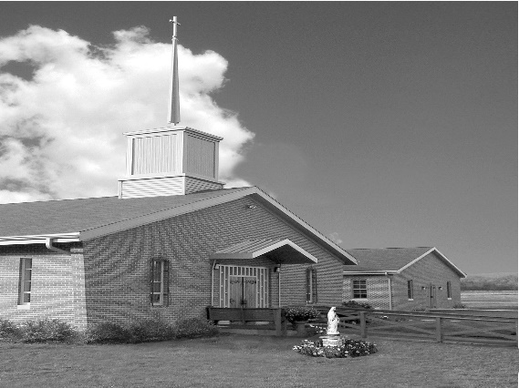
Phone: Phone: (570) 925-6969
E-mail: ctk@epix.net
Website: ctkbenton.weebly.com
Pastor: Rev. Richard J. Mowery
(570) 784-0801
Administrator: Fr. Andrew P. St. Hilaire
(570) 784-3123 (717) 884-9523
frasthilaire@hbgdiocese.org
CYE Coordinator: Betty Hnylanski
(570) 594-3687, bhnylan@gmail.com
Secretary: Lee Ann Boiwka
(570) 864-3090, boiwka@epix.net
Office Hours: Monday & Thursday, 8am -12pm

August 7, 2022 – 19th Sunday in Ordinary Time

“At an hour you do not expect, the Son of Man will come.”

Both the creed we profess and today's Gospel leave no doubt: When we die, we will have to account for every moment of our lives. What did we do with the gifts we were given? What did we fail to do? Will our lives reflect what Saint John Paul II called the civilization of love or the culture of death?

Liturgy of the Word
The first reading recalls the faith and courage of the people on the night of the Passover. The author of Hebrews writes, faith is the realization of what is hoped for and evidence of things not seen. In the Gospel, Jesus encourages the disciples to remain vigilant and be prepared for the return of the Son of Man.

**Daily Mass Times – Monday at 9:00 a.m. and Friday at 6:00 p.m. There will
no longer be a Thursday Morning 9:00 a.m. Mass.**
In your prayers, please remember: Intentions of the Holy Father, all Priests including Msgr. Lawrence, Fr. Mowery, Fr. St. Hilaire and Fr. Sola, Josephine Folayemi Adewole, Michael Bardi, Maureen Beck, Lorena Bennet, Butch Bogart, Christina Capriola, Russell Castrogiovanni, Cobert Family, Edward Connell, Alan & Jen Culp, Michael Farrell, Michael Fontinell, Deb & Paul Haden, Ray Hunsinger, Vivian Whitenight Hynick, Carl Kalie, Margaret Kalie, Joseph LaBonte, Mary Ann Levan, James Mazonkey, Bernie Nichols, Nancy Oman, Sabo Family, Joan Sansouci, Jackie Scherer, Diane Talanca, Pat Treier’s daughter Christy, Sally Tucker, Max Whitenight, Nancy Wisbar, Sonny Womelsdorf, and all the Parishioners of CTK.

Stewardship: July 31, 2022

Offerings $1906.00
Mission Coop $65.00
Project Fund/Rainy Day $10.00
St. Nick $50.00

Total $2031.00

Mass Intentions
Saturday, August 6 – Marilyn LaBonte by Joseph LaBonte
Sunday, August 7 – People of the Parish
Monday, August 8 – People of the Parish
Friday, August 12 – People of the Parish
Saturday, August 13 – Marie Akers by Mary Ann Zeveney
Sunday, August 14 – David Strazdus, Birthday Blessings, by Deborah Shaffer

Mass intentions are available in memory of, or in honor of a loved one. The donation for having a Mass said for a personal request is $10.00. You can drop your request in the collection or contact the parish office.

Lector Schedule Extraordinary Minister
August 7 – Peter Yastishock Judith Scavone
August 14 – Barb Treier P.J. Haden
Benton Food Bank - For the month of August we will be collecting hand soaps and paper towels. The Food Bank at the N4C’s is the 3rd Tuesday of every month. Anyone in need is encouraged to come between 9:00 a.m. -11:00 a.m. and also 4:30 p.m. – 6:30 p.m.

Unborn Candle Donations $3.00/ week, $5.00/ 2 weeks or $10.00/ month.
Month of August – Mark & Patricia Sullivan

Pierogi Making Schedule – Fridays: August 12, 19 starting at 8:00 a.m.

CYE News: CYE preparations continue over the summer months. Registrations for new students (Grades PreSchool through High School) should be submitted as soon as possible. They can be found at the Church entrance and can be placed in the offertory collection baskets at Mass or dropped off at the parish office. There is a two-year Preparation period for the sacraments of Reconciliation, Eucharist, and Confirmation. Children preparing to receive those sacraments should begin their preparations in a timely manner.
CYE needs and welcomes volunteers to help in the classrooms as teacher aides and substitutes. Diocesan clearances are required. Please contact Ms Betty or the parish office ASAP to begin the clearance process. The rewards of sharing your faith journey and learning along with the children is priceless.

CTK Parish Picnic – We are planning a Parish Picnic/Brunch at the Benton Park immediately following Mass on Sunday, September 4th. Please sign the sheet on the back counter of the church if you are interested and plan on attending.

Thank you to the Knights of Columbus – a special thank you for donating the proceeds of the Memorial Day Rummage Sale. The $827.25 will go into the Project Fund. Your generosity is truly appreciated.

A Prayer for the People of Ukraine

God of love,
Our world is wrought with war and violence
as brother turns on brother,
and the innocent awake to gunfire and bombs.
May Your compassion and healing
move hearts and bring a new day to Ukraine.
Fortify your children to resist aggression
and instead become instruments of peace.
We ask this in the name of the One
who is the Price of Peace, Jesus Christ. Amen

We need Volunteers – Margaret Kalie, one of our faithful parishioners, is currently on bed rest and then will be having surgery. During this time, we are asking parishioners to visit Bob and Peg, provide meals and/or offer respite care time. There will be a sign up sheet, or you can call Sharon Tishler at 570-956-4949 or Meg Geffken at 570-204-9031 to volunteer. Your help is most appreciated.

Trip to Medjugorje (“Heaven on Earth”): Irene Mbih, a parishioner from St. Joseph's parish in Danville, is organizing a trip to Medjugorje from September 8-15. The guide, Julie, is a cousin of Vicfka, one of the visionaries. The official website for the trip is medjugorje.org. Click on “pilgrimages” and the Sept 8th week, and there will be all the information you need on that site. The price depends upon the departure city and whether rooming alone, about $2700 excluding tips for drivers, etc. Contact minangirene@gmail.com for more info.

Matrimony: A Calling to Forgive: “Mercy is the force that reawakens us to new life and instills in us the courage to look to the future with hope.” Retrouvaille offers a welcoming and loving space to couples who have been living with the misery of a failing marriage. Retrouvaille offers hope: hope that it is not too late, hope of a different and better marriage. Retrouvaille helps couples to show each other mercy through the opportunities it provides to listen, to forgive, to be reconciled and to move into their futures believing that God loves them and with His help and their efforts, their marriages can be healed and restored. Retrouvaille provides help for marriage problems/difficulties/crises. The next Retrouvaille weekend in Harrisburg, PA is September 9 – 11. For more information about an upcoming Retrouvaille Weekend program for couples, contact the registration team @ 717.356.2185 or visit our website: HelpOurMarriage.org

