Christ the King Catholic Church
300 Mendenhall Lane, P.O. Box 297 Benton, PA
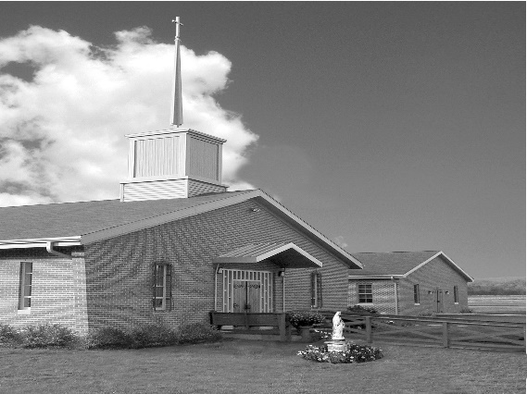
Phone: Phone: (570) 925-6969
E-mail: ctk@epix.net
Website: ctkbenton.weebly.com
Pastor: Rev. Richard J. Mowery
(570) 784-0801
Administrator: Fr. Andrew P. St. Hilaire
(570) 784-3123 (717) 884-9523
frasthilaire@hbgdiocese.org
CYE Coordinator: Betty Hnylanski
(570) 594-3687, bhnylan@gmail.com
Secretary: Lee Ann Boiwka
(570) 864-3090, boiwka@epix.net
Office Hours: Monday & Thursday, 8am -12pm

July 24, 2022 – 17th Sunday in Ordinary Time

“Knock and keep knocking; trust God’s goodness and don’t give up.”

Why does the man in Jesus’ prayer illustration keep knocking? Two reasons: He knows his friend heard him; he knows this friend has bread. Why should we pray without giving up? We know God hears our prayers and that he is able to provide for us. When we keep seeking him and knocking, we show trust in his faithfulness.

Liturgy of the Word
In the first reading, Abraham intercedes for Sodom and Gomorrah, asking the Lord to save the city if even 10 righteous people are found there. Paul writes to the Colossians and encourages them to trust the grace of baptism to take away sins and give life. In the Gospel, Jesus teaches his disciples to pray. He tells them to ask, seek, and knock.

**Daily Mass Times – Monday, July 25th, at 9:00 a.m. and Friday, July 29th, at 6:00 p.m. There will no longer be a Thursday Morning 9:00 a.m. Mass.**
In your prayers, please remember: Intentions of the Holy Father, all Priests including Msgr. Lawrence, Fr. Mowery, Fr. St. Hilaire and Fr. Sola, Josephine Folayemi Adewole, Michael Bardi, Maureen Beck, Lorena Bennet, Butch Bogart, Christina Capriola, Russell Castrogiovanni, Cobert Family, Edward Connell, Alan & Jen Culp, Michael Farrell, Michael Fontinell, Deb & Paul Haden, Ray Hunsinger, Vivian Whitenight Hynick, Carl Kalie, Margaret Kalie, Joseph LaBonte, Mary Ann Levan, James Mazonkey, Bernie Nichols, Nancy Oman, Sabo Family, Joan Sansouci, Jackie Scherer, Pat Treier’s daughter Christy, Sally Tucker, Max Whitenight, Nancy Wisbar, Sonny Womelsdorf, and all the Parishioners of CTK.

Stewardship: July 17, 2022

Offerings $1648.00
Mission Coop $50.00
Project Fund/Rainy Day $150.00

Total $1848.00

Mass Intentions
Saturday, July 23 – People of the Parish
Sunday, July 24 – Catherine & Kenneth Masters by Ann & Donald Berends
Monday, July 25 – Helen Howanitz (Health Blessings) by Micca Family
Friday, July 29 – People of the Parish
Saturday, July 30 – Jack Surfield by Anne Kingsbury
Sunday, July 31 – Nicholas Sabo by Mary Ellen Neal

Mass intentions are available in memory of, or in honor of a loved one. The donation for having a Mass said for a personal request is $10.00. You can drop your request in the collection or contact the parish office.

Lector Schedule Extraordinary Minister
July 24 – Meg Geffken Shanna Haden
July 31 – Mary Ann Zeveney Stephen Root
Benton Food Bank - For the month of July we will be collecting toilet paper. Thank you for your generosity! The Food Bank at the N4C’s is the 3rd Tuesday of every month. Anyone in need is encouraged to come between 9:00 a.m. -11:00 a.m. and also 4:30 p.m. – 6:30 p.m.

Unborn Candle Donations $3.00/ week, $5.00/ 2 weeks or $10.00/ month.
Month of July – Richard & Tamara Lindner

Pierogi Making Schedule – Fridays: July 29 and August 5, 12, 19 starting at 8:00 a.m.

CYE News: CYE preparations continue over the summer months. Registrations for new students (Grades PreSchool through High School) should be submitted as soon as possible. They can be found at the Church entrance and can be placed in the offertory collection baskets at Mass or dropped off at the parish office. There is a two-year Preparation period for the sacraments of Reconciliation, Eucharist, and Confirmation. Children preparing to receive those sacraments should begin their preparations in a timely manner.
CYE needs and welcomes volunteers to help in the classrooms as teacher aides and substitutes. Diocesan clearances are required. Please contact Ms Betty or the parish office ASAP to begin the clearance process. The rewards of sharing your faith journey and learning along with the children is priceless.

CTK Parish Picnic – We are planning a Parish Picnic/Brunch at the Benton Park immediately following Mass on Sunday, September 4th. Please sign the sheet on the back counter of the church if you are interested and plan on attending.

Adoration & Confessions – Sunday mornings we will have Adoration from 8:00 a.m. until 8:45 a.m. Father will also be offering Confessions both Saturday and Sunday in the Confessional. (It will no longer be in the CYE building). Saturday will be 4 – 4:45 p.m. and Sunday will be 8 – 8:45 a.m.
Save the Dates:

On July 24th, immediately following the 9:00 a.m. Mass, Father Andrew will offer a brief proposal of his general vision for the parish. But offering any kind of proposal is intended to receive feedback and facilitate conversation. Therefore, there will be plenty of time for parishioners to ask questions and share their thoughts.

On July 31st, immediately following the 9:00 a.m. Mass, Mark Sullivan will be giving a brief presentation on The Universal Call to Holiness: Finding Joy. Mark is in a five-year deaconate formation program with the Diocese of Harrisburg. He is just completing his first year of aspirancy. There will be time for discussion and questions.

Join us for these presentations along with coffee and donuts.

We need Volunteers – Margaret Kalie, one of our faithful parishioners, is currently on bed rest and then will be having surgery. During this time, we are asking parishioners to visit Bob and Peg, provide meals and/or offer respite care time. There will be a sign up sheet, or you can call Sharon Tishler at 570-956-4949 or Meg Geffken at 570-204-9031 to volunteer. Your help is most appreciated.

CTK Registration Forms – If you haven’t submitted one in the last six months, please be sure to fill out a new registration form. A few things that are of importance are your phone number, especially if you no longer have a landline and only a cell number, updated address and your e-mail address.
Weekly e-mails go out which give you any updates and announcements. You can drop completed forms in the collection or at the Parish Office.

44th Annual Men’s Retreat, sponsored by Corpus Christi Parish, will be held on the August 5-7 weekend at the beautiful campus of Mount St. Mary’s University, Emmitsburg, MD. It is open to all men in the diocese, age 14 and older. MARK YOUR CALENDAR NOW, so you’ll remember this weekend to renew your spirit and His Love in your life. Father Larry Richards, Erie, PA, will lead us this year. Reservations require a minimum $60 deposit and should be made early to ensure a room is held for you. Contact Andrew Matragrano at (570) 275-0972 or ematra@ptd.net.

