Christ the King Catholic Church
300 Mendenhall Lane, P.O. Box 297 Benton, PA
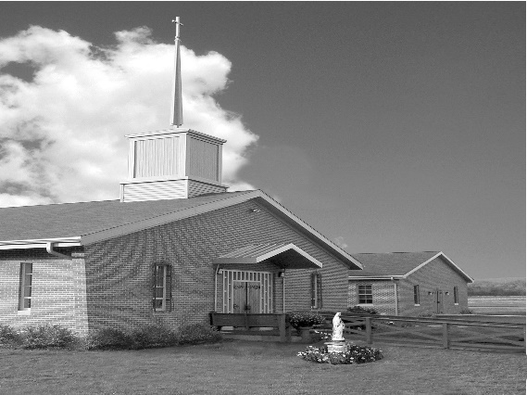
Phone: Phone: (570) 925-6969
E-mail: ctk@epix.net
Website: ctkbenton.weebly.com
Pastor: Rev. Richard J. Mowery
(570) 784-0801
Administrator: Fr. Andrew P. St. Hilaire
(570) 784-3123 (717) 884-9523
frasthilaire@hbgdiocese.org
CYE Coordinator: Betty Hnylanski
(570) 594-3687, bhnylan@gmail.com
Secretary: Lee Ann Boiwka
(570) 864-3090, boiwka@epix.net
Office Hours: Monday & Thursday, 8am -12pm

July 17, 2022 – 16th Sunday in Ordinary Time

“The Lord wants us to live unburdened, free to be close to his healing presence.”

Much of modern-day life involves the busyness of everyday tasks. The Lord asks that we simply come to him and allow ourselves to be healed and made whole, to allow him to pour his grace into our hearts and lives. This requires us to pause and to go to him in silence and stillness.

Liturgy of the Word
Abraham and Sarah provide hospitality to three men who appear nearby his tent. One of the men tells Abraham that when he comes again in a year, Sarah will have a son. Paul writes to the Colossians that he rejoices in his sufferings and joins them with the sufferings of Christ on behalf of the Church. In the Gospel, Jesus enters a village where two sisters attend to him. Martha is burdened, anxious, and worried as she tries to complete tasks; Mary sits at the Lord’s feet and listens to him. Jesus says Mary has chosen the better part.

** The parish office will be closed Monday, July 18th. It will be open Thursday, July 21st.

In your prayers, please remember: Intentions of the Holy Father, all Priests including Msgr. Lawrence, Fr. Mowery, Fr. St. Hilaire and Fr. Sola, Josephine Folayemi Adewole, Michael Bardi, Maureen Beck, Lorena Bennet, Butch Bogart, Christina Capriola, Russell Castrogiovanni, Cobert Family, Edward Connell, Alan & Jen Culp, Michael Farrell, Michael Fontinell, Deb & Paul Haden, Ray Hunsinger, Vivian Whitenight Hynick, Carl Kalie, Margaret Kalie, Joseph LaBonte, Mary Ann Levan, James Mazonkey, Bernie Nichols, Nancy Oman, Sabo Family, Joan Sansouci, Jackie Scherer, Pat Treier’s daughter Christy, Sally Tucker, Max Whitenight, Nancy Wisbar, Sonny Womelsdorf, and all the Parishioners of CTK.

Stewardship: July 10, 2022

Offerings $1768.00
Project Fund/Rainy Day $50.00
St. Nick $20.00

Total $1838.00

Mass Intentions
Saturday, July 16 - People of the Parish
Sunday, July 17 – Anne Eustice blessings by Renee Hansen
Monday, July 18 – Kim Zaludek by Micca Family
Thursday, July 21 – People of the Parish
Saturday, July 23 – People of the Parish
Sunday, July 24 – Catherine & Kenneth Masters by Ann & Donald Berends

Mass intentions are available in memory of, or in honor of a loved one. The donation for having a Mass said for a personal request is $10.00. You can drop your request in the collection or contact the parish office.

Lector Schedule Extraordinary Minister
July 17 – Anne Eustice Patricia Sullivan
July 24 – Meg Geffken Shanna Haden
Benton Food Bank - For the month of July we will be collecting toilet paper. Thank you for your generosity! The Food Bank at the N4C’s is the 3rd Tuesday of every month. Anyone in need is encouraged to come between 9:00 a.m. -11:00 a.m.

Unborn Candle Donations $3.00/ week, $5.00/ 2 weeks or $10.00/ month.
Month of July – Richard & Tamara Lindner

Pierogi Making Schedule – Fridays: July 22, 29 and August 5, 12, 19 starting at 8:00 a.m.

CYE News: CYE preparations continue over the summer months. Registrations for new students (Grades PreSchool through High School) should be submitted as soon as possible. They can be found at the Church entrance and can be placed in the offertory collection baskets at Mass or dropped off at the parish office. There is a two-year Preparation period for the sacraments of Reconciliation, Eucharist, and Confirmation. Children preparing to receive those sacraments should begin their preparations in a timely manner.
CYE needs and welcomes volunteers to help in the classrooms as teacher aides and substitutes. Diocesan clearances are required. Please contact Ms Betty or the parish office ASAP to begin the clearance process. The rewards of sharing your faith journey and learning along with the children is priceless.

CTK Parish Picnic – We are planning a Parish Picnic/Brunch at the Benton Park immediately following Mass on Sunday, September 4th. Please sign the sheet on the back counter of the church if you are interested and plan on attending.

Adoration & Confessions – Sunday mornings we will have Adoration from 8:00 a.m. until 8:45 a.m. Father will also be offering Confessions both Saturday and Sunday in the Confessional. (It will no longer be in the CYE building). Saturday will be 4 – 4:45 p.m. and Sunday will be 8 – 8:45 a.m.
Catholic Campus Ministry (CCM) Open Bite Night - It’s that time of the year again! Catholic Campus Ministry (CCM) is looking for groups (from either on campus or the local community) who would be interested in taking part in one of our most important and well-known events—Open Bite Night!

Held every Wednesday evening at the Newman House (located 4 houses down from Carver Hall) throughout the semester, Open Bite Night is open to all Bloomsburg University students. Each week a different club, organization or group of people acts as “guest chefs” for the meal. It is a wonderful opportunity for students to come together, meet new people, and have a homemade meal FOR FREE! If you are interested, please see Father Andrew or call Gabriella Zimmerman 570-784-3123.

Save the Dates:
On July 17th and 31st, immediately following the 9:00 a.m. Mass, Mark Sullivan will be giving brief presentations on Prayer: A Conversion with God and The Universal Call to Holiness: Finding Joy. Mark is in a five-year deaconate formation program with the Diocese of Harrisburg. He is just completing his first year of aspirancy. There will be time for discussion and questions.

On July 24th, immediately following the 9:00 a.m. Mass, Father Andrew will offer a brief proposal of his general vision for the parish. But offering any kind of proposal is intended to receive feedback and facilitate conversation. Therefore, there will be plenty of time for parishioners to ask questions and share their thoughts.

Join us for these presentations along with coffee and donuts.

Weeding & Trimming the Church Grounds – Looking for Volunteers to keep our Church grounds looking nice. If you have any extra time, feel free to do weeding and/or trimming around the Church.

CTK Registration Forms – If you haven’t submitted one in the last six months, please be sure to fill out a new registration form. A few things that are of importance are your phone number, especially if you no longer have a landline and only a cell number, updated address and your e-mail address.
Weekly e-mails go out which give you any updates and announcements. You can drop completed forms in the collection or at the Parish Office.

