Christ the King Catholic Church
300 Mendenhall Lane, P.O. Box 297 Benton, PA
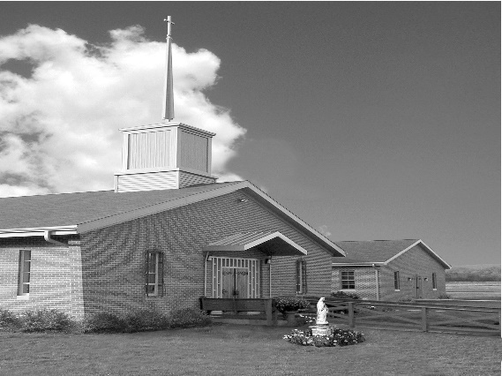
Phone: Phone: (570) 925-6969
E-mail: ctk@epix.net
Website: ctkbenton.weebly.com
Pastor: Rev. Richard J. Mowery
(570) 784-0801
Administrator: Rev. Olusola Adewole, O.P.
(570) 784-3123,
FrOAdewole@hbgdiocese.org
CYE Coordinator: Betty Hnylanski
(570) 594-3687, bhnylan@gmail.com
Secretary: Lee Ann Boiwka
(570) 864-3090, boiwka@epix.net
Office Hours: Monday & Thursday, 8am -12pm

January 9, 2022 – Baptism of the Lord

“The grace of God has appeared, saving all.”

All grace we receive – actual and sanctifying – comes through God’s kindness, generous love, and mercy. Nothing we do merits this gift, or the salvation it provides. Through the sacraments, first among them baptism, we are infused with the Holy Spirit and made heirs in hope of eternal life.

Liturgy of the Word
In the first reading, Isaiah speaks the Lord’s words for Jerusalem to take comfort because their service is at an end. In the second reading, Paul writes that [Christ] saved us through the bath of rebirth and renewal by the Holy Spirit. In the Gospel, after Jesus is baptized, the Spirit descends upon him, and a voice speaks from heaven.

In your prayers, please remember: Intentions of the Holy Father, all Priests including Msgr. Lawrence, Fr. Mowery and Fr. Sola, Josephine Folayemi Adewole, Lorena Bennet,
Butch Bogart, Christina Capriola, Russell Castrogiovanni, Cobert Family, Michael Fontinell, Deb Haden, Ray Hunsinger, Vivian Whitenight Hynick, Margaret Kalie, Dick Kocher, Mary Ann Levan, James Mazonkey, Nora & Terry McDaniels, Bernie Nichols, Joan Pauley, Helen Raski, Sabo Family, Joan Sansouci, Pat Scardigli, Jackie Scherer, Dot Shelmet, Pat Treier’s daughter Christy, Max Whitenight, Sonny Womelsdorf, Stan Zalot, and all the Parishioners of CTK.

Stewardship: January 2, 2022
Offerings $1168.00
Christmas $45.00
Rainy Day/Project Fund $20.00
Solemnity of Mary $315.00
St. Nicholas Fund $13.00

Total $1561.00

Mass Intentions
Saturday, January 8 – People of the Parish
Sunday, January 9 –Tom Tishler by Sharon Tishler
Monday, January 10 – Sonja Patterson by Steve & Sue Root
Thursday, January 13 – Joseph Tapsak by Sharon Tishler
Saturday, January 15 – Nicholas Sabo by Justa Sabo
Sunday, January 16 –Children & Catechists of the CYE Program by Betty Hnylanski

Mass intentions are available in memory of, or in honor of a loved one. The donation for having a Mass said for a personal request is $10.00. You can drop your request in the collection or contact the parish office.

Lector Schedule Extraordinary Minister
January 9 – Anne Eustice Stephen Root
January 16 – Peter Yastishock Shanna Haden

From Benton Head Start – “We want to express our gratitude for the kindness of gifts your Parish provided to our families. There has been added Joy for the Holidays due to your generosity.

New Parishioners in 2021 – A very special and warm welcome to our new parishioners/families who have joined Christ the King this past year:

Kathleen Judge
Mr. & Mrs. Michael (Amanda) McHenry and family
Deacon and Mrs. Earl (Denise) Roberts
Mr. & Mrs. Gaelan (Hope) Sheehan and family

CYE News: CYE classes resume on Sunday, January 9 for students in grades 1 through 11 beginning with 9:00 am Mass and concluding at 11:30 with dismissal from the education building.
Decision Point class for students in grades 8-11 also resumes on Sunday January 9 from 11:30-2:15. Lunch will be provided. We look forward to seeing everyone.

Benton Food Bank - For the month of January we will be collecting canned goods. Thank you for your generosity! The Food Bank at the N4C’s is the 3rd Tuesday of every month. Anyone in need is encouraged to come between 9:00 a.m. -11:00 a.m.

Just a reminder – Please do not drop off books, prayer cards, DVDs/CD’s, etc. without bringing them to the Office on Monday or Thursday mornings, or giving them to Father to approve. Your cooperation is appreciated!
Unborn Candle Donations $3.00/ week, $5.00/ 2 weeks or $10.00/ month.
Month of January – Marie & Russell Castrogiovanni

Are you willing to let go of your Marriage? Many couples continue to struggle in a marriage but are not willing to give up on each other. There is hope. Retrouvaille is a program designed to help struggling marriages regain their health. It helps a husband and a wife rediscover or re-awaken the love, trust and commitment that originally brought them together. For more information about the January 28-30, 2022 weekend for couples, contact the registration team at retrouvaillehbg@gmail.com. or 717- 356-2185.

March for Life: There will be a bus going to the MARCH FOR LIFE on Friday, January 2Ist! Come to DC to experience the largest annual rally and march in the world! The bus, leaving from St Joseph's in Danville is sponsored by their Knights of Columbus and will only cost $5 per person! More details to come. Call St. Joe's (570-275-2512) to get on the list or Rhonda (570-784-7616) for questions.

Catholic Counseling options are nearby: Heart of Mercy Counseling Ministry (Sisters of the Good Shepherd), in the Danville area now has two licensed therapists available to serve adults: individual, couples, and families. Fee based on sliding scale. Please contact either one of them to schedule an appointment if you are seeking counseling based in Catholic teachings: Sr. Patricia Marie Barnette, Licensed Professional Counselor, 352 -328-8145 OR: Sr. Mary Frances Altavilla, Licensed Clinical Social Worker, 410-245-0870.

Pray for Priest: let us remember to pray regularly for all Priests and Bishops, for their holiness and fortitude, as well as for the specific Priests we know. Let us also continue to pray that God will raise up many more good and faithful Priests who will answer His call.

