Christ the King Catholic Church
300 Mendenhall Lane, P.O. Box 297 Benton, PA
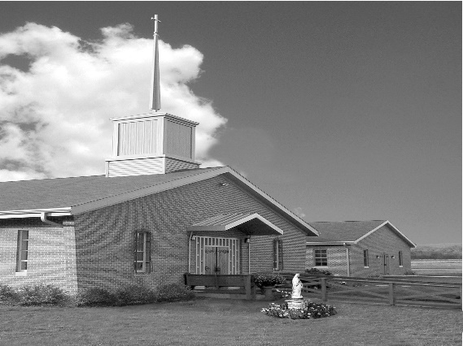
Phone: Phone: (570) 925-6969
E-mail: ctk@epix.net
Website: ctkbenton.weebly.com
Pastor: Rev. Richard J. Mowery
(570) 784-0801
Administrator: Rev. Olusola Adewole, O.P.
(570) 784-3123,
FrOAdewole@hbgdiocese.org
CYE Coordinator: Betty Hnylanski
(570) 594-3687, bhnylan@gmail.com
Secretary: Lee Ann Boiwka
(570) 864-3090, boiwka@epix.net
Office Hours: Monday & Thursday, 8am -12pm

January 30, 2022 – Fourth Sunday in Ordinary Time

“Take to heart the Good News.”

As Jesus spoke to the crowd in the synagogue, he speaks to us here: Today this Scripture passage is fulfilled in your hearing. Our response ought to be different, however, than those who ran him out of town. Through the Holy Spirit, the word of God is able to penetrate our hearts and transform us into missionary disciples of God’s love.

Liturgy of the Word
Jeremiah recounts how God appointed him to be a prophet and warned him that he would face adversity. Paul encourages the Corinthians in striving for spiritual gifts, the greatest of which is love. In the Gospel, Jesus, while in Nazareth, is acclaimed for his preaching. However, the crowd quickly turns against him.

Change in Mass Time – The Saturday evening Mass will be at 4:00 p.m. instead
of 5:00 p.m. for the winter months. Confession will begin at 3:15.

In your prayers, please remember: Intentions of the Holy Father, all Priests including Msgr. Lawrence, Fr. Mowery and Fr. Sola, Josephine Folayemi Adewole, Lorena Bennet,
Butch Bogart, Christina Capriola, Russell Castrogiovanni, Cobert Family, Michael Fontinell, Shiela Gilbert, Deb Haden, Ray Hunsinger, Vivian Whitenight Hynick, Margaret Kalie, Dick Kocher, Mary Ann Levan, James Mazonkey, Nora & Terry McDaniels, Bernie Nichols, Joan Pauley, Helen Raski, Sabo Family, Joan Sansouci, Pat Scardigli, Jackie Scherer, Dot Shelmet, Pat Treier’s daughter Christy, Sally Tucker, Max Whitenight, Sonny Womelsdorf, Stan Zalot, and all the Parishioners of CTK.

Stewardship: January 23, 2022
Offerings $1723.00
Latin America/Africa $15.00
Rainy Day/Project Fund $70.00
St. Nicholas Fund $70.00

Total $1878.00

Mass Intentions

Saturday, January 29 – Kim Todd by the Womelsdorf Family
Sunday, January 30 – David Williams by Don & Mary Wilce
Monday, January 31 – Sonja Patterson by Anne Eustice
Thursday, February 3 – Nancy Wisbar by Lee Ann Boiwka
Friday, February 4 – Frank Merk by Sharon Tishler
Saturday, February 5 – Mary Ellen Depietro by Madeline Depietro
Sunday, February 6 – Joseph Tapsak by Marie & Russ Castrogiovannia

Mass intentions are available in memory of, or in honor of a loved one. The donation for having a Mass said for a personal request is $10.00. You can drop your request in the collection or contact the parish office.

Lector Schedule Extraordinary Minister
January 30 – Meg Geffken Paul J. Haden
February 6 – Steven Root Meg Geffken
Just a reminder – Please do not drop off books, prayer cards, DVDs/CD’s, etc. without bringing them to the Office on Monday or Thursday mornings, or giving them to Father to approve. Your cooperation is appreciated!

Blessing of Throats: February 3 is the feast of St. Blaise, the day on which we traditionally bless throats. The story is that St. Blaise miraculously cured a little boy who nearly died because of a fishbone in his throat. We pray that God will protect us through his prayer. “Through the intercession of Saint Blaise, bishop and martyr, may God deliver you from every disease of the throat and from every other illness.” Blessing of the Throats will take place Thursday, February 3rd, at the 9:00 a.m. Mass.

February 2, Wednesday – Please celebrate with Us – Candlemas & the Feast of the Flame of Love of the Immaculate Heart of Mary. St. Joseph Church, 68 Center Street, Danville, PA

The Feast of the Presentation (Candlemas Day) commemorates the presentation of Jesus in the Temple, forty days after his birth. Simeon, inspired by the Holy Spirit, takes the Child Jesus in his arms and declares him as a light of revelation to all nations. (Luke 2: 22-38)
6:30 Blessing of the Candles - Father Timothy Marcoe
6:35 Holy Mass
7:25 Reflection – Setting Hearts Ablaze with Mary’s Flame of Love
7:30 Flame of Love Rosary
8:15 Passing the Flame

Benton Food Bank - For the month of February we will be collecting tissues. Thank you for your generosity! The Food Bank at the N4C’s is the 3rd Tuesday of every month. Anyone in need is encouraged to come between 9:00 a.m. -11:00 a.m.

Frost Bite Festival – February 19, 2022, 12 p.m. – 5 p.m. at Our Lady of Mercy Catholic Church, 304 Slabtown Road, Catawissa, PA. Pre orders highly suggested by February 6, 2022 by calling 570-336-4771. Menu is Pierogies, Potato Cakes, Beef BBQ, Soups, Hot Dogs Baked Goods and Raffles.

Unborn Candle Donations $3.00/ week, $5.00/ 2 weeks or $10.00/ month.
Month of February – Judy Womelsdorf

2022 Annual Black Catholic Apostolate Mass: His Eminence, Cardinal Wilton D. Gregory, Archbishop of Washington, will serve as Principal Celebrant of the Diocese of Harrisburg's Annual Black Catholic Apostolate Mass. The Mass will be Sunday, February 13, at 12 noon at St. Catherine Laboure Parish, 4000 Derry Street, Harrisburg, PA. All are invited to attend.

Society of the Propagation of the Faith Membership Sunday – February 6th.
On the first Sunday in February, parishioners throughout our diocese are invited to make a special commitment to the worldwide mission of Jesus, through the Society for the Propagation of the Faith. At Baptism, we are called to be a missionary, to share our faith and pass on the Good News of Jesus among the mission poor. Through the Propagation of the Faith, we can reach out to the peoples of the world by providing prayers and financial assistance to missionary priests, religious Sisters and Brothers, and lay catechists.
Membership envelopes are included in your February collections envelope packet. Thank you for your generosity!

