Christ the King Catholic Church
300 Mendenhall Lane, P.O. Box 297 Benton, PA
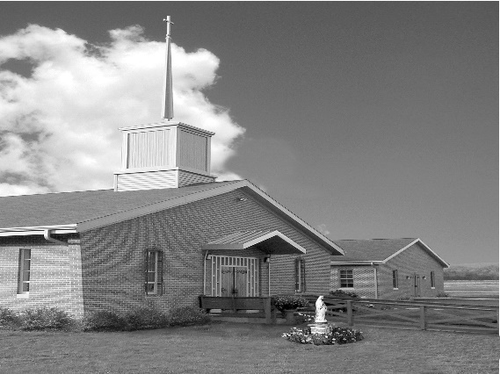
Phone: Phone: (570) 925-6969
E-mail: ctk@epix.net
Website: ctkbenton.weebly.com
Pastor: Rev. Richard J. Mowery
(570) 784-0801
Administrator: Rev. Olusola Adewole, O.P.
(570) 784-3123,
FrOAdewole@hbgdiocese.org
CYE Coordinator: Betty Hnylanski
(570) 594-3687, bhnylan@gmail.com
Secretary: Lee Ann Boiwka
(570) 864-3090, boiwka@epix.net
Office Hours: Monday & Thursday, 8am -12pm

January 2, 2022 – Epiphany of the Lord

At the threshold of a new year, we keep our experiences of the outgoing year in our hearts. Our difficulties and challenges might remain, but we have every reason to be joyful and hopeful for the newborn King, Jesus Christ our Lord, is the basis of our joy and hope. The Holy Father, Pope Francis, says that as we celebrate Christmas and a new year beckons, we learn from St. Joseph to cultivate spaces of silence in which another Word can emerge: that of the Holy Spirit who dwells in us. May the Lord bless you and keep you. May the Lord make his face shine upon you and be gracious to you. May the Lord lift his countenance upon you and give you peace. WISHING YOU A VERY HAPPY AND PROSPEROUS NEW YEAR!

Fr. Olusola Adewole, O.P.

**January 9th – Second collection to support the Church in Central & Eastern Europe.

We will be taking the Christmas decorations down after Mass,
please plan on staying to help!
In your prayers, please remember: Intentions of the Holy Father, all Priests including Msgr. Lawrence, Fr. Mowery and Fr. Sola, Josephine Folayemi Adewole, Lorena Bennet,
Butch Bogart, Christina Capriola, Russell Castrogiovanni, Cobert Family, Michael Fontinell, Deb Haden, Ray Hunsinger, Vivian Whitenight Hynick, Margaret Kalie, Dick Kocher, Mary Ann Levan, James Mazonkey, Nora & Terry McDaniels, Bernie Nichols, Joan Pauley, Helen Raski, Sabo Family, Joan Sansouci, Pat Scardigli, Jackie Scherer, Dot Shelmet, Douglas Talanca, Pat Treier’s daughter Christy, Max Whitenight, Sonny Womelsdorf, Stan Zalot, and all the Parishioners of CTK.

Stewardship: December 26, 2021
Offerings $1733.00
Christmas $1913.00
Mission Coop $25.00
Oplataka $20.00
Rainy Day $35.00
St. Nicholas Fund $30.00

Total $3756.00

Mass Intentions
Saturday, January 1 – Sophie Pointon by Kathy & Rich Walker
Sunday, January 2 – Jack Eustice by Ann Eustice
Monday, January 3 – Father Sola and Family by Joe & Lee Ann Boiwka
Thursday, January 6 – No Mass
Friday, January 7 – Joseph Tapsak by Steve & Sue Root
Saturday, January 8 – People of the Parish
Sunday, January 9 –Tom Tishler by Sharon Tishler

Mass intentions are available in memory of, or in honor of a loved one. The donation for having a Mass said for a personal request is $10.00. You can drop your request in the collection or contact the parish office.

Lector Schedule Extraordinary Minister
January 2 – Paul Haden Meg Geffken
January 9 – Anne Eustice Stephen Root

Epiphany Blessing: It is traditional to ask God’s blessing on our homes. We have printed cards for this blessing that you are encouraged to place above the main doors of your homes. These cards have been placed on the table at the entrance to the church. The coming year, 2022, the initials, C. M. B. are marked above the main doorway. There are two explanations for the initials: Christus Mansionen Benedicat. These three Latin words mean: “May Christ bless this home.” They are also the first initials of the legendary Magi: Casper, Melchior, and Balthazar. While placing this blessing above the doorway of your home, pray: “May all who come to our home this year rejoice to find Christ living among us; and may we seek and serve Christ in everyone we meet. Amen.”

Thank You – A very special “Thank You” to Rick Kingsbury for donating the Poinsettias on the Altar for Christmas and to Anne Kingsbury who so graciously delivers them to CTK each year.

New Parishioners in 2021 – A very special and warm welcome to our new parishioners/families who have joined Christ the King this past year:

Kathleen Judge
Mr. & Mrs. Michael (Amanda) McHenry and family
Deacon and Mrs. Earl (Denise) Roberts
Mr. & Mrs. Gaelan (Hope) Sheehan and family

CYE News: Many blessings to all this Christmas season. CYE classes resume on Sunday, January 9 for students in grades 1 through 11 beginning with 9:00 am Mass and concluding at 11:30 with dismissal from the education building.
Decision Point class for students in grades 8-11 also resumes on Sunday January 9 from 11:30-2:15. Lunch will be provided. We look forward to seeing everyone.

Unborn Candle Donations $3.00/ week, $5.00/ 2 weeks or $10.00/ month.
Month of January – Marie & Russell Castrogiovanni
Benton Food Bank - For the month of January we will be collecting canned goods. Thank you for your generosity! The Food Bank at the N4C’s is the 3rd Tuesday of every month. Anyone in need is encouraged to come between 9:00 a.m. -11:00 a.m.

Are you willing to let go of your Marriage? Many couples continue to struggle in a marriage but are not willing to give up on each other. There is hope. Retrouvaille is a program designed to help struggling marriages regain their health. It helps a husband and a wife rediscover or re-awaken the love, trust and commitment that originally brought them together. For more information about the January 28-30, 2022 weekend for couples, contact the registration team at retrouvaillehbg@gmail.com. or 717- 356-2185.

March for Life: There will be a bus going to the MARCH FOR LIFE on Friday, January 2Ist! Come to DC to experience the largest annual rally and march in the world! The bus, leaving from St Joseph's in Danville is sponsored by their Knights of Columbus and will only cost $5 per person! More details to come. Call St. Joe's (570-275-2512) to get on the list or Rhonda (570-784-7616) for questions.

Catholic Counseling options are nearby: Heart of Mercy Counseling Ministry (Sisters of the Good Shepherd), in the Danville area now has two licensed therapists available to serve adults: individual, couples, and families. Fee based on sliding scale. Please contact either one of them to schedule an appointment if you are seeking counseling based in Catholic teachings: Sr. Patricia Marie Barnette, Licensed Professional Counselor, 352 -328-8145 OR: Sr. Mary Frances Altavilla, Licensed Clinical Social Worker, 410-245-0870.

Pray for Priest: let us remember to pray regularly for all Priests and Bishops, for their holiness and fortitude, as well as for the specific Priests we know. Let us also continue to pray that God will raise up many more good and faithful Priests who will answer His call.

