Christ the King Catholic Church
300 Mendenhall Lane, P.O. Box 297 Benton, PA
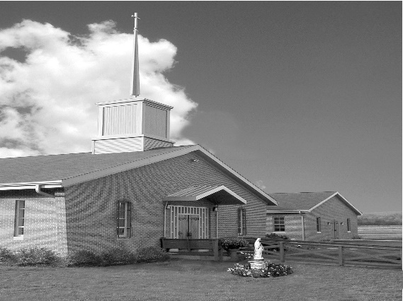
Phone: Phone: (570) 925-6969
E-mail: ctk@epix.net
Website: ctkbenton.weebly.com
Pastor: Rev. Richard J. Mowery
(570) 784-0801
Administrator: Fr. Andrew P. St. Hilaire
(570) 784-3123 (717) 884-9523
frasthilaire@hbgdiocese.org
CYE Coordinator: Betty Hnylanski
(570) 594-3687, bhnylan@gmail.com
Secretary: Lee Ann Boiwka
(570) 864-3090, boiwka@epix.net
Office Hours: Monday & Thursday, 8am -12pm

January 29, 2023 – Fourth Sunday in Ordinary Time

“From a beatitude perspective, discipleship is worth the cost, and suffering
will not have the last word.”

Jesus gives us a different point of view on suffering and discipleship through the beatitudes. Suffering will not have the last word; rather, those who suffer will be blessed. Discipleship is not without cost, but it will be rewarded. With a beatitude perspective, we are reassured and inspired to press onward with rejoicing rather than fear.

In the first reading, the prophet speaks of the humble and righteous remnant of Israel. In the second reading, Paul explains that God calls the weak and lowly so there can be only boasting in the Lord. In the Gospel Jesus goes up a mountain, where his disciples follow him, and he teaches them with a series of statements promising blessings and rewards for those who suffer, especially for his sake as disciples.

The Parish Office will be closed the week of February 6th through February 10th.
In case of emergency you can reach Father Andrew at 717-884-9523.

In your prayers, please remember: Intentions of the Holy Father, all Priests including
Fr. Mowery, Fr. St. Hilaire and Fr. Sola, Lisa Baehre, Sue Barchik, Michael Bardi, Maureen Beck, Lorena Bennet, Christina Capriola, Russell Castrogiovanni, Cobert Family, Michael Farrell, Deb Haden,Vivian Whitenight Hynick, Bob Kalie, Carl Kalie, Margaret Kalie, Joseph LaBonte, Mary Ann Levan, Bernie Nichols, Nancy Oman, Logan & Oliver Root, Richard Scavone, Jackie Scherer, Scott Thomas, Sally Tucker, Max Whitenight, Nancy Wisbar, Sonny Womelsdorf, Mary Ann Zeveney and all the Parishioners of CTK.

Stewardship: January 22, 2023

Offerings $1233.50
Rainy Day $70.00
Poinsettias $10.00
Solemnity of Mary $10.00

Total $1323.50

Mass Intentions

Saturday, January 28 – Edward Connell by Jim McMahon
Sunday, January 29 – Gloria Cashman by Gloria Galer Hess
Monday, January 30 – Lee Ann Boiwka (Birthday Blessings) by John & Mary Everett
Friday, February 3 – Mary Ann Kohberger by Meg Geffken
Saturday, February 4 – Otto Lindner by Richard & Tamara Lindner
Edward Tunaitis by Tunaitis/Mueller Families
Sunday, February 5 – People of the Parish

Mass intentions are available in memory of, or in honor of a loved one. The donation for having a Mass said for a personal request is $10.00. You can drop your request in the collection or contact the parish office.

Lector Schedule Extraordinary Minister Collection Stewards
January 29 – Stephen Root Meg Geffken Anne Eustice & Florence Tapsak
February 5 - Peter Yastishock Mark Sullivan Sharon Tishler & Dottie Poles
CYE News – Sunday, February 19, Mardi Gras from 10-11:30. This is a Youth Group Fundraiser. Food, Fun, and Fellowship. Come join the fun and help our CYE youth. Great way to celebrate before the Lenten season begins.
.

Unborn Candle Donations $3.00/ week, $5.00/ 2 weeks or $10.00/ month.
Month of January – In Memory of Ray Hunsinger

Benton Food Bank - From now until February 19th we will be collecting boxes of tissues. The Food Bank at the N4C’s is the 3rd Tuesday of every month.

Please continue to save the following – they can be brought to the church and placed on the table at the entrance of the Church:
- Used Greeting Cards – They are sent to St. Jude’s Ranch for Boys and used for various projects. You can cut out the section of the card that has been written on.
- Stamps for the Wounded – help cheer a hospitalized or out-patient Veteran.
- Tabs from cans – Taken to the Ronald McDonald House at Geisinger Medical Center in Danville.

We welcome two new families to our Christ the King Family: Kenneth & Theresa Pochatko and their daughters Irena and Julianna, and Gert & Bruce Whipple.

Parish Council/Finance Committee – Our next meeting is on Monday, February 13th at 6:30 in the Social Hall.
Second Collection for the Propagation of the Faith is Saturday & Sunday, February 4 & 5

“Go make disciples of all nations” By our baptism, we are called to share our faith with our family and friends, with our neighbors, indeed, with the whole world.
Next Sunday, we are invited to make a special commitment as missionaries. We are invited to join in the worldwide mission of Jesus by joing the Society for the Propagation of the Faith, reaching out to the people of the world in more than 1,150 mission dioceses.
In making this commitment, we pledge to PRAY daily for the missionary work of the Church, offering our personal crosses for mssionaries and those they serve

Offer regular Financial Help in support of those who bring the “Good News” of Jesus to our brothers and sisters in the missions.

Please say “yes” to this special missionary call next weekend.

Sisters of Saints Cyril & Methodius in Danville are looking for 2 Full-Time Housekeepers, 1 Full-Time Cook, 1 Full-Time Dishwasher and 1 Part-Time 3rd shift Nurses’ Aide. Please contact our HR Department for more information at 570-275-3581 ext. 156 or e-mail scole@sscm.org

Stillwater Christian Church presents Sister 2 Sister – I choose Joy
February 3rd & 4th, Friday 5:30 – 9:30 p.m. and Saturday 8:00 a.m. – noon.
Adults $30, Teens $20. Worship Leader/Speaker – Julie Nevel and Speaker Love Lockman. You can register by call 570-925-2356 or by texting “LINK” to 570-380-9884 to receive the online link to register.

2023 Men’s Conference
Saturday, March 18th, the Diocese of Harrisburg will host its annual Men’s Conference at the Diocesan Center in Harrisburg. Marcel LeJeune, President and Founder of Catholic Missionary Disciples will offer the keynote address. Breakout session presenters include Marcel LeJeune, Bishop Gainer, Fr. Ryan Fischer, Deacon Armando Torres, and Deacon Virgilio Centenera.
Mass celebrated by Bishop Gainer, Confession, and Adoration of the Blessed Sacrament are all part of this annual event. For more details, visit https://www.hbgdiocese.org/men.

