Christ the King Catholic Church
300 Mendenhall Lane, P.O. Box 297 Benton, PA
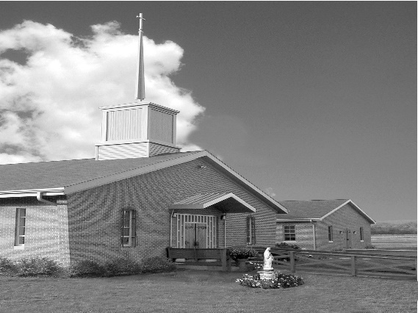
Phone: Phone: (570) 925-6969
E-mail: ctk@epix.net
Website: ctkbenton.weebly.com
Pastor: Rev. Richard J. Mowery
(570) 784-0801
Administrator: Rev. Olusola Adewole, O.P.
(570) 784-3123,
FrOAdewole@hbgdiocese.org
CYE Coordinator: Betty Hnylanski
(570) 594-3687, bhnylan@gmail.com
Secretary: Lee Ann Boiwka
(570) 864-3090, boiwka@epix.net
Office Hours: Monday & Thursday, 8am -12pm

January 23, 2022 – Third Sunday in Ordinary Time

“The law of the Lord delights the human heart and guides the steps of our lives.”

Today’s Gospel opens with the words and intentions of Luke the Evangelist. He has decided to write a Gospel – a narrative of the events regarding Jesus Christ that will draw from the memories of those who witnessed his life, death, and resurrection, and who have handed on his teachings to future generations. We cling to that Gospel message, which reminds us of God’s mercy and challenges us to live in Christ.

Liturgy of the Word
Nehemiah, Ezra, and others instruct the people to rejoice and not be sad, for their God has made the day holy. Saint Paul instructs the Corinthians, using the image of the body to describe the Church and explaining that each person has a role in it. In the Gospel, Jesus reads from the book of the prophet Isaiah in the synagogue in Nazareth and proclaims, Today this Scripture passage is fulfilled in your hearing.

Change in Mass Time – The Saturday evening Mass will be at 4:00 p.m. instead
of 5:00 p.m. for the winter months. Confession will begin at 3:15.

In your prayers, please remember: Intentions of the Holy Father, all Priests including Msgr. Lawrence, Fr. Mowery and Fr. Sola, Josephine Folayemi Adewole, Lorena Bennet,
Butch Bogart, Christina Capriola, Russell Castrogiovanni, Cobert Family, Michael Fontinell, Shiela Gilbert, Deb Haden, Ray Hunsinger, Vivian Whitenight Hynick, Margaret Kalie, Dick Kocher, Mary Ann Levan, James Mazonkey, Nora & Terry McDaniels, Bernie Nichols, Joan Pauley, Helen Raski, Sabo Family, Joan Sansouci, Pat Scardigli, Jackie Scherer, Dot Shelmet, Pat Treier’s daughter Christy, Sally Tucker, Max Whitenight, Sonny Womelsdorf, Stan Zalot, and all the Parishioners of CTK.

Stewardship: January 16, 2022
Offerings $1528.00
Churches in Africa & Latin America $162.00
Rainy Day/Project Fund $160.00
St. Nicholas Fund $20.00
Votives $54.00

Total $1924.00

Mass Intentions

Saturday, January 22 – Joseph Tapsak by Meg Geffken
Sunday, January 23 – Justa Sabo & Family by Elizabeth, James & TJ Hnylanski
Monday, January 24 – Joseph Tapsak by Anne Eustice
Thursday, January 27 – Michael Gavigan by Florence Tapsak
Saturday, January 29 – Kim Todd by the Womelsdorf Family
Sunday, January 30 – David Williams by Don & Mary Wilce

Mass intentions are available in memory of, or in honor of a loved one. The donation for having a Mass said for a personal request is $10.00. You can drop your request in the collection or contact the parish office.

Lector Schedule Extraordinary Minister
January 23 – Mary Ann Zeveney Patricia Sullivan
January 30 – Meg Geffken Paul J. Haden
Just a reminder – Please do not drop off books, prayer cards, DVDs/CD’s, etc. without bringing them to the Office on Monday or Thursday mornings, or giving them to Father to approve. Your cooperation is appreciated!

May He Rest in the Peace of the Lord! Please pray for the soul of Stanley Zalot who died on January 9, 2022. The parish community of Christ the King extends its deepest sympathies to his family, relatives, and friends on their loss. Stanley wanted all those involved in the Renewal Group to know how much it meant to him and how he enjoyed attending Christ the King. There will be a Mass said at Christ the King in Memory of him on Sunday, March 20th at 9:00 a.m.

February 2, Wednesday – Please celebrate with Us – Candlemas & the Feast of the Flame of Love of the Immaculate Heart of Mary. St. Joseph Church, 68 Center Street, Danville, PA

The Feast of the Presentation (Candlemas Day) commemorates the presentation of Jesus in the Temple, forty days after his birth. Simeon, inspired by the Holy Spirit, takes the Child Jesus in his arms and declares him as a light of revelation to all nations. (Luke 2: 22-38)
6:30 Blessing of the Candles - Father Timothy Marcoe
6:35 Holy Mass
7:25 Reflection – Setting Hearts Ablaze with Mary’s Flame of Love
7:30 Flame of Love Rosary
8:15 Passing the Flame

CYE News: The Decision point class for grades 8-12 will be held on January 23 from 11:30-2:15. Lunch will be provided. God bless you and your families.

Benton Food Bank - For the month of January we will be collecting canned goods. Thank you for your generosity! The Food Bank at the N4C’s is the 3rd Tuesday of every month. Anyone in need is encouraged to come between 9:00 a.m. -11:00 a.m.

Unborn Candle Donations $3.00/ week, $5.00/ 2 weeks or $10.00/ month.
Month of January – Marie & Russell Castrogiovanni

2021 Diocesan Annual Campaign

Parish Goal for 2021: $9,322.00
Total Paid: $12,670.00
Overgoal in cash: $3,348.00

Number of Donors: 41
Registered Households: 119
Percentage of Participation: 34.45%

Week of Prayer for Christian Unity 2022 - January 18-25
‎‎The Week of Prayer for Christian Unity will be observed from January 18 until January 25, 2022. All of the faithful are encouraged to engage in activities which foster unity and reconciliation among Christian groups, including ecumenical dialogue, joint charitable service, and participation in services of prayer for Christian unity. More information and resources for the week may be found at www.geii.org.

WE ASKED

Loving Creator, We asked for strength, and you gave us difficulties to make us strong.

We asked for wisdom, and you gave us problems to solve.

We asked for prosperity, and you gave us purpose and brains to use
.
We asked for courage, and you gave us fears to overcome.

We asked for patience, and you gave us situations where we were forced to wait.

We asked for love, and you gave us troubled people to help.

We asked for justice, and you called us to be just and lead with integrity.

Lord, we may have received nothing that we asked for or wanted. And yet, we receive everything that we needed. For this we give thanks. - By Colleen Hanycz

