Christ the King Catholic Church
300 Mendenhall Lane, P.O. Box 297 Benton, PA
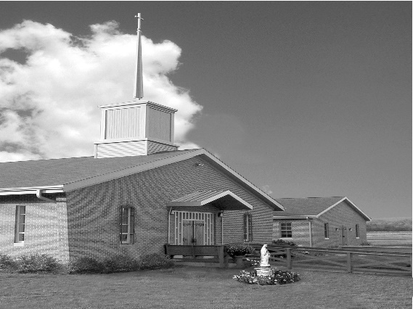
Phone: Phone: (570) 925-6969
E-mail: ctk@epix.net
Website: ctkbenton.weebly.com
Pastor: Rev. Richard J. Mowery
(570) 784-0801
Administrator: Rev. Olusola Adewole, O.P.
(570) 784-3123,
FrOAdewole@hbgdiocese.org
CYE Coordinator: Betty Hnylanski
(570) 594-3687, bhnylan@gmail.com
Secretary: Lee Ann Boiwka
(570) 864-3090, boiwka@epix.net
Office Hours: Monday & Thursday, 8am -12pm

February 6, 2022 – Fifth Sunday in Ordinary Time

Listen for God’s call and follow the Lord.

In all of today’s readings, people hear the Lord calling them to service, and all of them change course to follow their vocation. Young or old, we all have the responsibility to listen for the Lord’s direction and answer with enthusiasm, as did Isaiah, Paul, Peter, James, and John.

Liturgy of the Word
Isaiah recounts his glorious vision of the Lord and his commissioning. Paul reminds the Corinthians of the Gospel he preached to them and lists the resurrected Jesus’ appearances, culminating in his own call and conversion. In the Gospel, after preaching from Simon’s fishing boat, Jesus tells him to put out into deep water. They catch a great number of fish and this leads Peter, James and John to follow Jesus.

Change in Mass Time – The Saturday evening Mass will be at 4:00 p.m. instead
of 5:00 p.m. for the winter months. Confession will begin at 3:15.

In your prayers, please remember: Intentions of the Holy Father, all Priests including Msgr. Lawrence, Fr. Mowery and Fr. Sola, Josephine Folayemi Adewole, Lorena Bennet,
Butch Bogart, Christina Capriola, Russell Castrogiovanni, Cobert Family, Michael Fontinell, Shiela Gilbert, Deb Haden, Ray Hunsinger, Vivian Whitenight Hynick, Margaret Kalie, Dick Kocher, Mary Ann Levan, James Mazonkey, Nora & Terry McDaniels, Bernie Nichols, Joan Pauley, Helen Raski, Sabo Family, Joan Sansouci, Pat Scardigli, Jackie Scherer, Dot Shelmet, Pat Treier’s daughter Christy, Sally Tucker, Max Whitenight, Nancy Wisbar, Sonny Womelsdorf, and all the Parishioners of CTK.

Stewardship: January 30, 2022
Offerings $978.00
Rainy Day/Project Fund $20.00
Solemnity of Mary $5.00
St. Nicholas Fund $30.00

Total $1033.00

Mass Intentions

Saturday, February 5 – Mary Ellen Depietro by Madeline Depietro
Sunday, February 6 – Joseph Tapsak by Marie & Russ Castrogiovannia
Monday, February 7 – Nicholas Sabo by Marie & Russ Castrogiovannia
Saturday, February 12 – Matt & Mary Conlon by Mary Ellen Neal
Sunday, February 13 – Joseph Tapsak by Kathy Wittinger

Mass intentions are available in memory of, or in honor of a loved one. The donation for having a Mass said for a personal request is $10.00. You can drop your request in the collection or contact the parish office.

Lector Schedule Extraordinary Minister
February 6 – Steven Root Meg Geffken
February 13 – Paul Haden Shanna Haden

Unborn Candle Donations $3.00/ week, $5.00/ 2 weeks or $10.00/ month.
Month of February – Judy Womelsdorf
(Looking for Parishioners to take a week, 2 weeks or a month for April – December)

Benton Food Bank - For the month of February we will be collecting tissues. Thank you for your generosity! The Food Bank at the N4C’s is the 3rd Tuesday of every month. Anyone in need is encouraged to come between 9:00 a.m. -11:00 a.m.

Benton Senior Center – N4C’s Building – Looking for new members. Things we do – Cards, WII Games, Shuffleboard, Trips, Information Speakers and Monthly Covered Dish.
Meals served daily at 11:30, transportation available. Hours 9 a.m. – 2 p.m., Monday thru Friday. Call 570-925-6533.

Society of the Propagation of the Faith Membership Sunday – February 6th.
On the first Sunday in February, parishioners throughout our diocese are invited to make a special commitment to the worldwide mission of Jesus, through the Society for the Propagation of the Faith. At Baptism, we are called to be a missionary, to share our faith and pass on the Good News of Jesus among the mission poor. Through the Propagation of the Faith, we can reach out to the peoples of the world by providing prayers and financial assistance to missionary priests, religious Sisters and Brothers, and lay catechists.
Membership envelopes are included in your February collections envelope packet. Thank you for your generosity!

2022 Annual Black Catholic Apostolate Mass: His Eminence, Cardinal Wilton D. Gregory, Archbishop of Washington, will serve as Principal Celebrant of the Diocese of Harrisburg's Annual Black Catholic Apostolate Mass. The Mass will be Sunday, February 13, at 12 noon at St. Catherine Laboure Parish, 4000 Derry Street, Harrisburg, PA. All are invited to attend.

Mass for Anointing of the Sick will be celebrated Sunday, February 13, at the 10:30 a.m. Mass at St. Columba. The sick, the elderly, the shut-ins are invited to come and to receive this special sacrament of the Anointing of the Sick. The homily will provide an explanation of this sacrament. Pope Paul II designated February 11, the feast of Our Lady of Lourdes, as World Day of the Sick, “a special time of prayer and sharing, of offering one’s suffering for the good of the Church and of reminding us to see in our sick brother and sister the face of Christ who, by suffering, dying, and rising, achieved the salvation of humankind.” (Letter Instituting the World Day of the Sick, 13 May 1992, 3).

Frost Bite Festival – February 19, 2022, 12 p.m. – 5 p.m. at Our Lady of Mercy Catholic Church, 304 Slabtown Road, Catawissa, PA. Pre orders highly suggested by February 6, 2022 by calling 570-336-4771. Menu is Pierogies, Potato Cakes, Beef BBQ, Soups, Hot Dogs Baked Goods and Raffles.

Heart of Mercy Counseling Ministry (Sisters of the Good Shepherd), in the Danville area has two licensed therapists available to serve adults for individual, or couples counseling. In -person or virtual counseling options. Please contact either one of them to schedule an appointment if you are seeking counseling based in Catholic teaching: Sr. Mary Frances Altavilla, Licensed Clinical Social Worker 410-245-0870 faltavilla@hotmail.com OR: Sr. Patricia Marie Barnette, Licensed Professional Counselor 352-328-8145 guadalupe531@aol.com (at Our Lady of Hope, Coal Town, on Mondays) .

Scholarship: The Harrisburg Diocese Council of Catholic Women Scholarship Committee invites high school senior girls to apply for a $1000 scholarship to be used for post-secondary education. Applicants must be sponsored by a relative who is a member of a parish CCW, and both applicants and sponsors must reside in the Harrisburg Diocese. The deadline to submit a completed application is March 31. Contact Joyce Scott at (717) 737 -0927 or hdccwscholarship@gmail.com for more information or to secure an application packet.

