Christ the King Catholic Church
300 Mendenhall Lane, P.O. Box 297 Benton, PA
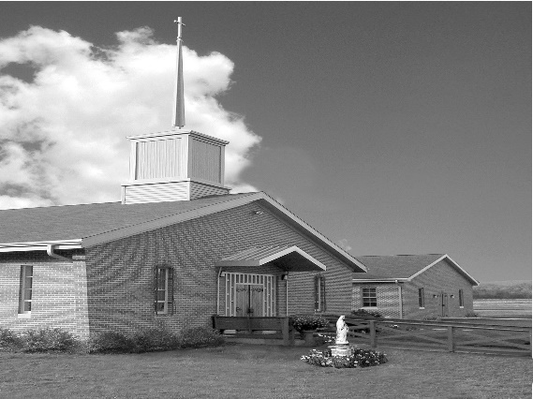
Phone: Phone: (570) 925-6969
E-mail: ctk@epix.net
Website: ctkbenton.weebly.com
Pastor: Rev. Richard J. Mowery
(570) 784-0801
Administrator: Fr. Andrew P. St. Hilaire
(570) 784-3123 (717) 884-9523
frasthilaire@hbgdiocese.org
CYE Coordinator: Betty Hnylanski
(570) 594-3687, bhnylan@gmail.com
Secretary: Lee Ann Boiwka
(570) 864-3090, boiwka@epix.net
Office Hours: Monday & Thursday, 8am -12pm

February 5, 2023 – Fifth Sunday in Ordinary Time

“Your light must shine before others.”

In both the Old and New Testaments, the secret to knowing the love of God is revealed: Share and love as God loves. God wants everyone to know the peace and joy we experience because he loves us and lights our way. He didn’t give us his love to keep; we must share it with others. The mystery is, the more we share his love and light, the more we know how loved we are.

In the first reading, Isaiah tells the Israelites that their light shall break forth like the dawn when they remove oppression, lies, and malicious speech from their midst and care for the hungry, the naked, and the homeless. In his Letter to the Corinthians, Saint Paul says he relies on the power of God to announce the mystery of Christ crucified. In the Gospel, Jesus tells his disciples that they are the salt of the earth and the light of the world. They must shine before others; their good deeds will glorify God.

The Parish Office will be closed the week of February 6th through February 10th.
In case of emergency you can reach Father Andrew at 717-884-9523.

In your prayers, please remember: Intentions of the Holy Father, all Priests including
Fr. Mowery, Fr. St. Hilaire and Fr. Sola, Lisa Baehre, Sue Barchik, Michael Bardi, Maureen Beck, Lorena Bennet, Christina Capriola, Russell Castrogiovanni, Cobert Family, Michael Farrell, Deb Haden,Vivian Whitenight Hynick, Bob Kalie, Carl Kalie, Margaret Kalie, Joseph LaBonte, Mary Ann Levan, Bernie Nichols, Nancy Oman, Logan & Oliver Root, Richard Scavone, Jackie Scherer, Scott Thomas, Sally Tucker, Max Whitenight, Nancy Wisbar, Sonny Womelsdorf, Mary Ann Zeveney and all the Parishioners of CTK.

Stewardship: January 29, 2023

Offerings $1413.50
Rainy Day $35.00
Votives $46.00

Total $1494.50

Mass Intentions

Saturday, February 4 – Otto Lindner by Richard & Tamara Lindner
Edward Tunaitis by Tunaitis/Mueller Families
Sunday, February 5 – People of the Parish
Monday, February 6 – Anne Eustice by Renee Hansen
Friday, February 10 – People of the Parish
Saturday, February 11 – Marilyn LaBonte by Joe LaBonte
Sunday, February 12 – Nicholas Sabo by Justa Sabo
Marisa & Ted Whitenight (Anniversary Blessings) by Boiwkas

Mass intentions are available in memory of, or in honor of a loved one. The donation for having a Mass said for a personal request is $10.00. You can drop your request in the collection or contact the parish office.

Lector Schedule Extraordinary Minister Collection Stewards
February 5 - Peter Yastishock Mark Sullivan Sharon Tishler & Dottie Poles
February 12 – Barb Treier PJ Haden Joe & Lee Ann Boiwka
CYE News – Mardi Gras is returning this year after a long wait with COVID restrictions
CYE Youth group fundraiser includes fun, good food, games, prizes and lots of laughter for all ages. Grades 7-12 have been working hard with Shanna Haden to prepare for the event. All parishioners are welcomed and encouraged to support this event on Sunday, February 19 from 10-11:30.
Help is needed and donations are requested. Please sign up on the counter in the back of the church.
The following items are needed
*Hot dogs and buns
* Cases of Water
* Sloppy Joes and buns
*Macaroni and cheese
* Two soups
*Individual baked goods
* Two Cakes for cake walk
*Prizes for kids
*Raffle baskets

Adult help is needed
Setup on Sunday February 12, 10:15-11:30
Kitchen help Sunday February 19, 10-11:30
Tear down Sunday February 19 11:30-12:00

Unborn Candle Donations $3.00/ week, $5.00/ 2 weeks or $10.00/ month.
Month of February – Judy & Sonny Womelsdorf

Parish Council/Finance Committee – Our next meeting is on Monday, February 13th at 6:30 in the Social Hall.

Anniversary Blessings to Marisa & Ted Whitenight on their 70th Wedding Anniversary February 8th. If you would like to send them a card you can do so at 90 Mill Street, Benton, PA 17814

World Day of the Sick at St. Joseph’s in Danville - In observance of the “World Day of the Sick”, on Sunday, February 12, 2023 a special Holy Hour of Prayer for the sick and those who care for them will take place in the church beginning at 11:45 am. (Additionally, the Sacrament of the Anointing of the Sick will be offered in the church immediately after each Mass this weekend, and will occur right before this Holy Hour). The Harrisburg Guild of the Catholic Medical Association invites all to join in this time of Eucharistic Adoration and prayer. Physicians, Nurses and medical professionals are particularly encouraged to attend to pray for the patients for which they care. The Holy Hour will include Exposition of the Blessed Sacrament, Scripture readings, prayers and a homily by Fr. Timothy Marcoe, pastor of St. Joseph Church, followed by Benediction. The World Day of the Sick is observed each year on February 11th which is the memorial of Our Lady of Lourdes. The day was instituted over 30 years ago by Saint Pope John Paul II and is a day of awareness intended for “prayer and sharing of offering one’s suffering for the good of the Church and of reminding everyone to see in his sick brother or sister the face of Christ”… Pope John Paul II (21 October 1992) “Message of the Holy Father Pope John Paul II for the First Annual World Day of the Sick”. For more information, contact Dr. Greg Burke, Harrisburg Guild president at drgburke@ptd.net or the Harrisburg Guild of the Catholic Medical Association at cathmedhbg@aol.com

Second Collection for the Propagation of the Faith
As disciples of Jesus, baptized into the Church and strengthened by the Holy Spirit, we are called to draw others to Christ: others in our family, in our neighborhoods; others even “to the ends of the earth.” More than 2,000 years after the birth of Jesus, some two-thirds of our human family do not yet know Him in faith as we do.

Through the Propagation of the Faith, we can reach those at work at “the ends of the earth” as we help support the Church’s evangelizing work in more than 1,150 mission dioceses worldwide. We are needed to offer daily prayer and regular financial help as well.

Please join the Propagation of the Faith today. Our parish will surely become more vibrant in faith as we become more missionary.

Blessing of Throats: February 3 is the feast of St. Blaise, the day on which we traditionally bless throats. The story is that St. Blaise miraculously cured a little boy who nearly died because of a fishbone in his throat. We pray that God will protect us through his prayer. “Through the intercession of Saint Blaise, bishop and martyr, may God deliver you from every disease of the throat and from every other illness.” Father will bless throats after all the Masses on February 4&5.

