Christ the King Catholic Church
300 Mendenhall Lane, P.O. Box 297 Benton, PA
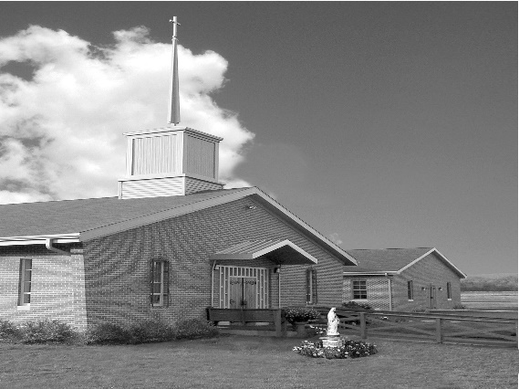
Phone: Phone: (570) 925-6969
E-mail: ctk@epix.net
Website: ctkbenton.weebly.com
Pastor: Rev. Richard J. Mowery
(570) 784-0801
Administrator: Rev. Olusola Adewole, O.P.
(570) 784-3123,
FrOAdewole@hbgdiocese.org
CYE Coordinator: Betty Hnylanski
(570) 594-3687, bhnylan@gmail.com
Secretary: Lee Ann Boiwka
(570) 864-3090, boiwka@epix.net
Office Hours: Monday & Thursday, 8am -12pm

February 27, 2022 – Eighth Sunday in Ordinary Time

“Jesus promises us that nothing is impossible with God.”

Our salvation has been won by Jesus. The kingdom of God awaits us, an inheritance that is imperishable, undefiled, and unfading. While we can do nothing to save ourselves, Jesus assures us that nothing is impossible with God. We can each enter the kingdom by following Jesus and living out the commandments.

Liturgy of the Word
Peter offers praise to the Father, who has granted salvation through his Son, Jesus. In the Gospel, Jesus tells his disciples that though it is hard for the rich to enter the Kingdom, all things are possible for God.

Ash Wednesday, March 2nd – Mass at 9:00 a.m. with Father Dominic Eshikena, O.P.

Stations of the Cross – Fridays at 6:00 p.m. during Lent.

No Daily Mass this week on Monday, Feb. 28th, Thursday, Mar. 3rd or Friday, Mar. 4th.
In your prayers, please remember: Intentions of the Holy Father, all Priests including Msgr. Lawrence, Fr. Mowery and Fr. Sola, Josephine Folayemi Adewole, Lorena Bennet,
Butch Bogart, Christina Capriola, Russell Castrogiovanni, Cobert Family, Michael Fontinell, Shiela Gilbert, Deb Haden, Ray Hunsinger, Vivian Whitenight Hynick, Margaret Kalie, Dick Kocher, Mary Ann Levan, James Mazonkey, Nora & Terry McDaniels, Bernie Nichols, Joan Pauley, Helen Raski, Sabo Family, Joan Sansouci, Pat Scardigli, Jackie Scherer, Pat Treier’s daughter Christy, Sally Tucker, Max Whitenight, Nancy Wisbar, Sonny Womelsdorf, and all the Parishioners of CTK.

Stewardship: February 13 February 20

Offerings $1104.16 $1863.75
Christmas $10.00
Poor Missions $450.00
Propagation of the Faith $100.00
Rainy Day/Project Fund $105.00
Solemnity of Mary $10.00
St. Nicholas Fund $85.00 $15.00

Total $1739.16 $2003.75

Mass Intentions
Saturday, February 26 – People of the Parish
Sunday, February 27 – Joseph Tapsak by Sue Duntley
Monday, February 28 – No Mass
Wednesday, March 2 – Father Sola and Family by CTK Family
Thursday, March 3 – No Mass
Friday, March 4 – No Mass
Saturday, March 5 – People of the Parish
Sunday, March 6 – Nicholas Sabo by Justa Sabo

Mass intentions are available in memory of, or in honor of a loved one. The donation for having a Mass said for a personal request is $10.00. You can drop your request in the collection or contact the parish office.

Lector Schedule Extraordinary Minister

February 27 – Barb Treier PJ Haden
March 6 – Peter Yastishock Lee Ann Boiwka

CYE News - The CYE youth group fundraiser for Mardi Gras has been postponed. A Spring Fling will be held in April/May this year in place of the Mardi Gras fundraiser.
Please remember in your prayers Corbin McHenry, who is in his final preparation to receive the sacraments of Reconciliation and Eucharist this spring.

Please remember Gavin Birkett, Collin Cashman, and Taylor Chikotas who are in their final preparation to receive the sacrament of Confirmation in May at St Columba.

Unborn Candle Donations $3.00/ week, $5.00/ 2 weeks or $10.00/ month.
Month of March – Judy Womelsdorf
(Looking for Parishioners to take a week, 2 weeks or a month for April – December)

Benton Food Bank - For the month of March we will be collecting Liquid Hand Soap. Thank you for your generosity! The Food Bank at the N4C’s is the 3rd Tuesday of every month. Anyone in need is encouraged to come between 9:00 a.m. -11:00 a.m.

Catholic Relief Services Rice Bowl – Please pick up your For Lent, For Life Rice Bowl on the back table. What you give up for Lent changes lives. 75% of your CRS Rice Bowl donations supports Catholic Relief Services’ work around the world. 25% helps fight hunger and poverty in your own community. Turn in your donation at the end of Lent marked CRS Rice Bowl.
2022 Diocesan Annual Campaign - The 2022 Diocesan Annual Campaign, One Faith, One Family, has begun. Because of the generosity of the faithful throughout the Diocese of Harrisburg, our 2021 effort was remarkable with 72 parishes reaching and exceeding their goals. The many ministries and programs which received funding are humbled by the interest in and support of their efforts. From Evangelization efforts, to the many social service programs offered by Catholic Charities, to ongoing education and formation for our seminarians, clergy and ordained deacons, to support for Catholic education, your gift does make a difference. Please prayerfully consider your gift this year to ensure that the mission of the Church is fulfilled. To learn more about the Diocesan Annual Campaign, please visit https://www.hbgdiocese.org/diocesan-annual-campaign/

Benton Senior Center – N4C’s Building – Looking for new members. Things we do – Cards, WII Games, Shuffleboard, Trips, Information Speakers and Monthly Covered Dish.
Meals served daily at 11:30, transportation available. Hours 9 a.m. – 2 p.m., Monday thru Friday. Call 570-925-6533.

Scholarship: The Harrisburg Diocese Council of Catholic Women Scholarship Committee invites high school senior girls to apply for a $1000 scholarship to be used for post-secondary education. Applicants must be sponsored by a relative who is a member of a parish CCW, and both applicants and sponsors must reside in the Harrisburg Diocese. The deadline to submit a completed application is March 31. Contact Joyce Scott at (717) 737 -0927 or hdccwscholarship@gmail.com for more information or to secure an application packet.

2022 Diocesan Men’s Conference - Mark your calendars for the Diocese of Harrisburg’s Men’s Conference, Becoming Champions for Christ, on April 2 at in the Diocesan Center, Harrisburg. Keynote speaker Adam Janke headlines a panel of excellent speakers that will focus on standing firm as men of faith among the challenges of today’s faith-less society. Adoration of the Blessed Sacrament with Benediction, Confession, and Mass celebrated by Bishop Ronald Gainer are also part of this annual event. Registration is $35 for in-person (includes light breakfast fare and lunch) and $20 for virtual. Register today or learn more at www.hbgdiocese.org/men.

