Christ the King Catholic Church
300 Mendenhall Lane, P.O. Box 297 Benton, PA
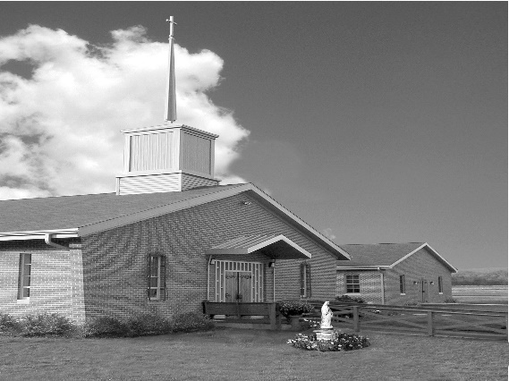
Phone: Phone: (570) 925-6969
E-mail: ctk@epix.net
Website: ctkbenton.weebly.com
Pastor: Rev. Richard J. Mowery
(570) 784-0801
Administrator: Fr. Andrew P. St. Hilaire
(570) 784-3123 (717) 884-9523
frasthilaire@hbgdiocese.org
CYE Coordinator: Betty Hnylanski
(570) 594-3687, bhnylan@gmail.com
Secretary: Lee Ann Boiwka
(570) 864-3090, boiwka@epix.net
Office Hours: Monday & Thursday, 8am -12pm

February 26, 2023 – First Sunday of Lent

“Through Christ we are made righteous and have eternal life.”

On this first Sunday of Lent, our readings bring into focus the great drama of our salvation history: Our first parents sinned, and through them death came to all. Yet our gracious God sent his Son not to condemn but to free us and show his power over Satan. Through him we are made righteous.

In the first reading, the serpent convinces the woman to eat fruit from the forbidden tree, which she shares with her husband. Their eyes are opened and they realize they are naked. In the second reading Paul writes that, through the obedience of Christ, many will become righteous. In the Gospel, Jesus is tempted by Satan after fasting for 40 days and 40 nights. Jesus resists all that Satan offers and commands him to get away.

Stations of the Cross every Friday during Lent, 6:00 p.m. at Christ the King

In your prayers, please remember: Intentions of the Holy Father, all Priests including
Fr. Mowery, Fr. St. Hilaire and Fr. Sola, Lisa Baehre, Michael Bardi, Maureen Beck, Lorena Bennet, Christina Capriola, Russell Castrogiovanni, Cobert Family, Honor & Joe Dell,
Alex Haden, Deb Haden,Vivian Whitenight Hynick, Bob Kalie, Margaret Kalie, Austin Kelsey, Joseph LaBonte, Mary Ann Levan, Bernie Nichols, Nancy Oman, Logan & Oliver Root, Richard Scavone, Jackie Scherer, Scott Thomas, Sally Tucker, Max Whitenight, Nancy Wisbar, Sonny Womelsdorf, Mary Ann Zeveney and all the Parishioners of CTK.

Mass Intentions

Saturday, February 25 – Carl Bloom by Anne Kingsbury
Sunday, February 26 – People of the Parish
Monday, February 27 – Salvatore Barbuto by Elaine Barbuto
Friday, March 3 – Maryellen Gambale Rose by Elaine Barbuto
Saturday, March 4 – Bill Lindner by Richard & Tamara Lindner
Sunday, March 5 – People of the Parish

Mass intentions are available in memory of, or in honor of a loved one. The donation for having a Mass said for a personal request is $10.00. You can drop your request in the collection or contact the parish office.

Stewardship: February 19, 2023

Offerings $1464.50
Rainy Day $98.00
Votives $53.00

Total $1615.50

Lector Schedule Extraordinary Minister Collection Stewards

February 26 – Pete Yastishock Shanna Haden Patricia & Mark Sullivan
March 5 – Pete Yastishock PJ Haden Sharon Tishler & Dottie Poles

Unborn Candle Donations $3.00/ week, $5.00/ 2 weeks or $10.00/ month.
Month of February – Judy & Sonny Womelsdorf

CYE News – WOW!!!!!! So many thanks to so many wonderful people who made the CYE Youth Group Mardi Gras celebration a success. We had many happy laughing children and adults enjoying the games, sharing fellowship with one another while partaking of some delicious food, taking chances on the beautifully donated raffle baskets, and cheering on the children while they played the cake walk. Beautiful people sharing their gourmet talents, donating creative raffle baskets, and rolling up their sleeves to help in so many ways. There were games for all ages to enjoy and students volunteering their services wherever they were needed. Thank you to the parishioners who came to celebrate with the children. Thank you Shanna Haden who teaches the high school CYE class and organized the event and thanks to the parents and parishioners who made this a great day for the children of our parish. A Happy and Holy Lent to all.

Place a Memorium, Prayer Request, Spiritual Notation or become a Sponsor for our new bulletin. The art department of Diocesan will design a spot for you which will appear weekly on our church bulletin’s advertisement page. What better way to show your continued love for those special to you and support your church bulletin at the same time. You can call Adam Snyder for more information at 1-814-771-8628 or contact the Parish Office at 570-925-6969.

Benton Food Bank - From now until March 20th we will be collecting liquid hand soap. The Food Bank at the N4C’s is the 3rd Tuesday of every month.

2023 Benton Community Lenten Services – Sunday Evenings at 7 p.m.

Date Location Speaker Special Music

2/26/23 Christ the King Pastor Gloria Kremer Waller UMC
3/05/23 UMC Benton Pastor Bill McClure Christ the King
3/12/23 Benton Christian Pastor Tyler Rauhauser Assembly of God
3/19/23 Assembly of God Pastor Ron Shelhamer Benton UMC
3/26/23 Raven Creek Rev. Andrew St. Hilaire Joe & Lorraine Feola

CRS Operation Rice Bowl – Please be sure to pick up your Rice Bowl for Lent. Through CRS Rice Bowl you help reach more than 190 million people with lifesaving support. 75% of your donation supports Catholic Relief Services work around the world. 25% helps fight hunger and poverty in your own community.

St. Columba School is searching for an Elementary Principal to serve as a beacon of Christ’s light while nurturing individual gifts in a faith-infused, academically challenging, safe and secure environment. Find out more regarding our K-8 school at https://www.saintcolumbaschool.org

Lenten Guidelines: The traditional Lenten practices of piety, fasting, almsgiving and other forms of self-denial are warmly recommended by the Church. The faithful observance of Lent should manifest itself in the imitation of Christ in daily life and in the readiness to sacrifice time and talents whenever possible, in personal, parish, and community efforts for those in spiritual or material need. The spiritual hunger of the unchurched locally and in mission lands can be a focus of prayers and charitable giving. Ash Wednesday and Good Friday are days of abstinence from meat for those 14 years of age or older. They are also days of fasting for those between the ages of 18 and 59 years of age. Those bound by the law of fasting may take one full meal. Two smaller meals are also permitted; liquids, including milk and fruit juices, are allowed. If health or ability to work is seriously affected, the law does not bind. All Fridays in Lent are days of abstinence (no meat) for those 14 years of age or older. Fridays of the year outside Lent remain days of penance. The Bishops of the United States highly recommended the traditional abstinence from meat on Fridays during the entire year, together with acts of mortification, for the cause of peace in the world. However, some other practice of voluntary self-denial or personal penance may be substituted.

Men’s Conference - On Saturday, March 18, the Diocese Harrisburg will host its annual Men’s Conference at the Diocesan Center in Harrisburg. Marcel LeJeune, President and Founder of Catholic Missionary Disciples, will offer the keynote address. Breakout session presenters include Marcel LeJeune, Bishop Gainer, Fr. Ryan Fmillischer, Deacon Armando Torres, and Deacon Virgilio Centenera. Mass celebrated by Bishop Gainer, Breakout Sessions, Confession, and Adoration are part of this annual event. For more details, visit https://www.hbgdiocese.org

