Christ the King Catholic Church
300 Mendenhall Lane, P.O. Box 297 Benton, PA
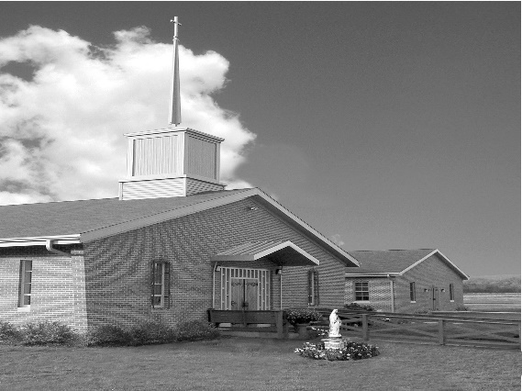
Phone: Phone: (570) 925-6969
E-mail: ctk@epix.net
Website: ctkbenton.weebly.com
Pastor: Rev. Richard J. Mowery
(570) 784-0801
Administrator: Fr. Andrew P. St. Hilaire
(570) 784-3123 (717) 884-9523
frasthilaire@hbgdiocese.org
CYE Coordinator: Betty Hnylanski
(570) 594-3687, bhnylan@gmail.com
Secretary: Lee Ann Boiwka
(570) 864-3090, boiwka@epix.net
Office Hours: Monday & Thursday, 8am -12pm

February 19, 2023 – Seventh Sunday in Ordinary Time

“Living a life of faith means acting with love and mercy.”

The call to spiritual perfection or holiness dominates our readings today. We are called to be perfect as the heavenly Father is perfect, and to demonstrate that holiness in the way we treat one another and in our knowledge that we are temples of God’s Holy Spirit.

In the first reading, the Lord calls his people to be holy and to love as he loves. Saint Paul writes that the Spirit of God dwells in [us]. In the Gospel, Jesus offers examples of what he means by fulfilling the law.

Ash Wednesday - Wednesday, February 22 – Mass will be at Christ the King at 9:00 a.m.
St. Columba Masses are 6:30 a.m., 8:30 a.m. and 7:00 p.m.
Catholic Campus Ministry in Bloomsburg Masses are 5:30 p.m. and 8:00 p.m.
St. Martha’s, Fairmount Springs, Mass at 6:00 p.m.

Stations of the Cross every Friday during Lent, 6:00 p.m., beginning Feb. 24th at Christ the King
In your prayers, please remember: Intentions of the Holy Father, all Priests including
Fr. Mowery, Fr. St. Hilaire and Fr. Sola, Lisa Baehre, Sue Barchik, Michael Bardi, Maureen Beck, Lorena Bennet, Christina Capriola, Russell Castrogiovanni, Cobert Family, Michael Farrell, Deb Haden,Vivian Whitenight Hynick, Bob Kalie, Carl Kalie, Margaret Kalie, Austin Kelsey, Joseph LaBonte, Mary Ann Levan, Bernie Nichols, Nancy Oman, Logan & Oliver Root, Richard Scavone, Jackie Scherer, Scott Thomas, Sally Tucker, Max Whitenight, Nancy Wisbar, Sonny Womelsdorf, Mary Ann Zeveney and all the Parishioners of CTK.

Mass Intentions

Saturday, February 18 – Tess Lindner by Richard & Tamara Lindner
Sunday, February 19 – People of the Parish
Monday, February 20 – Salvatore Barbuto, Jr. by Elaine Barbuto
Wednesday, February 22 – Maryellen Gambale Rose by Elaine Barbuto
Friday, February 24 – People of the Parish
Saturday, February 25 – Carl Bloom by Anne Kingsbury
Sunday, February 26 – People of the Parish

Mass intentions are available in memory of, or in honor of a loved one. The donation for having a Mass said for a personal request is $10.00. You can drop your request in the collection or contact the parish office.

Stewardship: February 5, 2023 February 12, 2023

Offerings $2066.50 $1741.75
Rainy Day $50.00
Poor Missions $50.00 $253.00
Propagation of the Faith $744.00
St. Nick $90.00 $45.00

Total $3000.50 $2039.75

Lector Schedule Extraordinary Minister Collection Stewards

February 19 – Paul Haden Patricia Sullivan Anne Eustice & Florence Tapsak
February 26 – Pete Yastishock Shanna Haden Patricia & Mark Sullivan

Unborn Candle Donations $3.00/ week, $5.00/ 2 weeks or $10.00/ month.
Month of February – Judy & Sonny Womelsdorf

CYE News –Mardi Gras - CYE Youth group fundraiser includes fun, good food, games, prizes and lots of laughter for all ages. Grades 7-12 have been working hard with Shanna Haden to prepare for the event. All parishioners are welcomed and encouraged to support this event on Sunday, February 19 from 10-11:30.

Place a Memorium, Prayer Request, Spiritual Notation or become a Sponsor for our new bulletin. The art department of Diocesan will design a spot for you which will appear weekly on our church bulletin’s advertisement page. What better way to show your continued love for those special to you and support your church bulletin at the same time. You can call Adam Snyder for more information at 1-814-771-8628 or contact the Parish Office at 570-925-6969.

Benton Food Bank - From now until March 20th we will be collecting liquid hand soap. The Food Bank at the N4C’s is the 3rd Tuesday of every month.

Our Lady of Mercy Church, 304 Slabtown Road, Catawissa, PA is having their 3rd Annual “Frost Bite Festival”. The event will take place Saturday, February 18th from 11:00 until 4:00. Several wonderful ethnic treats will be available, along with traditional picnic foods. Walk-ins and take-outs are both available.

2023 Benton Community Lenten Services
On February 26, 2023 the Lenten Service is at Christ the King at 7:00 p.m. The theme will be “Temptation, Confession, Vigilance and God’s Promises. Speaker will be Pastor Gloria Kremer and music provided by Waller UMC Choir. Since Christ the King is hosting the Lenten Service we need goodies and finger foods for the Social after. You can bring them Saturday evening after Mass, Sunday morning after Mass or Sunday evening before the Service. Thank you in advance!
The 2022 Diocesan Annual Campaign is completed. Here is our report as of 1/31/23

Parish Goal for 2022: $9,442.53
Total Paid: $14,622.00
Over goal in cash: $5,179.47

Average per donor: $365.55
Number of Donors: 40
Registered Households: 120
Percentage of Participation: 33.33%

CRS Operation Rice Bowl – Please be sure to pick up your Rice Bowl for Lent. Through CRS Rice Bowl you help reach more than 190 million people with lifesaving support. 75% of your donation supports Catholic Relief Services work around the world. 25% helps fight hunger and poverty in your own community.

Prayer Warriors – If you are interested and willing to become a Prayer Warrior for Christ the King, please contact the parish office at 570-925-6969 or ctk@epix.net.

And there people brought to him a paralytic lying on a stretcher. When Jesus saw their faith, he said to the paralytic, “Courage, child, your sins are forgiven.” Matthew 9:2

It began years ago with one simple prayer request via e-mail. Someone my mom knew was struggling and needed prayers. The handful of us who received the email prayed this person through. Since then, my mother’s Prayer Warrior list has grown. The group is now large and active. We’re constantly praying for someone, and the results are astounding. When the faithful join forces and petition God on someone’s behalf, the power is immense.

That’s what happened with the paralytic in Matthew 9. It was the faith of the people who brought him on a stretcher that inspired Jesus to heal him.

When circumstances paralyze us, it’s the faith and prayers of other believers that lift us up, bring us to God and move his heart to heal ours.

Compassionate Christ, increase my faith so my prayers for others aid in their healing.

