Christ the King Catholic Church
300 Mendenhall Lane, P.O. Box 297 Benton, PA
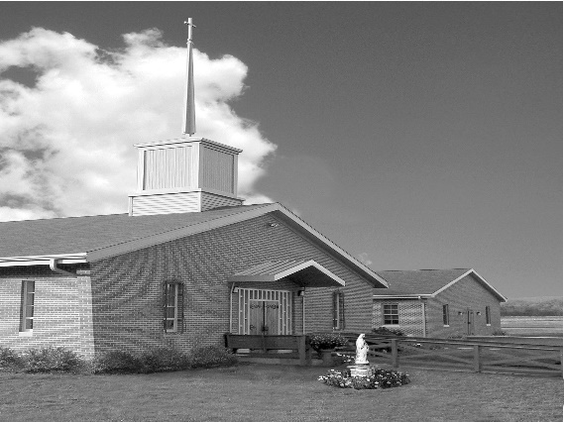
Phone: Phone: (570) 925-6969
E-mail: ctk@epix.net
Website: ctkbenton.weebly.com
Pastor: Rev. Richard J. Mowery
(570) 784-0801
Administrator: Rev. Olusola Adewole, O.P.
(570) 784-3123,
FrOAdewole@hbgdiocese.org
CYE Coordinator: Betty Hnylanski
(570) 594-3687, bhnylan@gmail.com
Secretary: Lee Ann Boiwka
(570) 864-3090, boiwka@epix.net
Office Hours: Monday & Thursday, 8am -12pm

February 13, 2022 – Sixth Sunday in Ordinary Time

“Blessed are those who trust in the Lord.”

So often we can be the source of our own suffering. Worldly pursuits and desires for wealth, status, promotion, and the like deceive us into placing our hope in people and things rather than the Lord. This life is fading and only God can offer us true satisfaction in the kingdom of heaven.

Liturgy of the Word
Jeremiah proclaims the Lord’s message, Cursed is the one who trusts in human beings … Blessed is the one who trusts in the Lord. Saint Paul asserts that if Jesus had not risen from the dead, the Corinthians’ faith would be in vain. In the Gospel, Jesus speaks to the crowd of disciples, giving examples of those who are blessed and those who experience woe.

Please note – The Parish Office will be closed the week of February 14th. If there is an emergency, you can contact St. Columba at 570-784-0801.

No Daily Mass this week on Monday, February 14th or Thursday, February 17th.

In your prayers, please remember: Intentions of the Holy Father, all Priests including Msgr. Lawrence, Fr. Mowery and Fr. Sola, Josephine Folayemi Adewole, Lorena Bennet,
Butch Bogart, Christina Capriola, Russell Castrogiovanni, Cobert Family, Michael Fontinell, Shiela Gilbert, Deb Haden, Ray Hunsinger, Vivian Whitenight Hynick, Margaret Kalie, Dick Kocher, Mary Ann Levan, James Mazonkey, Nora & Terry McDaniels, Bernie Nichols, Joan Pauley, Helen Raski, Sabo Family, Joan Sansouci, Pat Scardigli, Jackie Scherer, Pat Treier’s daughter Christy, Sally Tucker, Max Whitenight, Nancy Wisbar, Sonny Womelsdorf, and all the Parishioners of CTK.

Stewardship: February 6, 2022
Offerings $1427.00
Propagation of Faith $133.00
Rainy Day/Project Fund $60.00
St. Nicholas Fund $205.00
Votives $30.00

Total $1855.00

Mass Intentions

Saturday, February 12 – Matt & Mary Conlon by Mary Ellen Neal
Sunday, February 13 – Joseph Tapsak by Kathy Wittinger
Monday, February 14 – No Mass
Thursday, February 17 – No Mass
Saturday, February 19 – People of the Parish
Sunday, February 20 – Nicholas Sabo by Justa Sabo

Mass intentions are available in memory of, or in honor of a loved one. The donation for having a Mass said for a personal request is $10.00. You can drop your request in the collection or contact the parish office.

Lector Schedule Extraordinary Minister
February 13 – Paul Haden Shanna Haden
February 20 – Anne Eustice Patricia Sullivan
CYE News - Reminder Cye religious instruction is held each Sunday beginning with 9:00 Mass and classes beginning at 10:00 with dismissal at 11:30. Masks must be worn while in the CYE building during class time.

Unborn Candle Donations $3.00/ week, $5.00/ 2 weeks or $10.00/ month.
Month of February – Judy Womelsdorf
(Looking for Parishioners to take a week, 2 weeks or a month for April – December)

Benton Food Bank - For the month of February we will be collecting tissues. Thank you for your generosity! The Food Bank at the N4C’s is the 3rd Tuesday of every month. Anyone in need is encouraged to come between 9:00 a.m. -11:00 a.m.

Benton Senior Center – N4C’s Building – Looking for new members. Things we do – Cards, WII Games, Shuffleboard, Trips, Information Speakers and Monthly Covered Dish.
Meals served daily at 11:30, transportation available. Hours 9 a.m. – 2 p.m., Monday thru Friday. Call 570-925-6533.

Mass for Anointing of the Sick will be celebrated Sunday, February 13, at the 10:30 a.m. Mass at St. Columba. The sick, the elderly, the shut-ins are invited to come and to receive this special sacrament of the Anointing of the Sick. The homily will provide an explanation of this sacrament. Pope Paul II designated February 11, the feast of Our Lady of Lourdes, as World Day of the Sick, “a special time of prayer and sharing, of offering one’s suffering for the good of the Church and of reminding us to see in our sick brother and sister the face of Christ who, by suffering, dying, and rising, achieved the salvation of humankind.” (Letter Instituting the World Day of the Sick, 13 May 1992, 3).
Frost Bite Festival – February 19, 2022, 12 p.m. – 5 p.m. at Our Lady of Mercy Catholic Church, 304 Slabtown Road, Catawissa, PA. Pre orders highly suggested by February 6, 2022 by calling 570-336-4771. Menu is Pierogies, Potato Cakes, Beef BBQ, Soups, Hot Dogs Baked Goods and Raffles.

Heart of Mercy Counseling Ministry (Sisters of the Good Shepherd), in the Danville area has two licensed therapists available to serve adults for individual, or couples counseling. In -person or virtual counseling options. Please contact either one of them to schedule an appointment if you are seeking counseling based in Catholic teaching: Sr. Mary Frances Altavilla, Licensed Clinical Social Worker 410-245-0870 faltavilla@hotmail.com OR: Sr. Patricia Marie Barnette, Licensed Professional Counselor 352-328-8145 guadalupe531@aol.com (at Our Lady of Hope, Coal Town, on Mondays) .

Scholarship: The Harrisburg Diocese Council of Catholic Women Scholarship Committee invites high school senior girls to apply for a $1000 scholarship to be used for post-secondary education. Applicants must be sponsored by a relative who is a member of a parish CCW, and both applicants and sponsors must reside in the Harrisburg Diocese. The deadline to submit a completed application is March 31. Contact Joyce Scott at (717) 737 -0927 or hdccwscholarship@gmail.com for more information or to secure an application packet.

2022 Diocesan Men’s Conference - Mark your calendars for the Diocese of Harrisburg’s Men’s Conference, Becoming Champions for Christ, on April 2 at in the Diocesan Center, Harrisburg. Keynote speaker Adam Janke headlines a panel of excellent speakers that will focus on standing firm as men of faith among the challenges of today’s faith-less society. Adoration of the Blessed Sacrament with Benediction, Confession, and Mass celebrated by Bishop Ronald Gainer are also part of this annual event. Registration is $35 for in-person (includes light breakfast fare and lunch) and $20 for virtual. Register today or learn more at www.hbgdiocese.org/men.

