Christ the King Catholic Church
300 Mendenhall Lane, P.O. Box 297 Benton, PA
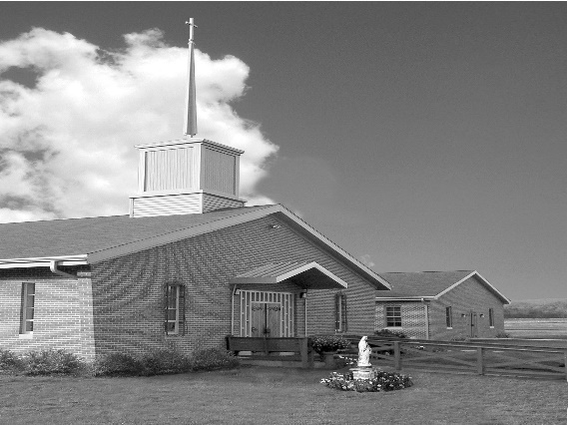
Phone: Phone: (570) 925-6969
E-mail: ctk@epix.net
Website: ctkbenton.weebly.com
Pastor: Rev. Richard J. Mowery
(570) 784-0801
Administrator: Rev. Olusola Adewole, O.P.
(570) 784-3123,
FrOAdewole@hbgdiocese.org
CYE Coordinator: Betty Hnylanski
(570) 594-3687, bhnylan@gmail.com
Secretary: Lee Ann Boiwka
(570) 864-3090, boiwka@epix.net
Office Hours: Monday & Thursday, 8am -12pm

December 5, 2021 – Second Sunday of Advent

“Make straight a path unto the Lord!”

Today we hear that John the Baptist proclaims a baptism of repentance for the forgiveness of sins. While repentance is a sobering act of admission of guilt, being forgiven of sin is a hope-filled relief that lifts the soul. Let us seek to prepare a straight path unto the Lord by pondering the lofty mountains we may have in our lives that need to be made low; and the age-old depths and gorges in our own character or soul that must be filled to level ground.

Liturgy of the Word
The poem of consolation from Baruch urges Jerusalem to look ahead in hope to days of God’s justice and glory. Saint Paul prays for an increase in virtue among the Philippians in preparation for Christ. In the Gospel, Luke places John the Baptist’s ministry in historical context before describing his call for a baptism of repentance.

December 8th – Immaculate Conception of the Blessed Virgin Mary – Mass at 9:00 a.m.
In your prayers, please remember: Intentions of the Holy Father, all Priests including Msgr. Lawrence, Fr. Mowery and Fr. Sola, Josephine Folayemi Adewole, Lorena Bennet, Christina Capriola, Russell Castrogiovanni, Cobert Family, Deb Haden, Ray Hunsinger, Vivian Whitenight Hynick, Joyce Kishbaugh, Dick Kocher, Mary Ann Levan, James Mazonkey, Nora & Terry McDaniels, Bernie Nichols, Joan Pauley, Helen Raski, Sabo Family, Joan Sansouci, Pat Scardigli, Jackie Scherer, Dot Shelmet, Douglas Talanca, Pat Treier’s daughter Christy, Max Whitenight, Sonny Womelsdorf, Stan Zalot, and all the Parishioners of CTK.

Stewardship: November 28, 2021

Offerings $911.00
Christmas $1000.00
Matthew 25 $100.00
Rainy Day $40.00
St. Nick $20.00

Total $2071.00

Mass Intentions

Saturday, December 4 – John Lindner by Richard & Tamara Lindner
Sunday, December 5 – Nicholas Sabo by Sharon Tishler
Monday, December 6 – Nicholas Sabo by Helen Raski
Wednesday, December 8 – People of the Parish
Thursday, December 9 – Judy Hudzik by Helen Raski
Saturday, December 11 – People of the Parish
Sunday, December 12 – Tom Tishler by Sharon Tishler

Mass intentions are available in memory of, or in honor of a loved one. The donation for having a Mass said for a personal request is $10.00. You can drop your request in the collection or contact the parish office.

Lector Schedule Extraordinary Minister
December 5 – Peter Yastishock Judith Scavone
December 12 – Barb Treier Paul J. Haden

Daily Readings for Advent “Your word, O Lord, is a lamp for my feet, a light for my path.” –
Psalm 119:105
Second Week - Sunday Romans 15:4-9, Monday Psalm 85, Tuesday Matthew 18:12-14, Wednesday Zechariah 2:14-17, Thursday Luke 1:26-38, Friday Matthew 11:16-19, Saturday Sirach 48:1-11
CYE News: December 5 - CYE sacrament of Reconciliation. Discussion of Advent wreath and Jesse tree. Discussion of Nativity.

December 12 - CYE sacrament of Reconciliation.
11:00 presentation of the Nativity in church. Parents should gather in church. Students will be dismissed following their presentation.

December 19- No CYE classes
December 25- Merry Christmas. Celebrate the birth of Our Savior
January 1 - Solemnity of Mary
January 3 - CYE Classes Resume
January 10 - CYE class. Decision Point Class grades 8-12, 11:30-2:15, lunch provided

Benton Food Bank - For the month of December we will continue to collect tissues and paper products. Thank you for your generosity! The Food Bank at the N4C’s is the 3rd Tuesday of every month. Anyone in need is encouraged to come between 9:00 a.m. -11:00 a.m.

Unborn Candle Donations $3.00/ week, $5.00/ 2 weeks or $10.00/ month.
Month of December –Justa & Nicholas Sabo

Jesse Tree –The gifts that we buy are for the men who are Veterans that live at the Orangeville Manor and also children of the Benton Head Start Program. Please have your gifts wrapped with the Star attached, back to Christ the King by the weekend of December 11 & 12. Your generosity is greatly appreciated!

Poinsettias – You can order a Poinsettia for the Altar in Memory of, or in Honor of a loved one. The sheets are at the exit of the Church. Donation is $10.00 per plant. You can drop your order off in the collection or stop by the Office on Monday or Thursday mornings.

Mark your Calendars – We will be decorating our Church for Christmas immediately following Mass on Sunday, December19th. Please plan to stay and help!
ADVENT, CHRISTMAS AND NEW YEAR SCHEDULE FOR 2021/22

SECOND SUNDAY OF ADVENT, DEC. 4 & 5 Saturday: Confessions @ 4p.m., Mass @ 5p.m. Sunday: Mass @ 9a.m. CYE Confessions @ 10.15a.m.

WEDNESDAY, DEC. 8 Mass of the Solemnity of the Immaculate Conception @ 9a.m.

THIRD SUNDAY OF ADVENT, DEC. 11 & 12 Saturday: Confessions @ 4p.m., Mass @ 5p.m. Sunday: Mass @ 9a.m. Advent Talk @ 10.15a.m. (Social Hall)

FOURTH SUNDAY OF ADVENT, DEC. 18 & 19 Saturday: Confessions @ 4p.m., Mass @ 5p.m. Sunday: Mass @ 9a.m.

FRIDAY, DEC. 24 Christmas Vigil Mass @ 5p.m.

SATURDAY, DEC. 25 Christmas Day Mass @ 9a.m.

SUNDAY, DEC. 26 Mass of the Holy Family of Jesus, Mary & Joseph @ 9a.m.

SATURDAY, JAN. 1, 2022 Solemnity of Mary Mother of God (Not a Holy Day of Obligation this year) Confessions @ 4p.m. Vigil Mass of the Epiphany of the Lord @ 5p.m.

SUNDAY, JAN. 2, The Epiphany of the Lord, Mass @ 9a.m.

THE BAPTISM OF THE LORD, Jan. 8 & 9 Saturday: Confessions @ 4p.m., Mass @ 5p.m. Sunday: Mass @ 9a.m.

Northern Deanery Advent Penance Service Schedule (Sacrament of Reconciliation)
* Confessions will be heard by various priests at each location, beginning at 7 pm *

Monday, Dec 13 St. Joseph, Danville
Tuesday, Dec 14 St. Monica, Sunbury and St. Mary, Berwick
Wednesday, Dec 15 St. Pius, Selinsgrove
Thursday, Dec 16 St. Joseph, Milton and St. Columba, Bloomsburg
Friday, Dec 17 Sacred Heart, Lewisburg ‎

December 12 - Advent Talk @ 10:15a.m. (Social Hall)

- Second Collection for Retirement Fund for Religious

