Christ the King Catholic Church
300 Mendenhall Lane, P.O. Box 297 Benton, PA
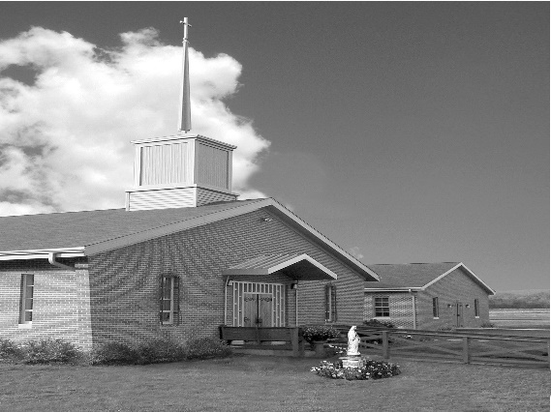
Phone: Phone: (570) 925-6969
E-mail: ctk@epix.net
Website: ctkbenton.weebly.com
Pastor: Rev. Richard J. Mowery
(570) 784-0801
Administrator: Fr. Andrew P. St. Hilaire
(570) 784-3123 (717) 884-9523
frasthilaire@hbgdiocese.org
CYE Coordinator: Betty Hnylanski
(570) 594-3687, bhnylan@gmail.com
Secretary: Lee Ann Boiwka
(570) 864-3090, boiwka@epix.net
Office Hours: Monday & Thursday, 8am -12pm

December 4, 2022 – Second Sunday of Advent

“Repent, for the kingdom of heaven is at hand!”

In the waters of baptism, we have been claimed for Christ. As we gather on this Advent Sunday, we recall and celebrate our rebirth in grace and our mission to prepare the way for the Lord. At the heart of this celebration is our repentance and our desire to be renewed with the spirit of the Lord.

Liturgy of the Word
Isaiah foretells the advent of the Messiah: Upon him will rest the Spirit’s gifts, and with him will come knowledge of the Lord. Saint Paul challenges the community to live in harmony with one another and to glorify the God and Father of our Lord Jesus Christ. In the Gospel, John the Baptist preaches a message of repentance.

The Immaculate Conception of the Blessed Virgin Mary – Thursday, December 8th

Vigil on Wednesday, December 7th, 7:00 p.m. – Adoration & Confessions begins at 6:00 p.m.
Thursday, December 8th, 9:00 a.m. Mass, Adoration & Confessions begins at 8:00 a.m.

In your prayers, please remember: Intentions of the Holy Father, all Priests including
Fr. Mowery, Fr. St. Hilaire and Fr. Sola, Lisa Baehre, Ken Barchik, Michael Bardi, Maureen Beck, Lorena Bennet, Christina Capriola, Joe Casarella, Russell Castrogiovanni, Cobert Family, Michael Farrell, Michael Fontinell, Deb Haden,Vivian Whitenight Hynick, Bob Kalie, Carl Kalie, Margaret Kalie, Joseph LaBonte, Mary Ann Levan, James Mazonkey, Bernie Nichols, Nancy Oman, Richard Scavone, Jackie Scherer, Diane & Doug Talanca, Sally Tucker, Max Whitenight, Nancy Wisbar, Sonny Womelsdorf, Mary Ann Zeveney and all the Parishioners of CTK.

Stewardship: November 27, 2022

Offerings $1550.50
Matthew 25 $50.00
Rainy Day $60.00

Total $1660.50

Mass Intentions

Saturday, December 3 – Ray Lindner by Richard & Tamara Lindner
Sunday, December 4 – Anne Eustice by Renee Hansen
Monday, December 5 – Nicholas Sabo by Justa Sabo
Wednesday, December 7 – People of the Parish
Thursday, December 8 – Deceased members of the Bauman & Boiwka Family
Friday, December 9 – Kathleen DiSalva by Ginny & Joe English
Saturday, December 10 – Anne Lindner by Richard & Tamara Lindner
Sunday, December 11 - Tom Tishler by Sharon Tishler

Mass intentions are available in memory of, or in honor of a loved one. The donation for having a Mass said for a personal request is $10.00. You can drop your request in the collection or contact the parish office.

Lector Schedule Extraordinary Minister Collection Stewards
December 4 – Steve Root Paul J. Haden Lee Ann Boiwka & Judie Scavone
December 11 – Barb Treier Lee Ann Boiwka Sharon Tishler & Dottie Poles
Tabs for Ronald McDonald House - I want to thank all of you who have donated the soda tabs. We have collected over 20 one gallon bags! Ronald McDonald House was so thankful. I want to remind you that the holidays are upon us and I'm sure a lot of soda will be used. Please remember to save your tabs. Merry Christmas and Happy New Years. Thanks, Tamara

Upcoming events for CYE in December. We prepare during the Advent season to celebrate the coming of Jesus in history, mystery, and majesty. We prepare, we remember, and we celebrate this Advent season in many ways. Jesus is truly the reason for the season.

December 4 - Advent workshop prepared for all CYE children by the high school CYE youth and their catechist Shanna Haden. We prepare ourselves by the reception of the sacrament of Reconciliation. The sacrament of Reconciliation will be available during the CYE Advent workshop from 10-11:30.

December 11 - We share our story of Advent and the preparation for Christmas with our families and friends. Children’s Advent/Christmas program beginning with 9:00 Mass and following. Also a parish meal of celebration and fellowship. The children will be involved in the program about the Advent Wreath, the Jesse tree, the Novena of St Andrew, and the First Nativity.

December 18 - We prepare our church for Christmas. Decorating the church is a parish family affair, beginning immediately after 9:00 Mass. please plan to stay after Mass and help with this event. Regular CYE classes will not be held.

Many thanks to those who donated snacks and drinks for the children on Sunday mornings after the 9:00 Mass. The donations are greatly appreciated. Ms Betty

Unborn Candle Donations $3.00/ week, $5.00/ 2 weeks or $10.00/ month.
Month of December – In Memory of Nick Sabo

Benton Food Bank - For the month of December we will be collecting boxed popcorn to pop. The Food Bank at the N4C’s is the 3rd Tuesday of every month. Anyone in need is encouraged to come between 9:00 a.m. -11:00 a.m. and also 4:30 p.m. – 6:30 p.m.

Christmas Wafers: Oplatky (“angel bread”) Christmas wafers are available for a $5 suggested donation. The oplatky are thin unleavened wafers similar to communion wafers. Today, in a concession to an ancient tradition, many people place straw and evergreen sprigs on a serving platter covered with a fine white napkin on which the oplatky rest. Families share the wafer on Christmas Eve as they gather together at the table, reconciling any differences, and remembering loved ones who have gone before them

Jesse Tree – There are still stars available on our Jesse tree. Gifts will be due back the weekend of December 10th & 11th.
This year we will be purchasing gifts for the children of Benton Head Start and also residents of the Gardens of Orangeville.

Note the following – 1. When you take a Star off the tree, please sign your name on the sheet next to the coordinating number of the Star you are taking. 2. The Gardens of Orangeville have asked that we put the presents in a gift bag rather than wrapping the gifts. Thank you!

Important Dates

December 11th – The CYE children will put on an Advent/Christmas Program immediately following the 9:00 a.m. Mass. We will then have our Christmas brunch. Please sign up to bring your favorite dish for the brunch. The sign-up sheet is on the back counter.

December 18th – Please plan to stay after Mass and help decorate the Church for the Christmas Season.

Christmas Hymn Sing – Benton Christian Church, December 4th at 7 p.m.
Join the community for an evening of Christmas music and fellowship. Refreshments to follow.

The 2023 Men's Conference is scheduled for March 18, 2023 at the Diocesan Center in Harrisburg. The Keynote Address will be given by Marcel LeJeune, President and Founder of Catholic Missionary Disciples. As a Catholic evangelist, international speaker, and award-winning author, Marcel loves to share his greatest passion - helping others come to know the love of Jesus and how to share that love with others. Stay tuned for more details to come!

