Christ the King Catholic Church
300 Mendenhall Lane, P.O. Box 297 Benton, PA
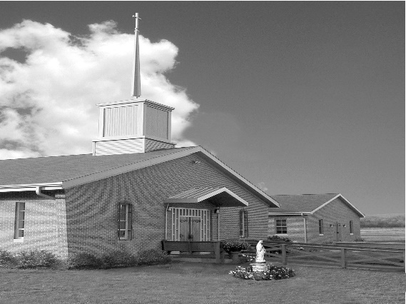
Phone: Phone: (570) 925-6969
E-mail: ctk@epix.net
Website: ctkbenton.weebly.com
Pastor: Rev. Richard J. Mowery
(570) 784-0801
Administrator: Rev. Olusola Adewole, O.P.
(570) 784-3123,
FrOAdewole@hbgdiocese.org
CYE Coordinator: Betty Hnylanski
(570) 594-3687, bhnylan@gmail.com
Secretary: Lee Ann Boiwka
(570) 864-3090, boiwka@epix.net
Office Hours: Monday & Thursday, 8am -12pm

December 19, 2021 – Fourth Sunday of Advent

“Christian communities are called to share in joy”

The interaction between Mary and Elizabeth can teach us about Christian community. The women share in the joy of being a part of God’s plan. Likewise, Christians can draw together to celebrate with one another, as well as to support one another.

Liturgy of the Word
Micah prophesies that the ruler of Israel will come from Bethlehem-Ephrathah. The author of the Letter to the Hebrews writes that Christ said that he had come to do God’s will and that all have been consecrated through the offering of the body of Jesus Christ once for all. In the Gospel, Mary visits Elizabeth and the child in Elizabeth’s womb leaps at the sound of Mary’s voice.

Daily Readings for Advent “Your word, O Lord, is a lamp for my feet, a light for my path.” –
Psalm 119:105
Fourth Week - Sunday Romans 1:1-17, Monday Judges 13:2-7, 24-25, Tuesday Isaiah 7:10-14, Wednesday Song of Songs 2:8-14, Thursday Luke 1:57-66, Friday Luke 1:67-79
In your prayers, please remember: Intentions of the Holy Father, all Priests including Msgr. Lawrence, Fr. Mowery and Fr. Sola, Josephine Folayemi Adewole, Lorena Bennet,
Butch Bogart, Christina Capriola, Russell Castrogiovanni, Cobert Family, Deb Haden, Ray Hunsinger, Vivian Whitenight Hynick, Margaret Kalie, Joyce Kishbaugh, Dick Kocher, Mary Ann Levan, James Mazonkey, Nora & Terry McDaniels, Bernie Nichols, Joan Pauley, Helen Raski, Sabo Family, Joan Sansouci, Pat Scardigli, Jackie Scherer, Dot Shelmet, Douglas Talanca, Pat Treier’s daughter Christy, Max Whitenight, Sonny Womelsdorf, Stan Zalot, and all the Parishioners of CTK.

Stewardship: December 12, 2021
Offerings $1374.00
Christmas $425.00
Immaculate Conception $187.00
Poinsettias $40.00
Retirement Fund for Religious $411.00

Total $2437.00

Mass Intentions
Saturday, December 18 – Bob Lindner by Richard & Tamara Lindner
Sunday, December 19 – Deceased Members of the Lizardi Family by Elizabeth Hnylanski
Monday, December 20 – Sabo Family by Paul Barclay
Thursday, December 23 – People of the Parish
Friday, December 24 – Daniel & Dolores Bauman and Lynne Greenly by Boiwka Family
Saturday, December 25 – Marilyn LaBonte by LaBonte Family
Sunday, December 26 – Dolores Strazdus by David Strazdus

Mass intentions are available in memory of, or in honor of a loved one. The donation for having a Mass said for a personal request is $10.00. You can drop your request in the collection or contact the parish office.

Lector Schedule Extraordinary Minister
December 19 - Meg Geffken Stephen Root
December 24 – Richard Lidner Judith Scavone
December 25 – Paul Haden Kathy Walker
December 26 - Mary Ann Zeveney Lee Ann Boiwka
CHRISTMAS MESSAGE DECEMBER 2021

God, in His mercy, has brought us once again to this auspicious moment to celebrate the birth of our Lord Jesus Christ, Emmanuel-God-with-us. This year has had its challenges. The pandemic is still with us, but we are grateful for the progress in curtailing it, even as we continue to implore God’s mercy on all those who are sick and those severely impacted by it. The Holy Father, Pope Francis, says that as we approach another Christmas, we learn from St. Joseph to cultivate spaces of silence in which another Word can emerge: that of the Holy Spirit who dwells in us. May the God-child born anew for us at Christmas fill us with His Spirit of love, hope, courage, fidelity, and truth. And may the light of His countenance shine upon you, bringing joy, happiness, comfort, peace, and blessings. MERRY CHRISTMAS!!!

Fr. Olusola Adewole, O. P.

Poinsettias in Honor or Memory of our Loved Ones on the Altar

In Honor of
Blessings in 2021 by Gloria & Avery

In Memory of
Anna Zumchak by Judy & Sonny Womelsdorf
Aunt Beatty Evans by Betty, T.J. & James Hnylanski
Bertha Heffner and Leona Chikotas by Noreen & Len Chikotas
Daniel & Dolores Bauman & Lynne Greenly by Joe & Lee Ann Boiwka
David Williams & Vincent Krajnak by Don & Mary Wilce
Deceased members of the Lizardi/Hnylanski Family by Betty, T.J. & James Hnylanski
Deceased members of the Walker & Pointon Families by Kathy & Rich Walker
Edward Mazonkey by Patricia Mazonkey
Jack & John B. Eustice by Anne Eustice
John & Yvonne Fontinell by Mary Fontinell
Lois & William Boiwka by Joe and Lee Ann Boiwka
Patrick J. Stemrich by Melanie Stemrich
Rocky Sullivan and Nicholas & Helen Mogish by Mark & Patricia Sullivan
Ronnie Poles by Dotty Poles
Tom & Tommy Tishler by Sharon Tishler
William J. Lenches II by Shanna & Paul Haden and Family
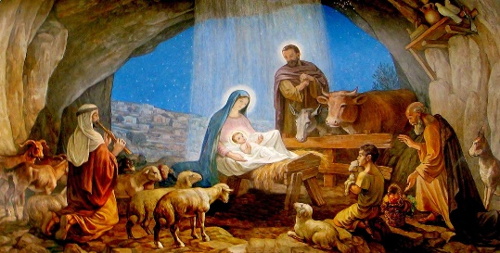
Christmas and New Year Schedule

Friday, Dec. 24 Christmas Vigil Mass @ 5p.m.

Saturday, Dec. 25 Christmas Day Mass @ 9a.m. (No 5:00 p.m. Mass)

Sunday, Dec. 26 Mass of the Holy Family of Jesus, Mary & Joseph @ 9a.m.

Saturday, Jan. 1, 2022 Solemnity of Mary Mother of God (Not a Holy Day of Obligation this year) Confessions @ 4p.m. Vigil Mass of the Epiphany of the Lord @ 5p.m.

Sunday, Jan. 2, The Epiphany of the Lord, Mass @ 9a.m.

The Baptism of the Lord, Jan. 8 & 9 Saturday: Confessions @ 4p.m., Mass @ 5p.m.
Sunday: Mass @ 9a.m.

Christmas Wafers: Oplatky (“angel bread”) Christmas wafers are available on the back counter for a $5.00 donation. The oplatky are thin unleavened wafers similar to communion wafers. Today, in a concession to an ancient tradition, many people place straw and evergreen sprigs on a serving platter covered with a fine white napkin on which the oplatky rest. Families share the wafer on Christmas Eve as they gather together at the table, reconciling any differences, and remembering loved ones who have gone before them.

CYE News:
December 19- No CYE classes
December 25- Merry Christmas. Celebrate the birth of Our Savior
January 1 - Solemnity of Mary
January 3 - No CYE Classes
January 10 - CYE class Resumes. Decision Point Class grades 8-12, 11:30-2:15, lunch provided

