Christ the King Catholic Church
300 Mendenhall Lane, P.O. Box 297 Benton, PA
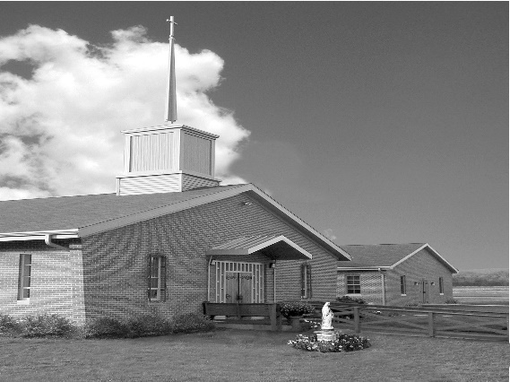
Phone: Phone: (570) 925-6969
E-mail: ctk@epix.net
Website: ctkbenton.weebly.com
Pastor: Rev. Richard J. Mowery
(570) 784-0801
Administrator: Fr. Andrew P. St. Hilaire
(570) 784-3123 (717) 884-9523
frasthilaire@hbgdiocese.org
CYE Coordinator: Betty Hnylanski
(570) 594-3687, bhnylan@gmail.com
Secretary: Lee Ann Boiwka
(570) 864-3090, boiwka@epix.net
Office Hours: Monday & Thursday, 8am -12pm

December 18, 2022 – Fourth Sunday of Advent

“God keeps his promises.”

Through the prophet Isaiah, the Lord reaffirms the promise of a savior for his people, a savior born under unusual circumstances who would clearly be God’s chosen one. After many years had passed since that promise – years in which the Lord continued to guide and prepare his people – we hear of its fulfillment in Matthew’s Gospel. In this final week of Advent, let us rejoice and praise God for he is faithful and keeps his promises.

Liturgy of the Word
Isaiah prophesies that the Lord will give his people a sign: A virgin shall conceive and give birth to a son and will name him Emmanuel. Paul introduces himself to the Romans as one called to be an apostle and set apart for the gospel of God, specifically among the Gentiles. In the Gospel, Matthew recounts how the birth of Jesus Christ came to pass, in accordance with Isaiah’s prophecy.

Second Collection today is for the Catholic Campus Ministry – Please be generous!

In your prayers, please remember: Intentions of the Holy Father, all Priests including
Fr. Mowery, Fr. St. Hilaire and Fr. Sola, Lisa Baehre, Ken Barchik, Michael Bardi, Maureen Beck, Lorena Bennet, Christina Capriola, Russell Castrogiovanni, Cobert Family, Michael Farrell, Deb Haden,Vivian Whitenight Hynick, Bob Kalie, Carl Kalie, Margaret Kalie, Joseph LaBonte, Mary Ann Levan, Bernie Nichols, Nancy Oman, Richard Scavone, Jackie Scherer, Diane & Doug Talanca, Sally Tucker, Max Whitenight, Nancy Wisbar, Sonny Womelsdorf, Mary Ann Zeveney and all the Parishioners of CTK.

Stewardship: December 11, 2022

Offerings $2452.50
Christmas $2555.00
Immaculate Conception $310.00
Poinsettias $110.00
Retirement for Religious $513.00
St. Nick $35.00

Total $5975.50

Mass Intentions

Saturday, December 17 – Marilyn LaBonte by Joseph LaBonte
Sunday, December 18 – Justin McClay by Fr. Andrew St. Hilaire
Monday, December 19 - Joanna Sarisky by Anne Eustice
Friday, December 23 – Gloria Goldy by Joe & Ginny English
Saturday, December 24 – Daniel & Dolores Bauman, Lynne Greenly by Boiwka’s
Sunday, December 25 – People of the Parish

Mass intentions are available in memory of, or in honor of a loved one. The donation for having a Mass said for a personal request is $10.00. You can drop your request in the collection or contact the parish office.

Lector Schedule Extraordinary Minister Collection Stewards

December 18 – Meg Geffken Judith Scavone Charlotte & Joe Casarella
December 25 – Paul Haden Patricia Sullivan Lee Ann & Joe Boiwka
Poinsettias – If you are interested in having a poinsettia on the altar in Honor of or Memory of a Loved one, fill out a form and drop it in the collection or bring it to the parish office. The donation is $10.00 per plant.

CYE News – No CYE class 12/18. Join our parish family to decorate the Church.

Monastery Pantry – Orders will be available to pick up after Mass on Saturday, December 17th and Sunday December 18th.

Unborn Candle Donations $3.00/ week, $5.00/ 2 weeks or $10.00/ month.
Month of December – In Memory of Nick Sabo

Benton Food Bank - For the month of December we will be collecting boxed popcorn to pop. The Food Bank at the N4C’s is the 3rd Tuesday of every month. Anyone in need is encouraged to come between 9:00 a.m. -11:00 a.m. and also 4:30 p.m. – 6:30 p.m.

Thank you note from the Benton Food Bank – Thank you for your continued donations in 2022. You can be sure they are greatly appreciated.

Diocesan Annual Campaign as of December 1, 2022

Parish Goal for 2022: $9,442.53
Total Paid: $13,572.00
Over goal in cash: $4,129.47
Average per donor: $348.00
Number of Donors: 39
Registered Households: 122
Percentage of Participation: 31.97%
Important Dates in December

December 18th after the 9am mass decorating the church

Saturday December 24th Christmas Eve Mass at 4pm (Confessions 2-3pm)

Sunday December 25th Christmas Day Mass at 9am

Weekday Mass during the Octave of Christmas (at 9am): Wednesday 12/28 Thursday 12/29 Friday 12/30 (no Mass on Monday 12/26 & Tuesday 12/27)

Opportunities for Confession in December
Before Christmas Eve Mass, Monday and Fridays at 8am, Saturdays 3-3:45pm,
Sundays 8-8:45am

Jesse Tree – A special thank you to all who participated in the Jesse Giving Tree. We were able to provide 17 gifts to the Benton Head Start and 34 gifts to the Gardens at Orangeville.

Cell Phone Numbers – If you now have a cell phone number (especially if you no longer have a land line), please contact the office to give us that number. You can do so by calling 570-925-6969 or drop an email to ctk@epix.net. Thank you!

Retrouvaille Weekend January 13–15

Is your marriage going down the right road . . . or is it a little off track? Life can be difficult, and so can the challenges you face in marriage.

Does the distance between you seem wide? Are you already separated? Looking for a better way? Retrouvaille can help and offers hope for a better relationship. Retrouvaille is a peer ministry of volunteer couples that can help you learn the tools of healthy communication, build intimacy and heal, just as they have done in their own marriages. Retrouvaille is Christian-based, and Catholic in origin, but welcomes couples of all faiths as well as non-religious couples. Retrouvaille can help get your relationship back on track.

The next Retrouvaille weekend is in Mechanicsburg, PA on January 13 – 15, 2023. For more information about an upcoming Retrouvaille Weekend program for couples, contact the registration team at 717-356-2185 or visit our website: HelpOurMarriage.org

