Christ the King Catholic Church
300 Mendenhall Lane, P.O. Box 297 Benton, PA
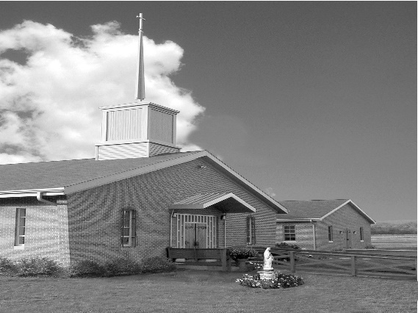
Phone: Phone: (570) 925-6969
E-mail: ctk@epix.net
Website: ctkbenton.weebly.com
Pastor: Rev. Richard J. Mowery
(570) 784-0801
Administrator: Fr. Andrew P. St. Hilaire
(570) 784-3123 (717) 884-9523
frasthilaire@hbgdiocese.org
CYE Coordinator: Betty Hnylanski
(570) 594-3687, bhnylan@gmail.com
Secretary: Lee Ann Boiwka
(570) 864-3090, boiwka@epix.net
Office Hours: Monday & Thursday, 8am -12pm

December 11, 2022 – Third Sunday of Advent (Gaudete Sunday)

“Make your hearts firm, because the coming of the Lord is at hand.”

On Gaudete Sunday we rejoice with all the earth in anticipation and preparation for Jesus’ birth and the coming of his kingdom. We, like John the Baptist, are blessed and included in the kingdom of heaven, not because of what we do but what Jesus does for us.

Liturgy of the Word
In the first reading, Isaiah describes how the earth will rejoice when the Lord comes to save his people. In the second reading, James encourages patient hearts, for the return of the Lord is at hand. In the Gospel, Jesus praises John the Baptist as God’s messenger and assures John’s disciples that he is the one John has been seeking.

Second Collection today is for Retirement Fund for Religious – Please be generous!

In your prayers, please remember: Intentions of the Holy Father, all Priests including
Fr. Mowery, Fr. St. Hilaire and Fr. Sola, Lisa Baehre, Ken Barchik, Michael Bardi, Maureen Beck, Lorena Bennet, Christina Capriola, Joe Casarella, Russell Castrogiovanni, Cobert Family, Michael Farrell, Michael Fontinell, Deb Haden,Vivian Whitenight Hynick, Bob Kalie, Carl Kalie, Margaret Kalie, Joseph LaBonte, Mary Ann Levan, James Mazonkey, Bernie Nichols, Nancy Oman, Richard Scavone, Jackie Scherer, Diane & Doug Talanca, Sally Tucker, Max Whitenight, Nancy Wisbar, Sonny Womelsdorf, Mary Ann Zeveney and all the Parishioners of CTK.

Stewardship: December 4, 2022

Offerings $2202.50
Christmas $25.00
Rainy Day $10.00
St. Nick $250.00
Votives $63.00

Total $2550.50

Mass Intentions

Saturday, December 10 – Anne Lindner by Richard & Tamara Lindner
Sunday, December 11 - Tom Tishler by Sharon Tishler
Monday, December 12 – Sally Hanlon by Minnie Mary Rossi
Friday, December 16 – Joanne Bendick by Anne Eustice & Pat Mazonkey
Saturday, December 17 – Marilyn LaBonte by Joseph LaBonte
Sunday, December 18 – Justin McLay by Fr. Andrew St. Hilaire

Mass intentions are available in memory of, or in honor of a loved one. The donation for having a Mass said for a personal request is $10.00. You can drop your request in the collection or contact the parish office.

Lector Schedule Extraordinary Minister Collection Stewards
December 11 – Barb Treier Lee Ann Boiwka Sharon Tishler & Dottie Poles
December 18 – Meg Geffken Judith Scavone Charlotte & Joe Casarella
Poinsettias – If you are interested in having a poinsettia on the altar in Honor of or Memory of a Loved one, fill out a form and drop it in the collection or bring it to the parish office. The donation is $10.00 per plant.

CYE News
Many thanks to Shanna Haden and the CYE students that helped to provide the Advent/Christmas workshop for the students. It was a delightful time for everyone.

December 11 - We share our story of Advent and the preparation for Christmas with our families and friends. Children’s Advent/Christmas program beginning with 9:00 Mass and following. Also a parish meal of celebration and fellowship. The children will be involved in the program about the Advent Wreath, the Jesse tree, the Novena of St Andrew, and the First Nativity.

December 18 - We prepare our church for Christmas. Decorating the church is a parish family affair, beginning immediately after 9:00 Mass. please plan to stay after Mass and help with this event. Regular CYE classes will not be held.

Unborn Candle Donations $3.00/ week, $5.00/ 2 weeks or $10.00/ month.
Month of December – In Memory of Nick Sabo

Benton Food Bank - For the month of December we will be collecting boxed popcorn to pop. The Food Bank at the N4C’s is the 3rd Tuesday of every month. Anyone in need is encouraged to come between 9:00 a.m. -11:00 a.m. and also 4:30 p.m. – 6:30 p.m.

Thank you note from the Benton Food Bank – Thank you for your continued donations in 2022. You can be sure they are greatly appreciated.

Christmas Wafers: Oplatky (“angel bread”) Christmas wafers are available for a $5 suggested donation. The oplatky are thin unleavened wafers similar to communion wafers. Today, in a concession to an ancient tradition, many people place straw and evergreen sprigs on a serving platter covered with a fine white napkin on which the oplatky rest. Families share the wafer on Christmas Eve as they gather together at the table, reconciling any differences, and remembering loved ones who have gone before them
Important Dates in December

December 11th at 10am CYE Advent/Christmas Concert, Brunch to follow Sunday

December 18th after the 9am mass decorating the church

Saturday December 24th Christmas Eve Mass at 4pm (Confessions 2-3pm)

Sunday December 25th Christmas Day Mass at 9am

Weekday Mass during the Octave of Christmas (at 9am): Wednesday 12/28 Thursday 12/29 Friday 12/30 (no Mass on Monday 12/26 & Tuesday 12/27)

Opportunities for Confession in December
Before Christmas Eve Mass, Monday and Fridays at 8am, Saturdays 3-3:45pm,
Sundays 8-8:45am

Cell Phone Numbers – If you now have a cell phone number (especially if you no longer have a land line), please contact the office to give us that number. You can do so by calling 570-925-6969 or drop an email to ctk@epix.net. Thank you!

Retrouvaille Weekend January 13–15

Is your marriage going down the right road . . . or is it a little off track? Life can be difficult, and so can the challenges you face in marriage.

Does the distance between you seem wide? Are you already separated? Looking for a better way? Retrouvaille can help and offers hope for a better relationship. Retrouvaille is a peer ministry of volunteer couples that can help you learn the tools of healthy communication, build intimacy and heal, just as they have done in their own marriages. Retrouvaille is Christian-based, and Catholic in origin, but welcomes couples of all faiths as well as non-religious couples. Retrouvaille can help get your relationship back on track.

The next Retrouvaille weekend is in Mechanicsburg, PA on January 13 – 15, 2023. For more information about an upcoming Retrouvaille Weekend program for couples, contact the registration team at 717-356-2185 or visit our website: HelpOurMarriage.org

