Christ the King Catholic Church
300 Mendenhall Lane, P.O. Box 297 Benton, PA
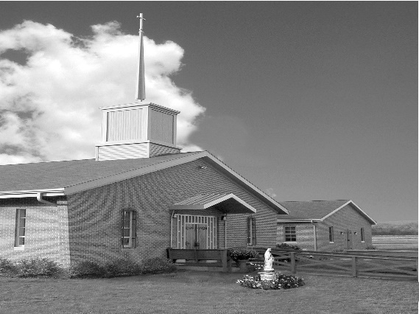
Phone: Phone: (570) 925-6969
E-mail: ctk@epix.net
Website: ctkbenton.weebly.com
Pastor: Rev. Richard J. Mowery
(570) 784-0801
Administrator: Fr. Andrew P. St. Hilaire
(570) 784-3123 (717) 884-9523
frasthilaire@hbgdiocese.org
CYE Coordinator: Betty Hnylanski
(570) 594-3687, bhnylan@gmail.com
Secretary: Lee Ann Boiwka
(570) 864-3090, boiwka@epix.net
Office Hours: Monday & Thursday, 8am -12pm

August 14, 2022 – 20th Sunday in Ordinary Time

“Persevere in running the race.”

Faithful disciples of the Lord Jesus will face opposition for living the truth and values of God’s kingdom. When confronted, we must keep our eyes fixed on Jesus and persevere in running the race.

LITURGY OF THE WORD

In the first reading, Jeremiah is thrown into a cistern and left to die. He is then rescued by a court official. The author of the Letter to the Hebrews encourages the community to persevere in running the race, keeping their eyes fixed on Jesus, who himself faced persecution. In the Gospel, Jesus tells his disciples that he has come not to bring peace but division.

The Assumption of the Blessed Virgin Mary – Mass on Monday, August 15th, at 6:00 p.m. No 9:00 a.m. Mass.

In your prayers, please remember: Intentions of the Holy Father, all Priests including Msgr. Lawrence, Fr. Mowery, Fr. St. Hilaire and Fr. Sola, Josephine Folayemi Adewole, Michael Bardi, Maureen Beck, Lorena Bennet, Butch Bogart, Christina Capriola, Russell Castrogiovanni, Cobert Family, Edward Connell, Alan & Jen Culp, Michael Farrell, Michael Fontinell, Deb & Paul Haden, Ray Hunsinger, Vivian Whitenight Hynick, Bob Kalie, Carl Kalie, Margaret Kalie, Joseph LaBonte, Mary Ann Levan, James Mazonkey, Bernie Nichols, Nancy Oman, Sabo Family, Joan Sansouci, Jackie Scherer, Diane Talanca, Pat Treier’s daughter Christy, Sally Tucker, Max Whitenight, Nancy Wisbar, Sonny Womelsdorf, and all the Parishioners of CTK.

Stewardship: August 7, 2022

Offerings $1698.00
Mission Coop $110.00
St. Nick $135.00

Total $1943.00

Mass Intentions
Saturday, August 13 – Marie Akers by Mary Ann Zeveney
Sunday, August 14 – David Strazdus, Birthday Blessings, by Deborah Shaffer
Monday, August 15 – Anne Eustice by Renee Hansen
Friday, August 19 – People of the Parish
Saturday, August 20 – Eleanor Rossi & Celia Trudnak by Mary Ann Zeveney
Sunday, August 21 – People of the Parish

Mass intentions are available in memory of, or in honor of a loved one. The donation for having a Mass said for a personal request is $10.00. You can drop your request in the collection or contact the parish office.

Lector Schedule Extraordinary Minister
August 14 – Barb Treier P.J. Haden
August 21 – Paul Haden Patricia Sullivan
Benton Food Bank - For the month of August we will be collecting hand soaps and paper towels. The Food Bank at the N4C’s is the 3rd Tuesday of every month. Anyone in need is encouraged to come between 9:00 a.m. -11:00 a.m. and also 4:30 p.m. – 6:30 p.m.

Unborn Candle Donations $3.00/ week, $5.00/ 2 weeks or $10.00/ month.
Month of August – Mark & Patricia Sullivan

Pierogi Making Schedule – Friday, August 19, starting at 8:00 a.m.

CYE News: Attention CYE catechists and helpers: there will be a BRIEF meeting on Sunday August 21 to review our CYE calendar and materials after the 9:00 Mass. I look forward to seeing you all.

CTK Parish Picnic – Our Parish Picnic/Brunch is at the Benton Park immediately following Mass on Sunday, September 4th. Please sign the sheet on the back counter of the church if plan to attend and what favorite dish you will bring.

Check out The Catholic Witness’ Website, and Sign up for the Free Digital Edition
The Catholic Witness delivers up-do-date news, photos, columns and videos on its website, www.catholicwitness.org. Visit the site to see the latest features, all in a user-friendly, mobile and dynamic layout. Through the website, readers can subscribe to The Witness’ free digital edition, which is distributed via e-mail on a bi-weekly basis. The digital edition includes links to the most recent news features, columns and event listings, as well as a printable PDF file. Visit www.catholicwitness.org and sign up today!

We need Volunteers – Margaret Kalie, one of our faithful parishioners, is currently on bed rest and then will be having surgery. During this time, we are asking parishioners to visit Bob and Peg, provide meals and/or offer respite care time. There will be a sign up sheet, or you can call Sharon Tishler at 570-956-4949 or Meg Geffken at 570-204-9031 to volunteer. Your help is most appreciated.
2022 Diocesan Annual Campaign Report as of August 3, 2022

Parish Goal for 2022: $9,442.53
Total Paid: $13,082.00
Outstanding Pledges: $250.00
Total Committed: $13,332.00
Over/(under)goal in cash: $3,639.47
% toward goal cash rec’d: 138.54%
Average per donor: $353.57
Number of Donors: 37
Registered Households: 119
Percentage of Participation: 31.09%

Matrimony: A Calling to Forgive: “Mercy is the force that reawakens us to new life and instills in us the courage to look to the future with hope.” Retrouvaille offers a welcoming and loving space to couples who have been living with the misery of a failing marriage. Retrouvaille offers hope: hope that it is not too late, hope of a different and better marriage. Retrouvaille helps couples to show each other mercy through the opportunities it provides to listen, to forgive, to be reconciled and to move into their futures believing that God loves them and with His help and their efforts, their marriages can be healed and restored. Retrouvaille provides help for marriage problems/difficulties/crises. The next Retrouvaille weekend in Harrisburg, PA is September 9 – 11. For more information about an upcoming Retrouvaille Weekend program for couples, contact the registration team @ 717.356.2185 or visit our website: HelpOurMarriage.org

Save your cancelled Stamps: CTK Ambassadors are collecting cancelled stamps (except flag stamps) for the Wounded Veterans. This organization asks for donations of cancelled stamps which they use in a rehab workshop. There is a basket on the table at the entrance of the church.

