Christ the King Catholic Church
300 Mendenhall Lane, P.O. Box 297 Benton, PA
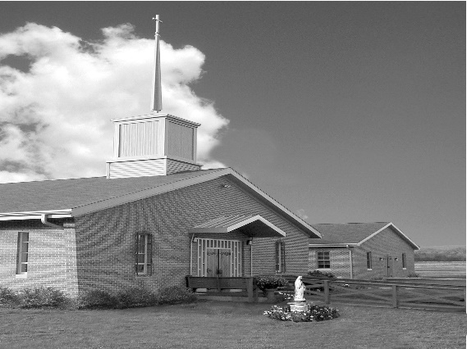
Phone: Phone: (570) 925-6969
E-mail: ctk@epix.net
Website: ctkbenton.weebly.com
Pastor: Rev. Richard J. Mowery
(570) 784-0801
Administrator: Rev. Olusola Adewole, O.P.
(570) 784-3123,
FrOAdewole@hbgdiocese.org
CYE Coordinator: Betty Hnylanski
(570) 594-3687, bhnylan@gmail.com
Secretary: Lee Ann Boiwka
(570) 864-3090, boiwka@epix.net
Office Hours: Monday & Thursday, 8am -12pm

April 3, 2022 – Fifth Sunday of Lent

“Jesus, who is love and mercy, heals and forgives.”

Jesus reveals the heart of the Father, who is love. Although we turn away from him, God does not choose to condemn or turn away from us. Instead, he offers to pay our debt, to take our sins to the cross. He comes to cleanse and heal us and give us a share in his life.

Liturgy of the Word
In the first reading from Isaiah, the Lord says to remember not the things of old, for he is doing a new thing. In Paul’s Letter to the Philippians, he proclaims that he does not have righteousness because of his own doing but rather only in Christ. In the Gospel, the scribes and Pharisees test Jesus by bringing a woman who had been caught in adultery. Jesus tells them that the one without
sin can cast the first stone.

Saturday evening Mass will return to 5 p.m. on April 2nd with Confessions 4 p.m.

Second Collection April 9 & 10 for Ukraine, please be generous!

The Parish Office will open at 8:30 on Monday for the month of April

In your prayers, please remember: Intentions of the Holy Father, all Priests including Msgr. Lawrence, Fr. Mowery and Fr. Sola, Josephine Folayemi Adewole, Maureen Beck, Lorena Bennet, Butch Bogart, Christina Capriola, Russell Castrogiovanni, Cobert Family, Michael Fontinell, Deb Haden, Ray Hunsinger, Vivian Whitenight Hynick, Carl Kalie, Margaret Kalie, Dick Kocher, Mary Ann Levan, James Mazonkey, Nora & Terry McDaniels, Bernie Nichols, Joan Pauley, Helen Raski, Sabo Family, Joan Sansouci, Pat Scardigli, Jackie Scherer, Pat Treier’s daughter Christy, Sally Tucker, Max Whitenight, Nancy Wisbar, Sonny Womelsdorf, and all the Parishioners of CTK.

Stewardship: March 27, 2022

Offerings $2088.00
Rainy Day/Project Fund $70.00
St. Nicholas Fund $30.00
Votives $54.00

Total $2242.00

Mass Intentions
Saturday, April 2 – John B. Eustice by Anne Eustice
Sunday, April 3 – Mike Talanca by Diane & Douglas Talanca
Monday, April 4 – Joseph Anthony Kaeli by Margaret Honse
Thursday, April 7 – Pat Scardigli by Steve & Sue Root
Saturday, April 9 – Josephine Folayemi Adewole by Kathy, Rich Walker & Mary Ellen Neal
Sunday, April 10 – Anne Eustice by Renee Hansen

Mass intentions are available in memory of, or in honor of a loved one. The donation for having a Mass said for a personal request is $10.00. You can drop your request in the collection or contact the parish office.

Lector Schedule Extraordinary Minister
April 3 – Paul Haden Meg Geffken
April 10 – Barb Treier & Peter Yastishock Judith Scavone

CYE News: Attention Parents of Preschool and Kindergarten children: Preparations are now in motion for a Preschool/Kindergarten CYE class. Please contact the parish office or Ms Betty, if you have a preschool or Kindergarten child. Materials are being ordered and we look forward to once again sharing this opportunity for age appropriate faith development with your family.
CYE Updates
April 3 - Sacrament of reconciliation
April 10 - Stations of the Cross
April 17 - Egg hunt after 9:00 Easter Sunday Mass

Unborn Candle Donations $3.00/ week, $5.00/ 2 weeks or $10.00/ month.
Month of April – Anne Kingsbury

Benton Food Bank - For the month of April we will be collecting cans of tuna. Thank you for your generosity! The Food Bank at the N4C’s is the 3rd Tuesday of every month. Anyone in need is encouraged to come between 9:00 a.m. -11:00 a.m.

The Harrisburg Diocesan Council of Catholic Women invites all women of the Diocese to attend the 96th Annual Convention - registration is now open. Our theme this year is “Be God’s Hands on Earth.” The convention will take place Saturday, April 23, 2022. at the Roman Catholic Diocesan Center, Harrisburg PA. More details are available on our website: https://hdccw.webs.com/hdccw-convention
Our Keynote Speaker will be Emily Jaminet who is executive director of the Sacred Heart Enthronement Network and coauthor of Divine Mercy for Moms, The Friendship Project, Pray Fully, and Our Friend Faustina.

Lenten Penance for Christ the King is Saturday, April 2nd beginning at 4:00 p.m. and Sunday, April 3rd beginning at 8:00 a.m.
Lenten Penance Nearby: Monday, April 4, 7:00 p.m. St Joseph, Danville; Tuesday, April 5, 7:00 p.m., St. Monica, Sunbury; Wednesday, April 6, 7:00 p.m., St. Pius, Selinsgrove; Thursday, April 7, 7:00 p.m., St. Columba; Friday, April 8, 7:00 p.m., Sacred Heart, Lewisburg.
Easter Flowers – You can order an Easter Flower for the Altar in Memory of, or in Honor of a loved one. The sheets are at the exit of the Church. Donation is $10.00 per plant. You can drop your order off in the collection or stop by the office on Monday or Thursday mornings.

LENTEN AND EASTER SEASON SCHEDULE FOR 2022

Stations of the Cross @ 6 p.m. on Fridays

CYE CONFESSIONS
Sunday, April 3 @ 10 a.m.

CHRIST THE KING LENTEN CONFESSIONS
Saturday, April 2 @ 4 p.m.
Sunday, April 3 @ 8 a.m. (Two Priests on hand)

PALM SUNDAY MASSES, APRIL 9 & 10
Saturday: 5 p.m. Mass
Sunday: 9 a.m. Mass

MONDAY OF HOLY WEEK, APRIL 11
Mass @ 9 a.m.
Chrism Mass @ St. Patrick Cathedral, Harrisburg, PA @ 2 p.m.

HOLY THURSDAY, APRIL 14
Mass of the Lord’s Supper @ 7 p.m.
Adoration of the Blessed Sacrament thereafter.

GOOD FRIDAY, APRIL 15
Stations of the Cross @ 2.30 p.m.
Celebration of the Passion of the Lord @ 3 p.m.

HOLY SATURDAY, APRIL 16
Easter Vigil Mass @ 8 p.m.

EASTER SUNDAY, APRIL 17
Mass @ 9 a.m.

FIRST EUCHARIST – MAY 1
Sunday, First Holy Communion at the 9:00 a.m. Mass
May Crowning to follow Mass

SACRAMENT OF CONFIRMATION, MAY 14
Saturday at St. Columba Church, Bloomsburg @ 10 a.m.
(Saturday, April 9, Confirmation Retreat at St. Joseph’s in Danville)

