Christ the King Catholic Church
300 Mendenhall Lane, P.O. Box 297 Benton, PA
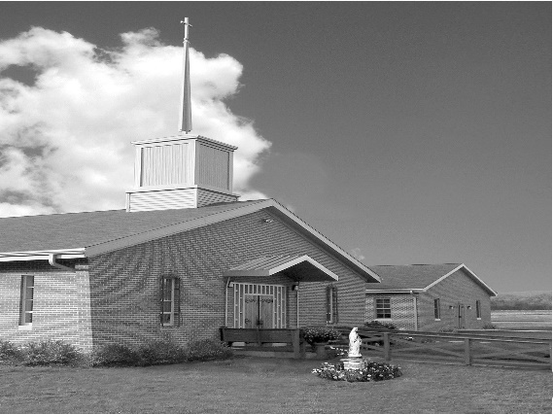
Phone: Phone: (570) 925-6969
E-mail: ctk@epix.net
Website: ctkbenton.weebly.com
Pastor: Rev. Richard J. Mowery
(570) 784-0801
Administrator: Rev. Olusola Adewole, O.P.
(570) 784-3123,
FrOAdewole@hbgdiocese.org
CYE Coordinator: Betty Hnylanski
(570) 594-3687, bhnylan@gmail.com
Secretary: Lee Ann Boiwka
(570) 864-3090, boiwka@epix.net
Office Hours: Monday & Thursday, 8am -12pm

April 24, 2022 – Second Sunday of Easter
Sunday of Divine Mercy

“My Lord and my God!”

When we receive the Eucharist, the body, blood, soul, and divinity of Jesus are substantially present, yet disguised under the appearance of bread and wine. As with Thomas, the Lord gives us the ability to see and believe in him. A good prayer for the moments of consecration, then, is the confession of faith that Thomas makes: My Lord and my God!

Liturgy of the Word
The Apostles continue preaching and healing as more people come to believe in Jesus Christ. In a vision, John records seeing the risen Lord, who says he was dead but lives. In the Gospel, after the Resurrection, Jesus appears to the disciples and blesses them with the Holy Spirit and the authority to forgive sins. Thomas doubts until he sees Jesus.

In your prayers, please remember: Intentions of the Holy Father, all Priests including Msgr. Lawrence, Fr. Mowery and Fr. Sola, Josephine Folayemi Adewole, Maureen Beck, Lorena Bennet, Butch Bogart, Christina Capriola, Russell Castrogiovanni, Cobert Family, Michael Fontinell, Deb Haden, Shanna Haden, Ray Hunsinger, Vivian Whitenight Hynick, Carl Kalie, Margaret Kalie, Dick Kocher, Joseph LaBonte, Mary Ann Levan, James Mazonkey, Nora & Terry McDaniels, Bernie Nichols, Joan Pauley, Helen Raski, Sabo Family, Joan Sansouci, Pat Scardigli, Jackie Scherer, Pat Treier’s daughter Christy, Sally Tucker, Max Whitenight, Nancy Wisbar, Sonny Womelsdorf, and all the Parishioners of CTK.

Stewardship: April 17, 2022

Offerings $1480.00
Easter $1705.00
Holy Thursday $222.00
Good Friday $184.00
Operation Rice Bowl $72.00
People of Ukraine $106.00
Project Fund $75.00

Total $3844.00

Mass Intentions
Saturday, April 23 – Doreen Dougherty (Health & Blessings) by Don & Mary Wilice
Sunday, April 24 – Dolores Bauman & Lynne Greenly by Joe & Lee Ann Boiwka
Monday, April 25 – Deceased members of Neal Family by Mary Ellen Neal
Thursday, April 28 – Mary English by Ginny & Joe English
Saturday, April 30 – John Charles by Richard & Tamara Lindner
Sunday, May 1 – Nicholas Sabo by Justa Sabo
Bianca Beck by Amanda McHenry

Mass intentions are available in memory of, or in honor of a loved one. The donation for having a Mass said for a personal request is $10.00. You can drop your request in the collection or contact the parish office.

Lector Schedule Extraordinary Minister
April 24 - Anne Eustice Shanna Haden
May 1 – Peter Yastishock Judith Scavone

Benton Food Bank - For the month of April we will be collecting cans of tuna. Thank you for your generosity! The Food Bank at the N4C’s is the 3rd Tuesday of every month. Anyone in need is encouraged to come between 9:00 a.m. -11:00 a.m.

Finance Committee and Parish Council – There will be a meeting Tuesday, April 26th. The Finance Committee will meet at 6:00 p.m. and the Parish Council at 7:00 p.m. in the Social Hall.

Work Day at Christ the King: We will have a work day led by the Knights of Columbus on May 7th starting at 9:00 a.m. to clean up the grounds for Spring and do some painting. Hope to see you there.

Chicken BBQ: The Danville Knights of Columbus is having a chicken BBQ dinner on April 30 from 4:00 to 6:30 p.m. in the school basement. Meals are eat-in or take-out. Cost of the meal is $12.00. Please contact Peter Taylor at 570-850-7755 for tickets.

The Paschal Candle is a symbol of the presence of the Risen Lord among the people of God. This special candle remains in the sanctuary through Pentecost Sunday. It is lit for all Masses and services during this season. After Pentecost, the Paschal Candle is placed near the baptismal font and is used at baptisms and funerals as a sign of the light of Christ being among us and leading us.
Divine Mercy Sunday - Sunday, April 24, is what is called “Divine Mercy Sunday.” St. Columba will have afternoon devotions to celebrate the feast of Divine Mercy. This celebration has its beginning in St. Faustina Kowalska, a Polish nun, who received special visions from Jesus in the early part of the 1900s. Her writings led to an increase of devotion to the merciful God through the passion of Jesus Christ. This “herald of mercy” was canonized in the year 2000. God asked her to spread this special devotion to His mercy through the Chaplet of Divine Mercy. Divine Mercy Sunday is celebrated annually and universally on the Sunday after Easter; i.e., the ninth day after Good Friday, the death of Jesus on the cross.

The schedule at St. Columba Church is: 1:30 p.m. - Exposition of the Blessed Sacrament; 1:40 p.m. - Sacrament of Penance until 2:45 p.m. 3:00 p.m. - Chaplet of Divine Mercy; 3:15 p.m. - Benediction of the Blessed Sacrament.

All are encouraged and invited to come and pray for God’s mercy. The Sunday of Divine Mercy, a special plenary indulgence is available under the usual conditions, a privileged occasion of grace and forgiveness for all people. The usual conditions are: Sacrament of Penance and Holy Communion within the octave and prayers for the Holy Father.

Weekend Retreat at Mount St. Mary’s University - “The Harrisburg Diocesan Council of Catholic Women (HDCCW) invites all women of the Diocese to join us for the Tenth Annual Weekend Retreat being held on the beautiful campus of Mount St. Mary's University, Emmitsburg, Maryland. The Retreat begins on Friday evening, June 10th until noon on Sunday, June 12, 2022. Our Retreat Master is Fr. Chris Alar, MIC, Director of The Association of Marian Helpers of the Immaculate Conception and host of “Living Divine Mercy” on EWTN. The registration deadline is May 16, 2022. Registration forms and more details are available on the HDCCW website http://hdccw.webs.com/retreat” or inquire at the Parish Office.
Change in the Retreat Master - Father Chris Alar is unable to serve in this role for 2022. Monsignor William King will be serving in his place.

Unborn Candle Donations $3.00/ week, $5.00/ 2 weeks or $10.00/ month.
Month of April – Anne Kingsbury

New Members – The Parish Family of Christ the King welcomes our newest parishioners
Bret & Dayna Rutkoski.

