Christ the King Catholic Church
300 Mendenhall Lane, P.O. Box 297 Benton, PA
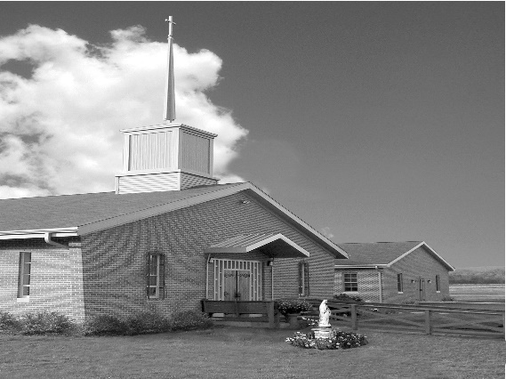
Phone: Phone: (570) 925-6969
E-mail: ctk@epix.net
Website: ctkbenton.weebly.com
Pastor: Rev. Richard J. Mowery
(570) 784-0801
Administrator: Rev. Olusola Adewole, O.P.
(570) 784-3123,
FrOAdewole@hbgdiocese.org
CYE Coordinator: Betty Hnylanski
(570) 594-3687, bhnylan@gmail.com
Secretary: Lee Ann Boiwka
(570) 864-3090, boiwka@epix.net
Office Hours: Monday & Thursday, 8am -12pm

April 17, 2022 – Easter Sunday of the
Resurrection of the Lord

Easter Message
Easter is the feast of life, joy, and the fulfilment of God’s promises to the human race. Easter is the celebration of our Redemption. The Lord has indeed risen, Alleluia. He is not in the tomb. Life has triumphed over death. Our risen Lord has overcome anguish, sorrow, and evil. He has brought us true peace. Pope Francis stresses that the peace Jesus gives to us at Easter is not the peace that follows the strategies of the world, which believes it can obtain it through force, conquest, and various forms of imposition. The peace of the risen Lord follows the way of humility and the cross: It is taking responsibility for others. May the peace and joy of the risen Lord abide with you, your families, and loved ones always. HAPPY EASTER!!!

Blessings,

Fr. 'Sola,op

In your prayers, please remember: Intentions of the Holy Father, all Priests including Msgr. Lawrence, Fr. Mowery and Fr. Sola, Josephine Folayemi Adewole, Maureen Beck, Lorena Bennet, Butch Bogart, Christina Capriola, Russell Castrogiovanni, Cobert Family, Michael Fontinell, Deb Haden, Shanna Haden, Ray Hunsinger, Vivian Whitenight Hynick, Carl Kalie, Margaret Kalie, Dick Kocher, Joseph LaBonte, Mary Ann Levan, James Mazonkey, Nora & Terry McDaniels, Bernie Nichols, Joan Pauley, Helen Raski, Sabo Family, Joan Sansouci, Pat Scardigli, Jackie Scherer, Pat Treier’s daughter Christy, Sally Tucker, Max Whitenight, Nancy Wisbar, Sonny Womelsdorf, and all the Parishioners of CTK.

Stewardship: April 10, 2022

Offerings $1456.30
Catholic Relief Services $435.00
Easter Flowers $180.00
Operation Rice Bowl $276.00
St. Nicholas Fund $60.00
People of Ukraine $904.00

Total $3311.30

Mass Intentions
Saturday, April 16 – Phil Novicki by Kathy and Rich Walker
Sunday, April 17 – Nicholas Sabo by Justa Sabo
Monday, April 18 – No Mass
Thursday, April 21 – Anne Eustice (Birthday Blessings) by Mary Ellen Neal
Saturday, April 23 – Doreen Dougherty (Health & Blessings) by Don & Mary Wilice
Sunday, April 24 – Dolores Bauman & Lynne Greenly by Joe & Lee Ann Boiwka

Mass intentions are available in memory of, or in honor of a loved one. The donation for having a Mass said for a personal request is $10.00. You can drop your request in the collection or contact the parish office.

Lector Schedule Extraordinary Minister
April 16 (Holy Saturday) – Richard Lindner & Kathy Walker
April 17 (Easter) – Paul Haden Patricia Sullivan
April 24 – Anne Eustice Shanna Haden
CYE News: We welcome our new CYE students Lucas McHenry and Andrew Kelsey. Ms. Maryann began the Pre/K K program this past Sunday. Parents of children in Preschool/Kindergarten are welcome to register their children for this class.
Easter egg hunt for children after Easter Sunday morning Mass. Come join the fun.

Confirmation candidates Gavin Birkett, Collin Cashman, and Taylor Chikotas participated in a Retreat at St Joseph’s Church in Danville last Saturday. Please pray for them as they continue on their journey in faith to full communion in the Catholic Church.

Unborn Candle Donations $3.00/ week, $5.00/ 2 weeks or $10.00/ month.
Month of April – Anne Kingsbury

Benton Food Bank - For the month of April we will be collecting cans of tuna. Thank you for your generosity! The Food Bank at the N4C’s is the 3rd Tuesday of every month. Anyone in need is encouraged to come between 9:00 a.m. -11:00 a.m.

The Harrisburg Diocesan Council of Catholic Women invites all women of the Diocese to attend the 96th Annual Convention - registration is now open. Our theme this year is “Be God’s Hands on Earth.” The convention will take place Saturday, April 23, 2022. at the Roman Catholic Diocesan Center, Harrisburg PA. More details are available on our website: https://hdccw.webs.com/hdccw-convention
Our Keynote Speaker will be Emily Jaminet who is executive director of the Sacred Heart Enthronement Network and coauthor of Divine Mercy for Moms, The Friendship Project, Pray Fully, and Our Friend Faustina.

Rice Bowls – Please turn in your offerings for Operation Rice Bowl.

Finance Committee and Parish Council – There will be a meeting Tuesday, April 26th. The Finance Committee will meet at 6:00 p.m. and the Parish Council at 7:00 p.m. in the Social Hall.

Flowers in Honor or Memory of a Loved One

In Memory of parents of Joan and Mike Bardi by Joan & Mike Bardi

In Memory of Dolores & Daniel Bauman and Lynne Greenly by Boiwka Family
In Memory of Lois & William Boiwka by Boiwka Family

In Memory of Beverly & John Charles by Richard & Tamara Lindner
In Memory of Anne & Ray Lindner by Richard & Tamara Lindner

In Memory of William Deglman by Dotty Poles
In Memory of Ronnie Poles by Dotty Poles

In Memory of Bertha Heffner & Leona Chikotas by Chikotas Family

In Memory of Jack & John B. Eustice by Anne Eustice

In Memory of John & Yvonne Fontinell by Mary Fontinell

In Memory of my Grandparents by Gavin & Nicole Birkett
In Honor of my Parents Michael & Claudine by Gavin & Nicole Birkett

In Memory of Deceased members of Lizardi/Hnylanski Family by Betty, T.J. & James Hnylanski
In Honor of Living members of Lizardi/Hnylanski Family by Betty, T.J. & James Hnylanski

In Honor of Ed Mazonkey Family by Pat Mazonkey

In Memory of Jeanne Merriman by Kathy Judge

In Honor of Kim Raspen by John Bendick

In Memory of Mary & Phillip Scavone by Judith & Richard Scavone

In Memory of John Sheeto by Linda Sheeto

In Memory of Tom & Tommy Tishler by Sharon Tishler

In Memory of Deceased members of Walker & Pointen Families by Kathy & Rich Walker

In Memory of Barbara & Stephen Wasilko by Bret & Dayna Rutkoski

In Memory of the Wilce & Williams Families by Don & Mary Wilce

In Memory of Gerald Zeveney by Mary Ann Zeveny
In Memory of John & Cecelia Trudnak by Mary Ann Zeveny

